USING RPC AND TERMINAL SERVICES TO REMOTELY CONNECT TO WINDOWS 2003 SERVER
- Turn on Remote Desktop
- my computer icon (on your desktop) - right click
If there is no such icon on the desktop, you can click on the start button and then right click the my
computer listing in the popup menu.
- Click properties from the drop down menu
- Click the remote tab as shown below.
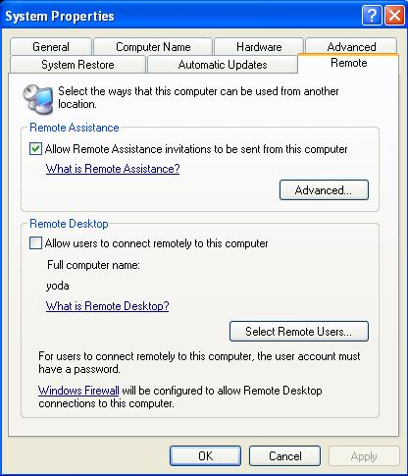
- In the “Remote Desktop” section, in the middle, put a check in the box next to “Allow users to connect remotely to this computer” as shown above (unchecked).
- Click either the OK or the Apply buttons on the bottom.
- Make sure RPC and Terminal Services are turned on in Services
- Click the start button
- Click run
- Type services.msc at the run line
- Look for both the RPC and the Terminal Services services; and start them if they aren’t started already.

- Add your unique port number in the registry at HKEY_LOCAL_MACHINE\SYSTEM\CurrentControlSet\Control\Terminal Server\WinStations\RDP-Tcp\PORT
If you’re going to connect to the server using unique, non-standard port, then:
- Click the start button
- Click run
- Type regedit
- Open each hive, with the plus keys, starting with HKEY_LOCAL_MACHINE, and going all the way to the PORT setting; as shown in blue lettering above.
You’ll need to change the setting to decimal from it’s default hex value, before putting in the unique number.
The standard number is 3389.
If there’s a unique number, besides 3389, in this registry setting, and connecting to the server isn’t working, then change the setting, from whatever number is there, back to the standard 3389 setting.

Reboot the server

