Manual System Check Procedures FOR WINDOWS SERVER 2003.
This section details the procedures that may be performed on the Windows Server 2003 console that will allow the reviewer to analyze the system for security vulnerabilities. Analysis determines the composite effect of Local policy and of Group Policy on WINDOWS 2003.

The following applications are used during the manual Security Readiness Review process:

- Windows Explorer
- Computer Manager
- Server Manager
- Microsoft Management Console
- Control Panel
- Registry Editor
- DumpSec
- Command Prompt

The DumpSec application is an analysis tool that permits the user to systematically review ACL, audit, and user information from the local system. This tool is not included with the basic installation of Windows Server 2003, but may be acquired or download from SomarSoft, Inc. (www.somarsoft.com).

The findings discovered during the execution of these procedures may be mapped to the PDIs found in Section 2.

NOTE 1: In a Windows 2000/2003 Domain, the review should be done with the reviewer logged on to the domain. The review will then reveal the actual effective settings on the box that may result from a combination of Group and Local policies.

NOTE 2: Depending on how the Windows Server 2003 desktop properties are configured, directions for using the START menu may not coincide with what the reviewer sees. Procedures specified assume that the default WINDOWS 2003 START menu is used.

A “” symbol appearing in a section title indicates a Platinum Standard setting.

A “” symbol appearing in a section indicates that the SRR script may return a false finding. The reviewer should review the finding output to determine if the potential finding is valid.

The label “(Future Check)” next to a section title is to alert sites that this is a new check that will become active in the near future. This is meant to give sites sufficient time to incorporate these changes prior to being held accountable in a Security Readiness Review.

Note: Each check is coded with its Gold Disk or Script automation status on the title line as follows:

[A] – Fully Automated (No reviewer interaction).
[AP] - Partially Automated (May require review of output).
[MA] - Currently a manual check, but could be automated or partially automated.
[M] - Manual check (Cannot be automated)

Note: The settings in this checklist are directed towards securing a native Windows environment (i.e. Windows 2000 or later OSs). If the environment is a mixed one, with down-level OSs, or maintains trusts with down-level OSs, then the following checks should be reviewed. Configuring them to the required setting could cause compatibility problems.

5.4.6.14 [A] Encryption of Secure Channel Traffic.
5.4.6.18 [AP] Strong Session Key (WIN2K/W2K3 Native Domains).
5.4.6.53 [AP] Restrict Anonymous Network Shares.
5.4.6.55 [AP] Everyone Permissions Apply to Anonymous Users
5.4.6.61 [AP] LAN Manager Hash Value
5.4.6.63 [AP] LanMan Compatible Password Option Not Properly Set
5.4.5.65 [A] Minimum Session Security for NTLM SSP-based (including secure RPC) Clients
5.4.6.66 [A] Minimum Session Security for NTLM SSP-based (including secure RPC) servers

5 Manual System Check Procedures FOR WINDOWS SERVER 2003. 5-1
5.1 Updating the Windows Server 2003 Security Options File 5-8
5.2 Using “Windows Explorer” 5-9
5.2.1 [A] Service Packs 5-11
5.2.2 [A] POSIX Subsystem File Components  5-12
5.2.3 [A] DLL for Strong Password Filtering 5-13
5.2.4 [A] Printer Share Permissions 5-14
5.3 Using the “Computer Management” console. 5-15
5.3.1 [A] Local NTFS Volumes 5-16
5.3.2 Installed Services 5-17
5.3.2.1 Removed 5-17
5.3.2.2 Removed 5-17
5.3.2.3 [A] NetMeeting Remote Desktop Sharing 5-17
5.3.2.4 [A] Remote Access Auto Connection Manager 5-17
5.3.2.5 [A] Remote Desktop Help Session Manager 5-18
5.3.2.6 [A] Remote Shell Service 5-18
5.3.2.7 [AP] Routing and Remote Access 5-18
5.3.2.8 [A] Simple TCP/IP Services 5-19
5.3.2.9 [AP] Task Scheduler 5-19
5.3.2.10 [A] Telnet 5-19
5.3.2.11 [A] Terminal Services 5-20
5.3.2.12 [M] Unnecessary Services 5-20
5.3.2.13 [AP] Virus-Protection Software 5-21
5.3.3 [A] File Shares 5-22
5.3.4 [M] USB Ports 5-23
5.4 Using the Microsoft Management Console 5-24
5.4.1 Password Policy Configuration 5-27
5.4.1.1 [A] Maximum Password Age 5-27
5.4.1.2 [A] Minimum Password Age 5-28
5.4.1.3 [AP] Minimum Password Length 5-28
5.4.1.4 [A] Password Uniqueness 5-28
5.4.1.5 [M] Enable Strong Password Filtering 5-29
5.4.1.6 [M] Disable Reversible Password Encryption 5-29
5.4.2 Account Lockout Configuration 5-30
5.4.2.1 [A] Bad Logon Attempts 5-30
5.4.2.2 [A] Bad Logon Counter Reset 5-31
5.4.2.3 [A] Lockout Duration 5-31
5.4.3 Kerberos Policy (Domain Controllers only) 5-32
5.4.3.1 [M] User Logon Restrictions 5-32
5.4.3.2 [M] Service Ticket Lifetime 5-33
5.4.3.3 [M] User Ticket Lifetime 5-33
5.4.3.4 [M] User Ticket Renewal Lifetime 5-33
5.4.3.5 [M] Computer Clock Synchronization 5-34
5.4.4 Audit Policy Configuration 5-35
5.4.4.1 [A] Auditing Enabled 5-35
5.4.4.2 [A] Auditing Configuration 5-36
5.4.5 User Rights Policy Configuration 5-37
5.4.5.1 [AP] User Rights Assignments 5-38
5.4.5.2 [AP] Users Granted “Act as part of the operating system” Privilege 5-40
5.4.5.3 [A] Users Granted “Allow logon through Terminal Services” Privilege 5-40
5.4.5.4 [A] Guests not given “Deny access this computer from network” Privilege 5-40
5.4.5.5 [A] Guests not given “Deny log on locally” Privilege 5-41
5.4.5.6 [A] Everyone not given “Deny log on through terminal services” Privilege 5-41
5.4.6 Security Options Configuration 5-42
5.4.6.1 [A] Disable Guest Account 5-43
5.4.6.2 [A] Limit Blank Passwords 5-43
5.4.6.3 [A] Built-in Administrator Account Renamed 5-43
5.4.6.4 [A] Built-in Guest Account Renamed 5-44
5.4.6.5 [AP] Halt on Audit Failure  5-44
5.4.6.6 [A] Undock Without Logging On 5-44
5.4.6.7 [A] Format and Eject Removable Media 5-45
5.4.6.8 [A] Secure Print Driver Installation 5-45
5.4.6.9 [A] Secure Removable Media 5-45
5.4.6.10 [AP] Unsigned Driver Installation Behavior  5-46
5.4.6.11 [A] Server Operators Scheduling Tasks (Domain Controller). 5-47
5.4.6.12 [A] LDAP Signing Requirements (Domain Controller). 5-48
5.4.6.13 [A] Computer Account Password Change Requests (Domain Controller). 5-48
5.4.6.14 [A] Encryption of Secure Channel Traffic. 5-48
5.4.6.15 [A] Signing of Secure Channel Traffic. 5-49
5.4.6.16 [A] Resetting Computer Account Password. 5-49
5.4.6.17 [A] Maximum Machine Account Password Age. 5-49
5.4.6.18 [AP] Strong Session Key (WIN2K/W2K3 Native Domains). 5-50
5.4.6.19 Consolidated with 5.4.1.5 5-50
5.4.6.20 [A] Disable Administrator Automatic Logon 5-50
5.4.6.21 [AP] Enable Not Saving of Dial-up Password (RAS installed only) 5-50
5.4.6.22 [A] Ctrl+Alt+Del Security Attention Sequence. 5-51
5.4.6.23 [AP] Display Legal Notice 5-51
5.4.6.24 [A] Disable Caching of Logon Credentials 5-52
5.4.6.25 [A] Password Expiration Warning 5-53
5.4.6.26 [A] Domain Controller Authentication to Unlock Workstation 5-54
5.4.6.27 [A] Smart Card Removal Option 5-54
5.4.6.28 [A] SMB Client Packet Signing. 5-54
5.4.6.29 [A] SMB Server Packet Signing. 5-55
5.4.6.30 [A] Unencrypted Passwords to 3rd Party SMB Servers 5-56
5.4.6.31 [A] Idle Time Before Suspending a Session 5-57
5.4.6.32 [A] Forcibly Disconnect when Logon Hours Expire 5-57
5.4.6.33 [A] Additional Winsock Connections 5-57
5.4.6.34 [A] Dynamic Winsock Backlog 5-58
5.4.6.35 [A] Winsock Quasi-free Connections 5-58
5.4.6.36 [A] Winsock Free Connections 5-58
5.4.6.37 [A] IP Source Routing 5-59
5.4.6.38 [A] Detection of Dead Gateways 5-59
5.4.6.39 [A] ICMP Redirects 5-59
5.4.6.40 Removed. 5-60
5.4.6.41 [A] NetBIOS Name Release 5-60
5.4.6.42 [A] Router Discovery 5-60
5.4.6.43 [A] Syn Attack Protection Level 5-61
5.4.6.44 [A] TCP Connection Responses 5-61
5.4.6.45 [A] TCP Data Retransmissions 5-61
5.4.6.46 [A] TCP Dropped Connect Requests 5-62
5.4.6.47 [A] Disable Media Autoplay 5-62
5.4.6.48 [A] Safe DLL Search Mode 5-62
5.4.6.49 [A] TCP Keep Alive Time 5-63
5.4.6.50 [A] Event Log Warning 5-63
5.4.6.51 [A] Screen Saver Grace Period 5-63
5.4.6.52 [MA] Anonymous SID/Name Translation 5-64
5.4.6.53 [AP] Restrict Anonymous Network Shares. 5-65
5.4.6.54 [A] Storage of Credentials or .NET Passports 5-65
5.4.6.55 [AP] Everyone Permissions Apply to Anonymous Users 5-65
5.4.6.56 [MA] Anonymous Access to Named Pipes 5-66
5.4.6.57 [MA] Remotely Accessible Registry Paths 5-66
5.4.6.58 [MA] Remotely Accessible Registry Paths and Sub-paths 5-67
5.4.6.59 [MA] Anonymous Access to Network Shares 5-67
5.4.6.60 [A] Sharing and Security Model for Local Accounts 5-68
5.4.6.61 [AP] LAN Manager Hash Value 5-68
5.4.6.62 [A] Force Logoff when Logon Hours Expire 5-68
5.4.6.63 [AP] LanMan Compatible Password Option Not Properly Set  5-69
5.4.6.64 [A] LDAP Client Signing 5-69
5.4.6.65 [A] Minimum Session Security for NTLM SSP-based (including secure RPC) Clients 5-70
5.4.6.66 [A] Minimum Session Security for NTLM SSP-based (including secure RPC) servers 5-70
5.4.6.67 [A] Recovery Console – Automatic Logon. 5-71
5.4.6.68 [A] Recovery Console - Set Command. 5-71
5.4.6.69 [A] Display Shutdown Button 5-71
5.4.6.70 [AP] Clear System Page File During Shutdown  5-72
5.4.6.71 [A] Strong Key Protection. 5-72
5.4.6.72 [A] FIPS compliant Algorithms. 5-73
5.4.6.73 [A] Objects Created by Members of the Administrators Group. 5-73
5.4.6.74 [A] Case Insensitivity for Non-Windows Subsystems. 5-73
5.4.6.75 [A] Global System Object Permission Strength. 5-74
5.4.6.76 [A] Optional Subsystems. 5-74
5.4.6.77 [A] Software Restriction Policies. 5-75
5.4.7 Event Log Configuration 5-76
5.4.7.1 [A] Event Log Sizes 5-77
5.4.7.2 [A] Restrict Event Log Access Over Network 5-78
5.4.7.3 [AP] Preserving Security Events 5-79
5.4.8 [A] Service Object Permissions 5-80
5.4.9 Registry Key Permissions and Auditing 5-81
5.4.9.1 [A] Anonymous Access to the Registry 5-83
5.4.9.2 [A] Registry Key Auditing 5-85
5.4.10 File and Directory Permissions 5-85
5.4.10.1 [AP] System Files 5-87
5.4.10.2 [A] File and Directory Auditing 5-89
5.5 Control Panel 5-90
5.5.1 [AP] Password Protected Screen Savers 5-91
5.5.2 [MA] Booting into Multiple Operating Systems 5-93
5.6 Registry Editor 5-94
5.6.1 Computer Administrative Templates Configuration 5-95
5.6.1.1 Netmeeting 5-96
5.6.1.1.1 [A] NetMeeting: Disable Remote Desktop Sharing. 5-96
5.6.1.2 Internet Explorer 5-96
5.6.1.2.1 [A] IE - Security Zones: Use Only Machine Settings 5-96
5.6.1.2.2 [A] IE - Security Zones: Do Not Allow Users to Change Policies 5-97
5.6.1.2.3 [A] IE - Security Zones: Do Not Allow Users to Add/Delete Sites 5-97
5.6.1.2.4 [A] IE - Make Proxy Settings Per Machine 5-98
5.6.1.2.5 [A] IE - Disable Automatic Install of Internet Explorer Components 5-98
5.6.1.2.6 [A] IE - Disable Periodic Check for Internet Explorer Software Updates 5-99
5.6.1.2.7 [A] IE - Disable Software Update Shell Notifications on Program Launch 5-99
5.6.1.3 Task Scheduler 5-100
5.6.1.3.1 [A] Task Scheduler - Hide Property Pages 5-100
5.6.1.3.2 [A] Task Scheduler - Prohibit New Task Creation 5-100
5.6.1.4 Terminal Services 5-101
5.6.1.4.1 [A] Terminal Services - Limit Users to One Remote Session 5-101
5.6.1.4.2 [A] Terminal Services - Limit Number of Connections 5-101
5.6.1.4.3 [A] Terminal Services - Do Not Allow Local Administrators to Customize Permissions 5-102
5.6.1.4.4 [A] Terminal Services - Remote Control Settings 5-102
5.6.1.4.5 [A] Terminal Services - Always Prompt Client for Password upon Connection 5-103
5.6.1.4.6 [A] Terminal Services - Set Client Connection Encryption Level 5-103
5.6.1.4.7 [A] Terminal Services – Secure Server 5-104
5.6.1.4.8 [A] Terminal Services - Do Not Use Temp Folders per Session 5-104
5.6.1.4.9 [A] Terminal Services - Do Not Delete Temp Folder upon Exit 5-105
5.6.1.4.10 [A] Terminal Services - Set Time Limit for Disconnected Sessions 5-105
5.6.1.4.11 [A] Terminal Services - Set Time Limit for Idle Sessions 5-106
5.6.1.4.12 [A] Terminal Services - Allow Reconnection from Original Client Only 5-106
5.6.1.4.13 [A] Terminal Services - Terminate Session When Time Limits are Reached 5-107
5.6.1.5 Windows Installer 5-108
5.6.1.5.1 [A] Windows Installer - Always Install with Elevated Privileges 5-108
5.6.1.5.2 [A] Windows Installer - Disable IE Security Prompt for Windows Installer Scripts 5-108
5.6.1.5.3 [A] Windows Installer - Enable User Control Over Installs 5-109
5.6.1.5.4 [A] Windows Installer - Enable User to Browse for Source While Elevated 5-109
5.6.1.5.5 [A] Windows Installer - Enable User to Use Media Source While Elevated 5-110
5.6.1.5.6 [A] Windows Installer - Enable User to Patch Elevated Products 5-110
5.6.1.5.7 [A] Windows Installer - Allow Admin to Install from Terminal Services Session 5-111
5.6.1.5.8 [A] Windows Installer - Cache Transforms in Secure Location on Workstation 5-111
5.6.1.6 Media Player (Computer) 5-112
5.6.1.6.1 [A] Media Player - Disabling Media Player for Automatic Updates 5-112
5.6.1.7 Windows Messenger 5-113
5.6.1.7.1 [A] Windows Messenger - Do Not Allow Windows Messenger to be Run 5-113
5.6.1.7.2 [A] Windows Messenger - Do Not Automatically Start Windows Messenger Initially 5-114
5.6.1.7.3 [A] Windows Messenger – Internet Access Blocked 5-114
5.6.1.8 Logon 5-115
5.6.1.8.1 [A] Logon - Always Wait for the Network at Computer Startup and Logon 5-115
5.6.1.9 Group Policy 5-116
5.6.1.9.1 [A] Group Policy - Turn Off Background Refresh of Group Policy 5-116
5.6.1.9.2 [A] Group Policy – Registry Policy Processing 5-116
5.6.1.10 Remote Assistance 5-117
5.6.1.10.1 [A] Remote Assistance - Solicited Remote Assistance 5-117
5.6.1.10.2 [A] Remote Assistance - Offer Remote Assistance 5-117
5.6.1.11 Error Reporting 5-118
5.6.1.11.1 [A] Error Reporting - Report Errors 5-118
5.6.1.12 Windows Time Service 5-119
5.6.1.12.1 [AP] Windows Time Service – Configure Windows NTP Client 5-119
5.6.1.13 Network Connections 5-120
5.6.1.13.1 [A] Network Connections – Internet Connection Sharing 5-120
5.6.1.13.2 [A] Network Connections – Prohibit Installation and Configuration of Network Bridge on the DNS Domain Network 5-120
5.6.1.14 SNMP 5-121
5.6.1.14.1 [AP] SNMP – Communities 5-121
5.6.1.14.2 [AP] SNMP – Permitted Managers 5-121
5.6.1.14.3 [AP] SNMP – Traps for Public Community 5-122
5.6.1.15 Printers 5-123
5.6.1.15.1 [A] Printers - Disallow Installation of Printers Using Kernel-mode Drivers 5-123
5.6.1.16 Media Player (User) 5-124
5.6.1.16.1 [A] Media Player – Prevent Codec Download 5-124
5.6.2 [A] POSIX Subsystem Registry Keys Installed  5-125
5.6.3 [AP] Security-related Software Patches 5-125
5.6.4 [A] Recycle Bin Configured to Delete Files 5-126
5.7 Using “DumpSec” (DumpACL) 5-127
5.7.1 User Account Configuration 5-128
5.7.1.1 [AP] Passwords Requirement 5-130
5.7.1.2 [AP] Passwords Expiration 5-130
5.7.1.3 [AP] Dormant Accounts 5-131
5.7.1.4 [A] Decoy Administrator Account 5-131
5.7.1.5 [AP] Restricted Administrator Group Membership 5-131
5.7.1.6 [M] Decoy Administrator Account Not Disabled. 5-132
5.7.1.7 [MA] HelpAssistant or Support_388945a0 Accounts Not Disabled. 5-132
5.8 Using “Command Prompt” 5-133
5.8.1 FTP (File Transfer Protocol) Server Configuration 5-134
5.8.1.1 [AP] Prohibited FTP Logins Permitted 5-134
5.8.1.2 [A] Access to System Drive Permitted 5-135
5.9 IAVM Compliance 5-136
5.10 Additional Microsoft Components. 5-137
5.10.1 Optional MS Components. 5-138
5.10.1.1 [MA] Print Services for UNIX. 5-138
5.10.1.2 [MA] ASP.NET Common Runtime Host (.NET Framework) 5-139
5.11 MQ Series security checks 5-140
5.11.1 [MA] MQSeries Log Configuration (Server only) 5-140
5.11.2 [MA] Queue Manager Log Configuration (Server) 5-141
5.11.3 [M] MCAUSER Attribute (Server) 5-141
5.11.4 [MA] MQM Group Existence (Server) 5-143
5.11.5 [MA] MQM Group Membership (Server) 5-143
5.11.6 [MA] Configuration Files (Server and Client) 5-144
5.11.7 [MA] MQSeries Files (Server and Client) 5-144
5.11.8 [M] MQ Series Services (Server and Client) 5-145
5.12 ORACLE Database security checks 5-146
5.12.1 [MA] Registry Permissions 5-147
5.12.2 [M] Oracle File Owner 5-147
5.12.3 [MA] Oracle File Permissions 5-148
5.12.4 [MA] File Permissions - strtSID.cmd (version 8 only) 5-148
5.12.5 [MA] File Permissions – listener.ora 5-149
5.12.6 [MA] File Permissions – snmp file 5-149
5.12.7 [M] File Permissions – SYSDBA password file 5-150
5.12.8 [M] Listener Clear Text Password 5-150
5.13 WebSphere Application Server (Server) 5-151
5.13.1 [M] Websphere Administrator Account 5-151
5.13.2 [M] Websphere Authentication 5-151
5.13.3 [M] Websphere File Security 5-152
5.14 Group Policy Object Protection (Domain Controllers only) 5-153
5.14.1 [M] Group Policy Permissions 5-153
5.14.2 [M] Group Policy Auditing 5-155
5.15 Password Integrity Checking 5-156
5.15.1 [M] Weak Passwords (Domain Controllers) 5-156

Updating the Windows Server 2003 Security Options File
The procedures outlined in this checklist depend upon the use of a Microsoft security options file that has been updated to include some additional security checks that are recommended either by NSA or DISA FSO guidance. The built-in Security Configuration and Analysis tool uses the Security Options file, to display various options that can be configured or analyzed.

Note: The procedure for viewing hidden folders and files in section 5.2 may need to be performed prior to completing this task.

To load the updated Security Options file, do the following:

- Rename the sceregvl.inf file in the %SystemRoot%\inf directory.
- Copy the updated sceregvl.inf file from the media provided (floppy, CD, etc.) to the %SystemRoot%\inf directory.
- Re-register scecli.dll by executing ‘regsvr32 scecli.dll’ at a command prompt.

The additional options will now appear the next time the Security Configuration and Analysis tool is started.

Using “Windows Explorer”
“Windows Explorer” permits users and administrators the capability to manage the permissions and audit configuration of file objects on NTFS volumes.

This program is accessed through the following procedures:
Click on the “Start” button.
Select “All Programs” from the “Start” Menu.
Select “Accessories”
Select “Windows Explorer.”

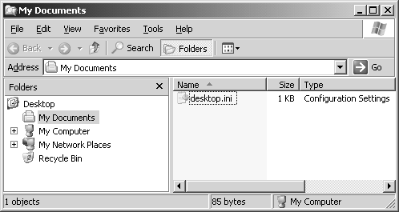
Upon completion, the “Windows Explorer” application should appear:

Finally, select the “Folder Options” item under the “Tools” menu.
In the “Folder Options” dialog box, on the “View Tab”, select the radio-button labeled, “Show hidden files and folders,” and uncheck the box labeled Hide protected operating system files. Click on the “OK” button to continue.

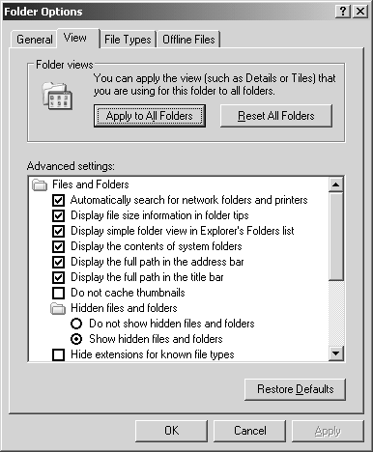

[A] Service Packs
This check verifies that the most-current service pack for Windows Server 2003, 128 bit version is installed.

- From the menu bar click “Start” and then “Run”.
- Type “winver.exe” in the dialog box and click OK.
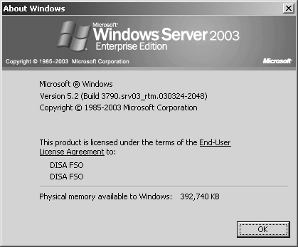

If the dialog box does not display “Version 5.2 (Build 3790…),” then this is a finding.

Category/MAC/IA: | II / 1-CSP, 2-CSP, 3-CSP / DCSQ-1
PDI: | 2.005: The required Windows Server 2003 service pack is not installed.
Reference: | DISA FSO Windows 2003 Addendum, Section 2.2

[A] POSIX Subsystem File Components 
- Select the “Search” button from the Tools bar.
- Enter the following name in the “Search for files and folders named” field:
POSIX PSX
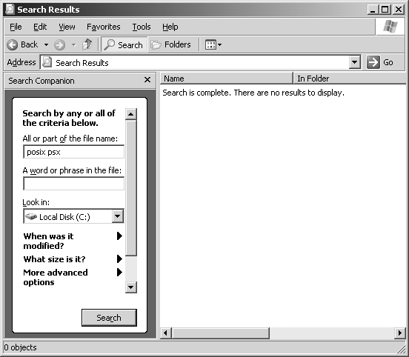
- Click on the “Search” button.

If the search indicates that the files “POSIX.EXE,” “PSXSS.EXE” or “PSXDLL.DLL” exist, then this is a finding.

Category/MAC/IA: | II / 1-CSP, 2-CSP, 3-CSP / DCSL-1
PDI: | 2.004: POSIX subsystem file components are installed.
Reference: | MS Windows Server 2003 Security Guide, pg. 101  DISA FSO Windows 2003 Addendum, Section 3.1

[A] DLL for Strong Password Filtering
- Select the “Search” button from the Tools bar.
- Enter the following names in the “Search for files and folders named” field:
EnPasFlt.dll PPEc32.dll

Note: DISANET requires the use of Password Policy Enforcer (PPE). For DISANET boxes, search for the existence of “PPEc32.dll”.
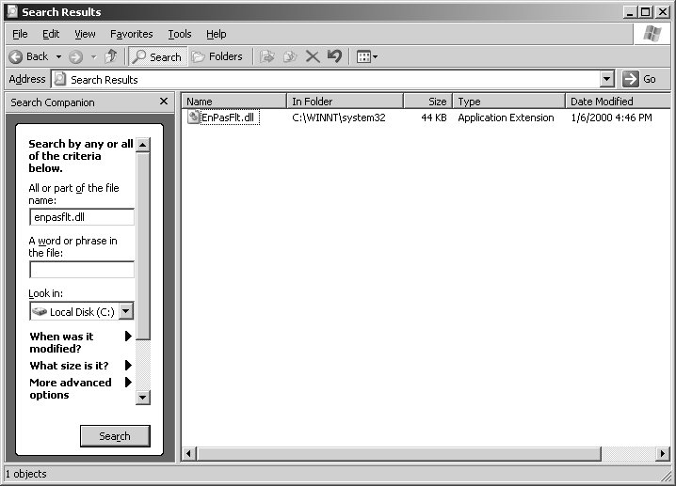
- Click on the “Search” button.

If the EnPasFlt.dll file’s size and modification date, following the search, does not match the above display, then this is a finding. If both the EnpasFlt and PPEc32.dll file are not present in the “%SystemRoot%\SYSTEM32” directory, then this is a finding.

Category/MAC/IA: | II / 1-CSP, 2-CSP, 3-CSP / IAIA-1
PDI: | 2.009: The current approved DLL for strong password filtering is not installed.
Reference: | DISA FSO Windows 2003 Addendum, Section 4.5.3

[A] Printer Share Permissions
This check verifies that shared printers have properly configured share permissions.

- Select the Control Panel directory
- Select the Printers directory.

If there are no locally attached printers, then mark this as “Not Applicable.”

Perform this check for each locally attached printer:

- Right click on a locally-attached printer.
- Select Sharing from the drop-down menu.

Perform this check on each printer that has the “Shared” radio-button selected:

- Select the Security tab

The following table lists the recommended printer share security settings:

Settings
Users: Print
Administrators: Full Control
SYSTEM: Full Control
CREATOR OWNER: Full Control

- If there are no shared local printers, then mark this as “Not Applicable.”
- If the share permissions do not match the above table, then this is a finding.

Category/MAC/IA: | III / 1-CSP, 2-CSP, 3-CSP / ECCD-1
PDI: | 3.027: Printer share permissions are not configured as recommended.
Reference: | DISA FSO Windows 2003 Addendum, Section 7.4

Using the “Computer Management” console.
In Windows 2003, the Computer Management console is used to configure a variety of System-related features for the local environment.

This program is accessed through the following procedures:

Select “Start”
Right-click the “My Computer” icon on the Start menu.
Select “Manage” from the drop-down menu.

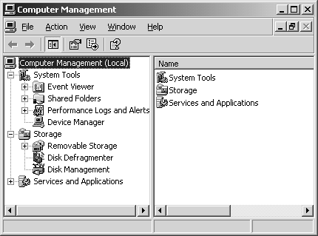

[A] Local NTFS Volumes
This check verifies that all local drives are configured using the NTFS format, enabling the use of Windows Server 2003’s security and auditing features.

- Expand the “Storage” object in the Tree window.
- Select the “Disk Management” object.
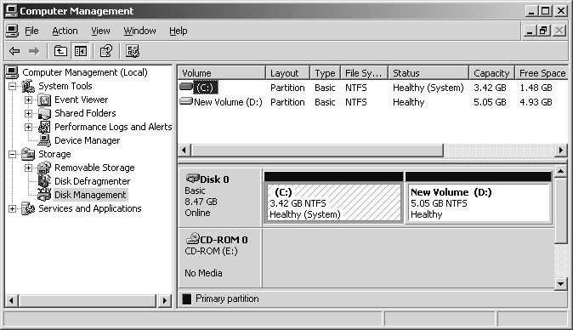

If the file system column does not indicate “NTFS” as the file system for each local hard drive, then this is a finding.

Category/MAC/IA: | I / 1-CSP, 2-CSP, 3-CSP / ECAR-3, ECCD-1, ECCD-2
PDI: | 2.008: Local volumes are not formatted using NTFS.
Reference: | MS Server 2003 Security Settings Guide, Chap 11, p. 270-271

Installed Services
This check verifies that prohibited services are not activated.

- Expand the “Services and Applications” object in the Tree window.
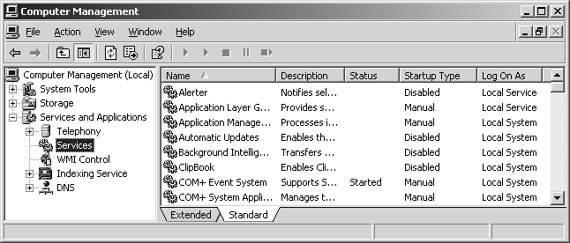
- Select the “Services” object.

Removed

Removed

[A] NetMeeting Remote Desktop Sharing
If the entry “NetMeeting Remote Desktop Sharing” appears in the service list and is not disabled, then this is a finding.

Category/MAC/IA: | II / 1-CSP, 2-CSP, 3-CSP / DCPP-1
PDI: | 5.063: “NetMeeting Remote Desktop Sharing” is not disabled.
Reference: | MS Server 2003 Security Settings Guide, Chap 4, p. 110-111, 137  DISA FSO Windows 2003 Addendum, Sect. 7.6.4

[A] Remote Access Auto Connection Manager
If the entry “Remote Access Auto Connection Manager” appears in the service list and is not disabled, then this is a finding.

Category/MAC/IA: | II / 1-CSP, 2-CSP, 3-CSP / DCPP-1
PDI: | 5.064: “Remote Access Auto Connection Manager ” is not disabled.
Reference: | MS Server 2003 Security Settings Guide, Chap 4, p. 110-111, 141  DISA FSO Windows 2003 Addendum, Sect. 7.6.7

[A] Remote Desktop Help Session Manager
If the entry “Remote Desktop Help Session Manager” appears in the service list and is not disabled, then this is a finding.

Category/MAC/IA: | II / 1-CSP, 2-CSP, 3-CSP / DCPP-1
PDI: | 5.065: “Remote Desktop Help Session Manager” is not disabled.
Reference: | MS Server 2003 Security Settings Guide, Chap 4, p. 110-111, 142  DISA FSO Windows 2003 Addendum, Sect. 7.6.8

[A] Remote Shell Service
If the entry “Remote Shell Service” appears in the service list and is not disabled, then this is a finding. This service is not a service provided with Windows Server 2003.
Category/MAC/IA: | II / 1-CSP, 2-CSP, 3-CSP / DCPP-1
PDI: | 5.008: “Remote Shell Service” is not disabled.
Reference: | DISA FSO Windows 2003 Addendum, Sect. 7.6.10

[AP] Routing and Remote Access
If the entry “Routing and Remote Access” appears in the service list and is not disabled, then this is a finding.

Category/MAC/IA: | II / 1-CSP, 2-CSP, 3-CSP / DCPP-1
PDI: | 5.067: “Routing and Remote Access” is not disabled.
Reference: | MS Server 2003 Security Settings Guide, Chap 4, p. 110-111, 147  DISA FSO Windows 2003 Addendum, Sect. 7.6.11

[A] Simple TCP/IP Services
If the entry “Simple TCP/IP Services” appears in the service list and is not disabled, then this is a finding.

Category/MAC/IA: | II / 1-CSP, 2-CSP, 3-CSP / DCPP-1
PDI: | 5.010: “Simple TCP/IP Services” are not disabled.
Reference: | MS Server 2003 Security Settings Guide, Chap 4, p. 110-111, 149  DISA FSO Windows 2003 Addendum, Sect. 7.6.16

[AP] Task Scheduler
If the “Task Scheduler” service is listed as “Disabled,” then mark this check as “NOT A FINDING.”

If this service is listed as either “Automatic,” or “Manual,” and the requirement for it is not documented with the ISSO , then this is a finding.

Category/MAC/IA: | II / 1-CSP, 2-CSP, 3-CSP / DCPP-1
PDI: | 5.009: The Task Scheduler service is either not controlled, or not disabled.
Reference: | MS Server 2003 Security Settings Guide, Chap 4, p. 110-111, 152  DISA FSO Windows 2003 Addendum, Sect. 7.6.15

[A] Telnet
If the entry “Telnet” appears in the service list and is not disabled, then this is a finding.

Category/MAC/IA: | II / 1-CSP, 2-CSP, 3-CSP / DCPP-1
PDI: | 5.013: “Telnet” is not disabled.
Reference: | MS Server 2003 Security Settings Guide, Chap 4, p. 110-111, 154  DISA FSO Windows 2003 Addendum, Sect. 7.6.16

[A] Terminal Services
If the entry “Terminal Services” appears in the service list and is not disabled, then this is a finding.

Note: If the system has the role as a Terminal Server, or the site is using terminal services for remote administration, then this would not be a finding.

Category/MAC/IA: | I / 1-CSP, 2-CSP, 3-CSP / DCPP-1
PDI: | 5.020: “Terminal Services” is not disabled.
Reference: | MS Server 2003 Security Settings Guide, Chap 4, p. 110-111, 154  DISA FSO Windows 2003 Addendum, Sect. 7.6.17

[M] Unnecessary Services
If the services that are not required, other than those listed above, appear in the service list, and are not disabled, then this is a finding.

Category/MAC/IA: | II / 1-CSP, 2-CSP, 3-CSP / DCPP-1
PDI: | 5.068: Unnecessary services are run on the system.
Reference: | MS Server 2003 Security Settings Guide, Chap 4, p. 110-111

[AP] Virus-Protection Software
This check verifies that a virus-protection program approved by DOD-CERT is installed and activated on the Windows Server 2003 system.

 NOTE: The scripts check for McAfee and Symantec Antivirus, corporate and client editions. Due to variation of installations, manual checks may be required for verifying Anti-Virus compliance.

 NOTE: If a recognized antivirus product such as Innoculator or another product is installed, and has a current signature file, then this would still be a finding, but the category code should be reduced to a IV.

If none of the following products are installed, then this is a finding:
____ Norton Antivirus is not installed.
If the entries “NAV Alert” and “NAV Auto-Protect” do not appear in the service list, then Norton Antivirus is not installed on the local system.

____ McAfee’s NetShield is not installed.
If “McAfee Alert Manager” and “McAfee NetShield Task Manager” do not appear in the service list, then McAfee’s NetShield is not installed.

____ Network Associates McShield (McAfee) is not installed.
If “Network Associates Alert Manager”, “Network Associates McShield,” and “Network Associates Task Manager” do not appear in the service list, then Network Associates McShield is not installed.

____ The anti virus engine is out of date.
If the anti virus engine is supported by CERT and is older than the currently CERT-provided release, then, this is a Category II finding. (If the signature file is also out of date, then it is a Category I finding.)

____ The anti virus signature file is out of date.
If the anti virus program signature file is not dated within the past 14 days, then, this is a finding. (If no signature file has been released in the previous 14 days, then the most current one is required.)

Note: The date of the signature file can generally be checked by starting the anti virus program from the toolbar icon or from the Start menu. The information may appear in the Anti Virus window or be available in the Help > About window. The location varies from product to product.

Category/MAC/IA: | I / 1-CSP, 2-CSP, 3-CSP / ECVP-1
PDI: | 5.007: An approved DOD virus scan program is not used and/or updated.
Reference: | DISA FSO Windows 2003 Addendum, Sect. 7.7

[A] File Shares
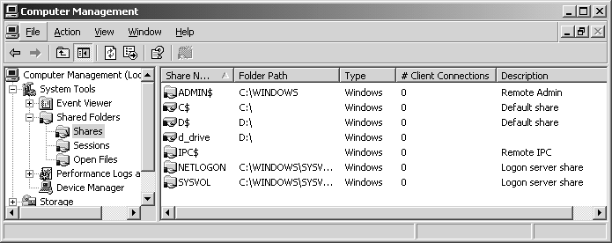
This check verifies that user-created file shares drives are configured properly.

- Expand the “System Tools” object in the Tree window.
- Select the “Shared Folders” object.
- Select the “Shares” object.
- Right click any user-created shares (ignore administrative shares; they usually have a “$” as the last character; ignore the Netlogon and Sysvol shares).
- Select Properties.
- Select the Share Permissions tab.

If user-created file shares have not been reconfigured to remove ACL permissions from the “Everyone group”, then this is a finding.

On Application Servers, if regular users have write or delete permissions to shares containing application binary files (i.e. .exe, .dll. .cmd, etc.), then this is a finding.

Category/MAC/IA: | II / 1-CSP, 2-CSP, 3-CSP / ECSC-1, ECAN-1
PDI: | 2.015: File share ACLs have not been reconfigured to remove the "Everyone" group.
Reference: | DISA FSO Windows 2003 Addendum, Section 7.3

[M] USB Ports
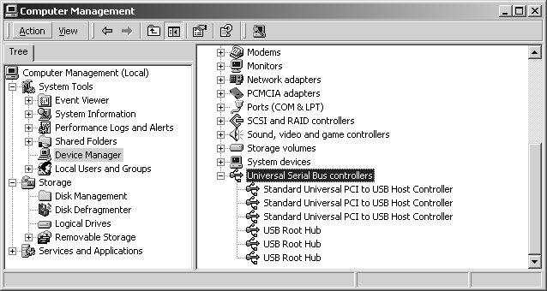
This check verifies that unused USB ports are disabled.

- Expand the “System Tools” object in the Tree window.
- Select the “Device Manager” object.
- Expand the “Universal Serial Bus Controllers” object.
- Verify with the SA that each controller listed is used.

If unused USB controllers exist that are not disabled, then this is a finding.

Note: If the site has a local policy that permits the use of Mobile USB devices, then this would not be applicable.
Category/MAC/IA: | II / 1-CSP, 2-CSP, 3-CSP / ECSC-1
PDI: | 1.031: Unused USB ports are not disabled.
Reference: | DISA FSO Windows 2003 Addendum, Section 7.9

Using the Microsoft Management Console
The Microsoft Management Console (MMC) is the primary system configuration tool for Windows Server 2003. It utilizes “Snap-in” functions to configure the various parts of the system.
The Security Configuration and Analysis snap-in permits the analysis of Account Policy, System Auditing, Local Policies, Event Logs, Services, Registry ACLs and Auditing, and File ACLs and Auditing.

Use the following procedure to use the MMC and load the Security Configuration and Analysis snap-in:

- Select “Start” and “Run” from the desktop.
- Type “mmc.exe” in the Run dialog.
- Select “File” from the MMC menu bar.
- Select “Add/Remove snap-in” from the drop-down menu.
- Click the “Add” button on the Standalone tab.
- Select the “Security Configuration and Analysis” snap-in and click the “Add” button.
- Click “Close”.
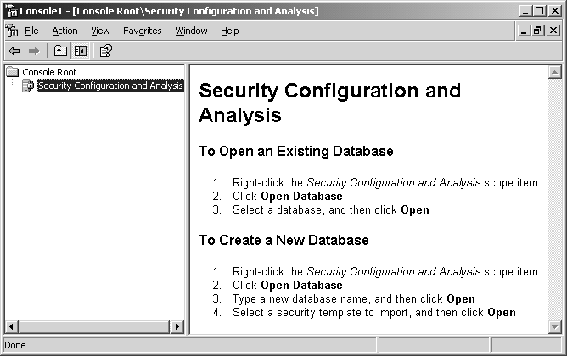
- Click “OK”.

Use the following procedure with the Security Configuration and Analysis snap-in to prepare the files for analyzing the system:

- Right-click on the Security Configuration and Analysis object in the left window.
- Select ‘Open Database’.
- Enter “C:\temp\scan\srr.sdb” for the database name.
- In the ‘Import Template’ window enter the appropriate file name for a server or Domain Controller (i.e. A:\FSOW2K3MS.inf).
- Check the box to “Clear the database before importing”.
- Select “Open”.
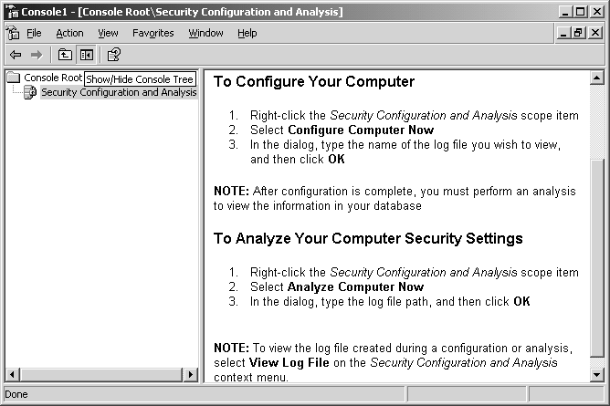

Use the following procedure to analyze the system:

- Right-click on the Security Configuration and Analysis object in the left window.
- Select ‘Analyze Computer Now’.
- Enter “C:\temp\scan\srr.log” for the log name in the ‘Error log file path’ window and click OK.

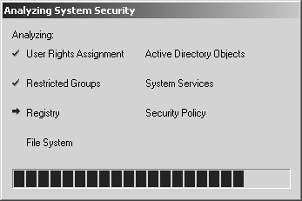
The following window will appear:

When the analysis is complete, the right pane will show the analysis objects.

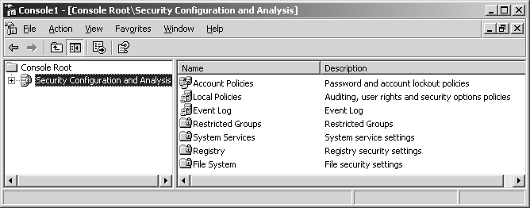

Password Policy Configuration
This check verifies that the system’s password policy conforms to DISA standards.

- Expand the “Security Configuration and Analysis” object in the tree window.
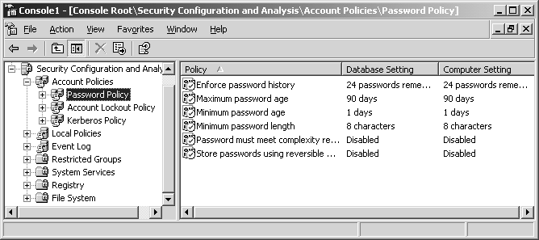
- Expand the “Account Policies” object and select “Password Policy”.

Note: The ‘Database Setting’ in the right pane reflects the required setting. The ‘Computer Setting’ is the effective setting on the machine, which is a combination of any applicable Group policies (WIN2K/W2K3 Domains) and the Local Security Policy.

[A] Maximum Password Age
If the value for the “Maximum password age” is greater than 90 days, then this is a finding. If the value is set to 0 (never expires), then this is a finding.

Category/MAC/IA: | II / 1-CSP, 2-CSP, 3-CSP / IAIA-1, IAIA-2
PDI: | 4.011: Maximum password age does not meet minimum requirements.
Reference: | MS Server 2003 Security Settings Guide, p. 6  DISA FSO Windows 2003 Addendum, Sect. 4.5.3

[A] Minimum Password Age
If the value for the “Minimum password age”, is less than one day, then this is a finding.

Category/MAC/IA: | II / 1-CSP, 2-CSP, 3-CSP / IAIA-1, IAIA-2
PDI: | 4.012: Minimum password age does not meet minimum requirements.
Reference: | MS Server 2003 Security Settings Guide, p. 7  DISA FSO Windows 2003 Addendum, Sect. 4.5.3

[AP] Minimum Password Length
If the value for the “Minimum password length,” is less than eight characters, then this is a finding.

Note: DISANET requires a password length of exactly seven. On DISANET boxes a password length of seven is not a finding.

Category/MAC/IA: | II / 1-CSP, 2-CSP, 3-CSP / IAIA-1, IAIA-2
PDI: | 4.013: Minimum password length does not meet minimum requirements.
Reference: | MS Server 2003 Security Settings Guide, p. 8  DISA FSO Windows 2003 Addendum, Sect. 4.5.3

[A] Password Uniqueness
If the value for “Enforce password history” is less than 24 passwords, then this is a finding.

Category/MAC/IA: | II / 1-CSP, 2-CSP, 3-CSP / IAIA-1, IAIA-2
PDI: | 4.014: Password uniqueness does not meet minimum requirements.
Reference: | MS Server 2003 Security Settings Guide, p. 6  DISA FSO Windows 2003 Addendum, Sect. 4.5.3

[M] Enable Strong Password Filtering
This check verifies that Windows 2000 is implementing strong password filtering and using NSA’s “ENPASFLT.DLL” password filter.

If the value for “Password must meet complexity requirements” is not disabled, or the term “enpasflt” is not included in the list of terms in the following registry value, then this would be a finding:

Registry Hive: HKEY_LOCAL_MACHINE
Subkey: \System\CurrentControlSet\Control\Lsa
Value Name: Notification Packages
Type: REG_MULTI_SZ
Value: EnPasFlt, or PPE, etc…

Note: DISANET requires the use of Password Policy Enforcer (PPE). PPE is an acceptable substitute. The same requirements apply if PPE is used instead of EnPasFlt.

Category/MAC/IA: | II / 1-CSP, 2-CSP, 3-CSP / IAIA-1, IAIA-2
PDI: | 3.028: The built-in Microsoft password filter is not disabled.
Reference: | MS Server 2003 Security Settings Guide, p. 9  DISA FSO Windows 2003 Addendum, Sect. 4.5.3

[M] Disable Reversible Password Encryption
This check verifies that Windows Server 2003 is configured to prevent passwords being stored using a two-way hash.

If the value for “Store password using reversible encryption” is not disabled, then this is a finding.

Category/MAC/IA: | II / 1-CSP, 2-CSP, 3-CSP / IAIA-1, IAIA-2
PDI: | 3.057: Reversible password encryption is not disabled.
Reference: | MS Server 2003 Security Settings Guide, p. 11

Account Lockout Configuration
This check verifies that the system’s account lockout policy conforms to DISA standards.

- Expand the “Security Configuration and Analysis” object in the tree window.
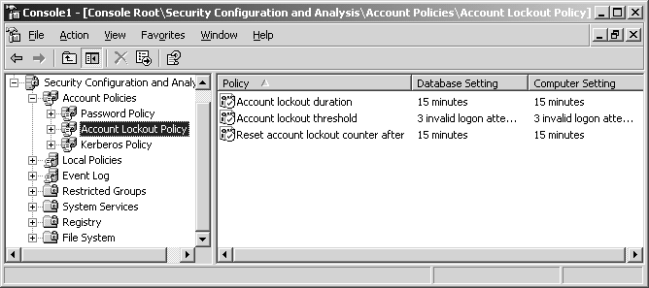
- Expand the “Account Policies” object and select “Account Lockout Policy”.

Note: The ‘Database Setting’ in the right pane reflects the required setting. The ‘Computer Setting’ is the effective setting on the machine.

[A] Bad Logon Attempts
If the “Account lockout threshold” is more than three attempts, then this is a finding.

Category/MAC/IA: | II / 1-CSP, 2-CSP, 3-CSP / ECLO-1, ECLO-2
PDI: | 4.002: Number of allowed bad logon attempts does not meet minimum requirements.
Reference: | MS Server 2003 Security Settings Guide, p. 14  DISA FSO Windows 2003 Addendum, Sect. 4.5.3

[A] Bad Logon Counter Reset
If the “Reset account lockout counter after” value is less than 15 minutes, then this is a finding.

Category/MAC/IA: | II / 1-CSP, 2-CSP, 3-CSP / ECLO-1, ECLO-2
PDI: | 4.003: Time before bad-logon counter is reset does not meet minimum requirements.
Reference: | MS Server 2003 Security Settings Guide, p. 15  DISA FSO Windows 2003 Addendum, Sect. 4.5.3

[A] Lockout Duration
If the “Account lockout duration” is less than 15 minutes, then this is a finding.

Category/MAC/IA: | II / 1-CSP, 2-CSP, 3-CSP / ECLO-1, ECLO-2
PDI: | 4.004: Lockout duration does not meet minimum requirements.
Reference: | MS Server 2003 Security Settings Guide, p. 13  DISA FSO Windows 2003 Addendum, Sect. 4.5.3

Kerberos Policy (Domain Controllers only)
This check verifies that the kerberos authentication settings are configured to the minimum required DISA standards.

- Expand the “Security Configuration and Analysis” object in the tree window.
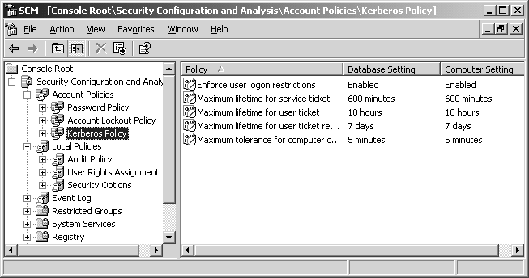
- Expand the “Account Policies” object and select “Kerberos Policy”.

Note: The ‘Database Setting’ in the right pane reflects the required setting. The ‘Computer Setting’ is the effective setting on the machine.

[M] User Logon Restrictions
This check verifies that the Kerberos Key Distribution Center (KDC) validates every request for a session ticket against the user rights policy of the target computer.

If the “Enforce user logon restrictions” is not set to ‘Enabled’, then this is a finding.

Category/MAC/IA: | II / 1-CSP, 2-CSP, 3-CSP / ECCT-1, ECCT-2
PDI: | 4.029: Kerberos user logon restrictions are not enforced.
Reference: | MS Server 2003 Security Settings Guide, p. 17

[M] Service Ticket Lifetime
This check verifies that the maximum amount of time (in minutes) that a granted session ticket can be used to access a particular service, meets DISA standards.

If the “Maximum lifetime for service ticket” is greater than ‘600’ minutes, then this is a finding.

Category/MAC/IA: | II / 1-CSP, 2-CSP, 3-CSP / ECCT-1, ECCT-2
PDI: | 4.030: Kerberos service ticket maximum lifetime does not meet minimum standards.
Reference: | MS Server 2003 Security Settings Guide, p. 17

[M] User Ticket Lifetime
This check verifies that the maximum amount of time (in hours) that a user's ticket-granting ticket (TGT) may be used, meets DISA standards.

If the “Maximum lifetime for user ticket” is greater than ‘10’ hours, then this is a finding.

Category/MAC/IA: | II / 1-CSP, 2-CSP, 3-CSP / ECCT-1, ECCT-2
PDI: | 4.031: Kerberos user ticket maximum lifetime does not meet minimum standards.
Reference: | MS Server 2003 Security Settings Guide, p. 17

[M] User Ticket Renewal Lifetime
This check verifies that the period of time (in days) during which a user's ticket-granting ticket (TGT) may be renewed, meets DISA standards.

If the “Maximum lifetime for user ticket renewal” is greater than ‘7’ days, then this is a finding.

Category/MAC/IA: | II / 1-CSP, 2-CSP, 3-CSP / ECCT-1, ECCT-2
PDI: | 4.032: Kerberos user ticket renewal maximum lifetime does not meet minimum standards.
Reference: | MS Server 2003 Security Settings Guide, p. 18

[M] Computer Clock Synchronization
This check verifies that the maximum time difference (in minutes) that Kerberos will tolerate between the time on a client's clock and the time on a server's clock, while still considering the two clocks synchronous, meets DISA standards.

If the “Maximum tolerance for computer clock synchronization” is greater than ‘5’ minutes, then this is a finding.

Category/MAC/IA: | II / 1-CSP, 2-CSP, 3-CSP / ECCT-1, ECCT-2
PDI: | 4.033: Computer clock synchronization tolerance does not meet minimum standards.
Reference: | MS Server 2003 Security Settings Guide, p. 19

Audit Policy Configuration
This check verifies that the minimum user account and object auditing on the local system is configured to DISA standards.

- Expand the “Security Configuration and Analysis” object in the tree window.
- Expand the “Local Policies” object and select “Audit Policy”.
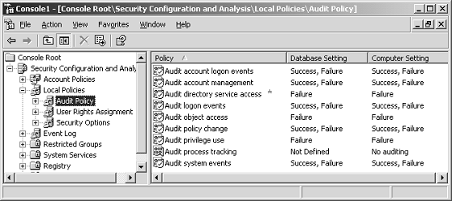
* On Member Servers this should be set to ‘Not Defined”.

Note: The ‘Database Setting’ in the right pane reflects the required setting. The ‘Computer Setting’ is the effective setting on the machine.

[A] Auditing Enabled
If all the values in the Policy window are set to “No auditing”, then this is a finding.

Category/MAC/IA: | II / 1-CSP, 2-CSP, 3-CSP / ECAR-1, ECAR-2, ECAR-3
PDI: | 4.007: Auditing is not enabled.
Reference: | MS Server 2003 Security Settings Guide, p. 21-25

[A] Auditing Configuration
Compare the settings in the Policy window with the figure in section 5.4.4. If system does not audit the events listed above, then this is a finding. Events with a value of “No Auditing” indicate those that are not required by DISA to be audited.

“Audit directory services access” can be set to “No Auditing” for 2003 member servers.

If auditing is disabled, then mark this check as a “FINDING.”

Category/MAC/IA: | II / 1-CSP, 2-CSP, 3-CSP / ECAR-1, ECAR-2, ECAR-3
PDI: | 4.008: System-auditing configuration does not meet minimum requirements.
Reference: | MS Server 2003 Security Settings Guide, p. 21-25  DISA FSO Windows 2003 Addendum, Sect. 6.4

User Rights Policy Configuration
This check verifies that the system’s user rights and advanced user rights policies are configured in accordance with DISA requirements.

- Expand the “Security Configuration and Analysis” object in the tree window.
- Expand the “Local Policies” object and select “User Rights Assignment”.
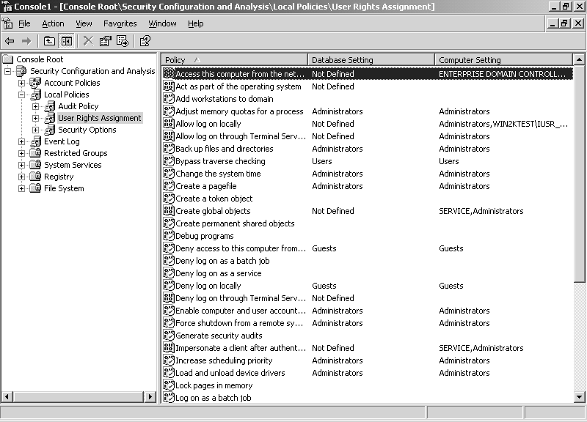

Note: The ‘Database Setting’ in the right pane reflects the required setting. The ‘Computer Setting’ is the effective setting on the machine.

[AP] User Rights Assignments
Review the settings in the Policy window against the table below. If there are any discrepancies, then this is a finding.

Users Rights | Domain  Controllers | Member  Servers
Access this computer from network | Administrators  Authenticated Users  Enterprise Domain  Controllers | Administrators  Users
Act as part of the operating system * | (None) | (None)
Add workstations to domain | (None) | (None)
Adjust memory quotas for a process | Administrators  LOCAL SERVICE  NETWORK SERVICE | Administrators  LOCAL SERVICE  NETWORK SERVICE
Allow log on locally* | Administrators  Backup Operators | Administrators  Backup Operators
Allow log on through Terminal Services | (None) | (None)
Backup files and directories* | Administrators  Backup Operators | Administrators  Backup Operators
Bypass traverse checking* | Authenticated Users | Users
Change the system time | Administrators | Administrators
Create a pagefile | Administrators | Administrators
Create a token object | (None) | (None)
Create a global objects | Administrators  LOCAL SERVICE  NETWORK SERVICE | Administrators  LOCAL SERVICE  NETWORK SERVICE
Create permanent shared objects | (None) | (None)
Debug programs | Administrators | Administrators
Deny access to this computer from the network | Guests  Support_388945a0 | Guests (** see note)  Support_388945a0
Deny logon as a batch job | Support_388945a0 | Support_388945a0
Deny logon as a service | (None) | (None)
Deny logon locally | Guests  Support_388945a0 | Guests  Support_388945a0
Deny log on through Terminal Services | Everyone | Everyone (unless configured as a terminal server)
Enable computer and user accounts to be trusted for delegation | Administrators | (None)
Force shutdown from a remote system | Administrators | Administrators
Generate security audits | LOCAL SERVICE  NETWORK SERVICE | LOCAL SERVICE  NETWORK SERVICE
Impersonate a client after authentication | Administrators  LOCAL SERVICE  NETWORK SERVICE | Administrators  LOCAL SERVICE  NETWORK SERVICE
Increase scheduling priority | Administrators | Administrators
Load and unload device drivers | Administrators | Administrators
Lock pages in memory | (None) | (None)
Log on as a batch job | (None) | (None)
Log on as a service * | NETWORK SERVICE | NETWORK SERVICE
Manage auditing and security log* | Auditor’s Group  (Exchange Enterprise Servers Group) | Auditor’s Group  (Exchange Enterprise Servers Group on Exchange server)
Modify firmware environment values | Administrators | Administrators
Perform volume maintenance tasks | Administrators | Administrators
Profile single process | Administrators | Administrators
Profile system performance | Administrators | Administrators
Remove computer from docking station | (None) | (None)
Replace a process level token | LOCAL SERVICE  NETWORK SERVICE | LOCAL SERVICE  NETWORK SERVICE
Restore files and directories* | Administrators  Backup Operators | Administrators  Backup Operators
Shut down the system | Administrators | Administrators
Synchronize directory service data | (None) | (None)
Take ownership of files or other objects | Administrators | Administrators
*Some applications require this right to function. Any exception needs to be documented.
**On Exchange Server 2003 supporting OWA, the Guests group should be removed and replaced with “Anonymous Logon”

Category/MAC/IA: | II / 1-CSP, 2-CSP, 3-CSP / ECLP-1
PDI: | 4.010: User and advanced user rights settings do not meet minimum requirements.
Reference: | MS Server 2003 Security Settings Guide, Chap 4, p. 29-52  DISA FSO Windows 2003 Addendum, Sect. 5.1

[AP] Users Granted “Act as part of the operating system” Privilege
If any user accounts, or groups, (to include administrators) are granted this right, then this is a finding.

Some applications require this right to function. Any exception needs to be documented with the ISSO.

Undocumented exceptions for applications are a finding.

Category/MAC/IA: | I / 1-CSP, 2-CSP, 3-CSP / ECLP-1
PDI: | 4.009: Unauthorized users are granted the right to “Act as part of the operating system”.
Reference: | MS Server 2003 Security Settings Guide, Chap 4, p. 30  DISA FSO Windows 2003 Addendum, Sect. 5.1

[A] Users Granted “Allow logon through Terminal Services” Privilege
If any user accounts, or groups, (to include administrators) are granted this right, then this is a finding.

Note: If the server is performing the role of a Terminal Server then this is not applicable.

Category/MAC/IA: | II / 1-CSP, 2-CSP, 3-CSP / ECLP-1
PDI: | 4.040: Unauthorized users are granted the right to “Allow logon through Terminal Services”.
Reference: | MS Server 2003 Security Settings Guide, Chap 4, p. 33  DISA FSO Windows 2003 Addendum, Sect. 5.1

[A] Guests not given “Deny access this computer from network” Privilege
If the built-in guests group is not listed as being denied this privilege, then this is a finding.

Category/MAC/IA: | I / 1-CSP, 2-CSP, 3-CSP / ECLP-1
PDI: | 4.025: Guests group is not assigned the right “Deny access this computer from the network.”
Reference: | MS Server 2003 Security Settings Guide, Chap 4, p. 38  DISA FSO Windows 2003 Addendum, Sect. 5.1

[A] Guests not given “Deny log on locally” Privilege
If the built-in guests group is not listed as being denied this privilege, then this is a finding.

Category/MAC/IA: | II / 1-CSP, 2-CSP, 3-CSP / ECLP-1
PDI: | 4.026: Guests group is not assigned the right “Deny log on Locally.”
Reference: | MS Server 2003 Security Settings Guide, Chap 4, p. 40  DISA FSO Windows 2003 Addendum, Sect. 5.1

[A] Everyone not given “Deny log on through terminal services” Privilege
If the built-in Everyone group is not listed as being denied this privilege, then this is a finding.

Note: If the server’s role is as a Terminal Server, then the “Guests” group should be assigned to this right.

Category/MAC/IA: | II / 1-CSP, 2-CSP, 3-CSP / ECLP-1
PDI: | 4.041: Specified users are not granted the right “Deny logon through Terminal Services”
Reference: | MS Server 2003 Security Settings Guide, Chap 4, p. 41  DISA FSO Windows 2003 Addendum, Sect. 5.1

Security Options Configuration
This check verifies that security options on the local system is configured to DISA standards.

- Expand the “Security Configuration and Analysis” object in the tree window.
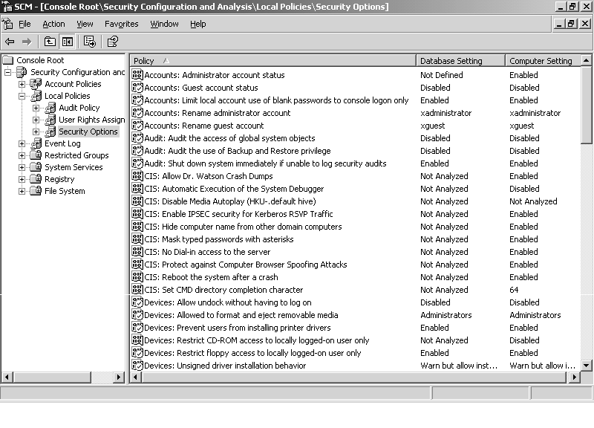
- Expand the “Local Policies” object and select “Security Options”.

Note: The ‘Database Setting’ in the right pane reflects the required setting. The ‘Computer Setting’ is the effective setting on the machine.

[A] Disable Guest Account
This check verifies that Windows Server 2003 is configured to disable the built-in guest account.

If the value for “Accounts: Guest account status” is not set to ” Disabled”, then this is a finding.

Category/MAC/IA: | II / 1-CSP, 2-CSP, 3-CSP / ECSC-1, IAAC-1
PDI: | 4.020: The built-in guest account is not disabled.
Reference: | MS Server 2003 Security Settings Guide, Chap 5, p. 54

[A] Limit Blank Passwords
This check verifies that Windows Server 2003 is configured to limit the use of blank passwords to local console logon only.

If the value for “Accounts: Limit local account use of blank passwords to console logon only” is not set to ” Enabled”, then this is a finding.

Category/MAC/IA: | I / 1-CSP, 2-CSP, 3-CSP / ECSC-1, IAIA-1
PDI: | 4.036: The use of local accounts with blank passwords is not restricted to console logons only.
Reference: | MS Server 2003 Security Settings Guide, Chap 5, p. 54

[A] Built-in Administrator Account Renamed
This check verifies that the built in Administrator account has been renamed.

If the value for “Accounts: Rename administrator account” is not set to a value other than “Administrator”, then this is a finding.

Category/MAC/IA: | II / 1-CSP, 2-CSP, 3-CSP / ECSC-1, IAAC-1
PDI: | 4.022: The built-in administrator account has not been renamed.
Reference: | MS Server 2003 Security Settings Guide, Chap 5, p. 55, Chap 11, p. 269-270

[A] Built-in Guest Account Renamed
This check verifies that the built in guest account has been renamed.

If the value for “Accounts: Rename guest account” is not set to a value other than “Guest”, then this is a finding.

Category/MAC/IA: | II / 1-CSP, 2-CSP, 3-CSP / ECSC-1, IAAC-1
PDI: | 4.021: The built-in guest account has not been renamed.
Reference: | MS Server 2003 Security Settings Guide, Chap 5, p. 56

[AP] Halt on Audit Failure 
This check verifies that the site has a documented policy and provable procedures in place to identify, in a timely manner, that a system has stopped writing to the Event logs. The policy and procedures will include instructions for protecting and archiving log data. If a site does not have a documented policy and procedures, then all servers, and machines that a site deems critical, will be required to utilize the CrashOnAudit Registry setting to ensure that if an audit failure occurs, the system will halt (see DISA FSO Windows 2003 Addendum, Sect. 6.3).

Note: This requirement applies to all servers, and those workstations that a site deems critical.

If the site has no procedures in place:

If the value for “Audit: Shut down system immediately if unable to log security audits” is not set to “Enabled”, then this is a finding.

Category/MAC/IA: | III / 1-CSP, 2-CSP, 3-CSP / ECSC-1, ECTP-1
PDI: | 3.015: System does not halt once an event log has reached its maximum size.
Reference: | MS Server 2003 Security Settings Guide, Chap 5, p. 58

[A] Undock Without Logging On
This check verifies that Windows Server 2003 is configured to require logon for undocking a machine.

If the value for “Devices: Allow Undock Without Having to Log On” is not set to ” Disabled”, then this is a finding.

Category/MAC/IA: | II / 1-CSP, 2-CSP, 3-CSP / ECSC-1
PDI: | 3.069: The system may be removed from the docking station without logging on first.
Reference: | MS Server 2003 Security Settings Guide, Chap 5, p. 59

[A] Format and Eject Removable Media
This check verifies that Windows Server 2003 is configured to only allow Administrators to format and eject removable media.

If the value for “Devices: Allowed to Format and Eject Removable Media” is not set to ” Administrators”, then this is a finding.

Category/MAC/IA: | II / 1-CSP, 2-CSP, 3-CSP / ECSC-1, ECPA-1
PDI: | 3.052: Ejection of removable NTFS media is not restricted to Administrators.
Reference: | MS Server 2003 Security Settings Guide, Chap 5, p. 60

[A] Secure Print Driver Installation
This check verifies that Windows Server 2003 is configured to allow only members of the “Administrators” and “Power Users” user groups to install printer drivers.

If the value for “Devices: Prevent users from installing printer drivers” is not set to “Enabled”, then this is a finding.

Category/MAC/IA: | III / 1-CSP, 2-CSP, 3-CSP / ECSC-1, ECLP-1
PDI: | 3.029: Print driver installation privilege is not restricted to administrators.
Reference: | MS Server 2003 Security Settings Guide, Chap 5, p. 60

[A] Secure Removable Media
This check verifies that Windows Server 2003 is configured to limit unauthorized access to removable media—floppy disks.

If the value for “Devices: Restrict floppy access to locally logged-on user only” is not set to “Enabled”, then this is a finding.

Category/MAC/IA: | III / 1-CSP, 2-CSP, 3-CSP / ECSC-1, ECLP-1
PDI: | 3.004: Removable media devices are not allocated upon user logon.
Reference: | MS Server 2003 Security Settings Guide, Chap 5, p. 62

[AP] Unsigned Driver Installation Behavior 
This check verifies that the unsigned driver behavior is set to “Warn but allow installation” (recommended setting) or “Do not allow installation”.

If the value for “Devices: Unsigned driver installation behavior” is not set to “Warn but allow installation” or “Do not allow installation”, then this is a finding.

Note: If the site is using a Software Update Server (SUS) server to distribute software updates, and the computer is configured to point at that server, then this can be set to "Silently succeed" to allow unattended installation of distributed updates. In this instance the setting will not be considered a finding.
To determine if an SUS server is used, see if the following registry key value exists and is pointing to an organizational or DOD SUS URL:

HKLM\Software\Policies\Microsoft\Windows\WindowsUpdate\WUServer, Reg_SZ: http://…

Category/MAC/IA: | III / 1-CSP, 2-CSP, 3-CSP / ECSC-1, DCSQ-1
PDI: | 3.050: The unsigned driver installation behavior is improperly set.
Reference: | MS Server 2003 Security Settings Guide, Chap 5, p. 63

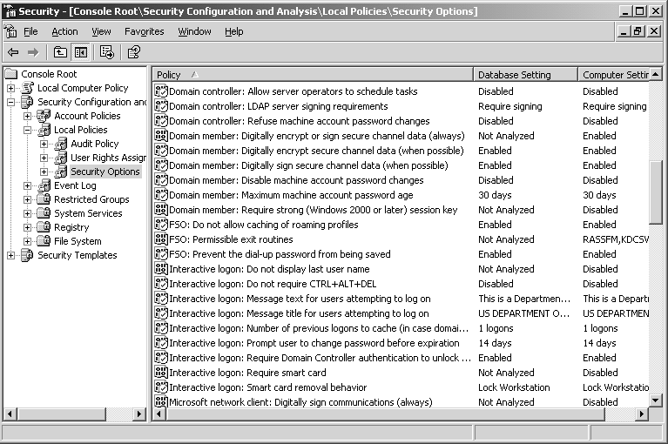

[A] Server Operators Scheduling Tasks (Domain Controller).
This check verifies that the Server Operators group is prevented from using the Task Scheduler Service (AT command) to schedule a task to automatically run.

If the value for “Domain Controller: Allow server operators to schedule tasks” is not set to “Disabled”, then this is a finding.

Category/MAC/IA: | II / 1-CSP, 2-CSP, 3-CSP / ECSC-1, ECLP-1
PDI: | 3.058: The Server Operators group can schedule tasks.
Reference: | MS Server 2003 Security Settings Guide, Chap 5, p. 63

[A] LDAP Signing Requirements (Domain Controller).
This check verifies that the Lightweight Directory Access Protocol (LDAP) server requires LDAP clients to negotiate data signing.

If the value for “Domain Controller: LDAP Server signing requirements” is not set to “Require signing”, then this is a finding.

Category/MAC/IA: | II / 1-CSP, 2-CSP, 3-CSP / ECSC-1
PDI: | 3.106: LDAP access signing is not required.
Reference: | MS Server 2003 Security Settings Guide, Chap 5, p. 64

[A] Computer Account Password Change Requests (Domain Controller).
This check verifies that requests to change the computer account password is not refused by the Domain Controller.

If the value for “Domain Controller: Refuse machine account password changes” is not set to “Disabled”, then this is a finding.

Category/MAC/IA: | III / 1-CSP, 2-CSP, 3-CSP / ECSC-1, IAIA-1, IAIA-2
PDI: | 3.107: The computer account password is prevented from being reset.
Reference: | MS Server 2003 Security Settings Guide, Chap 5, p. 65

[A] Encryption of Secure Channel Traffic.
This check verifies that the computer will always digitally encrypt secure channel data when possible.

If the value for “Domain Member: Digitally encrypt secure channel data (when possible)” is not set to “Enabled”, then this is a finding.

Note: If the value for “Domain Member: Digitally encrypt or sign secure channel data (always)” is set to “Enabled”, then this would not be a finding. (Enabling this setting will prevent a Windows Server 2003 system from authenticating properly with a Windows NT PDC/BDC)

Category/MAC/IA: | II / 1-CSP, 2-CSP, 3-CSP / ECSC-1, ECCT-1, ECCT-2
PDI: | 3.043: Outgoing secure channel traffic is not encrypted when possible.
Reference: | MS Server 2003 Security Settings Guide, Chap 5, p. 65

[A] Signing of Secure Channel Traffic.
This check verifies that the computer will always sign secure channel data when possible.

If the value for “
Domain Member: Digitally sign secure channel data (when possible)” is not set to “Enabled”, then this is a finding.

Note: If the value for “Secure channel: Digitally encrypt or sign secure channel data (always)” is set to “Enabled”, then this would not be a finding.

Category/MAC/IA: | II / 1-CSP, 2-CSP, 3-CSP / ECSC-1, ECCT-1, ECCT-2
PDI: | 3.042: Outgoing secure channel traffic is not signed when possible.
Reference: | MS Server 2003 Security Settings Guide, Chap 5, p. 65

[A] Resetting Computer Account Password.
This check verifies that the computer account password is not prevented from being reset every week.

If the value for “Domain Member: Disable Machine Account Password Changes” is set to “Enabled”, then this is a finding.

Category/MAC/IA: | III / 1-CSP, 2-CSP, 3-CSP / ECSC-1, IAIA-1, IAIA-2
PDI: | 3.044: The computer account password is prevented from being reset.
Reference: | MS Server 2003 Security Settings Guide, Chap 5, p. 67

[A] Maximum Machine Account Password Age.
This check verifies that the computer account password is changed, at a maximum, every 30 days.

If the value for “Domain Member: Maximum Machine Account Password Age” is not set to “30”, or less, then this is a finding.

Category/MAC/IA: | III / 1-CSP, 2-CSP, 3-CSP / ECSC-1, IAIA-1, IAIA-2
PDI: | 4.043: The maximum age for machine account passwords is not set to requirements.
Reference: | MS Server 2003 Security Settings Guide, Chap 5, p. 68

[AP] Strong Session Key (WIN2K/W2K3 Native Domains).
This check verifies that the computer is configured to require a strong session key.

If the value for “Domain Member: Require Strong (Windows 2000 or Later) Session Key” is not set to “Enabled”, then this is a finding.

Category/MAC/IA: | II / 1-CSP, 2-CSP, 3-CSP / ECSC-1
PDI: | 4.044: The system is not set to require a strong session key.
Reference: | MS Server 2003 Security Settings Guide, Chap 5, p. 69

Consolidated with 5.4.1.5

[A] Disable Administrator Automatic Logon
This check verifies that Windows Server 2003 is configured to prevent the automatic logon of the Administrator account and does not save a default password.

If the value for “FSO: Permit Administrator Automatic Logon” is not set to “Disabled”, then this is a finding.

Category/MAC/IA: | I / 1-CSP, 2-CSP, 3-CSP / ECSC-1, ECPA-1
PDI: | 3.040: Administrator automatic logon is enabled.
Reference: | DISA FSO Windows 2003 Addendum, Sect. 4.5.2

[AP] Enable Not Saving of Dial-up Password (RAS installed only)
This check verifies that Windows Server 2003, with Remote Access Services (RAS) installed, is configured to enable the option to prevent a dial-up password from being saved between dial-up sessions. This is only applicable if the RAS service has been configured.

If the value for “FSO: Prevent the dial-up password from being saved” is not set to “Enabled”, then this is a finding.

Category/MAC/IA: | II / 1-CSP, 2-CSP, 3-CSP / ECSC-1
PDI: | 3.024: The option to prevent the password in dial-up networking from being saved is not enabled.
Reference: | DISA FSO Windows 2003 Addendum, Sect. 4.3.1

[A] Ctrl+Alt+Del Security Attention Sequence.
This check verifies that the Ctrl+Alt+Del security attention sequence is enabled.

If the value for “Interactive Logon: Do not require CTRL-ALT-DEL” is not set to “Disabled”, then this is a finding.

Category/MAC/IA: | II / 1-CSP, 2-CSP, 3-CSP / ECSC-1, ECRC-1
PDI: | 3.032: Ctrl+Alt+Del security attention sequence is Disabled
Reference: | MS Server 2003 Security Settings Guide, Chap 5, p. 70

[AP] Display Legal Notice
This check verifies that Windows Server 2003 is configured to display a legal notice prior to logging on.

____ Legal notice text is not defined.

If the value for “Interactive Logon: Message text for users attempting to log on” is not set to the following example or its equivalent, then this is a finding.

THIS IS A DEPARTMENT OF DEFENSE COMPUTER SYSTEM. THIS COMPUTER SYSTEM, INCLUDING ALL RELATED EQUIPMENT, NETWORKS, AND NETWORK DEVICES (SPECIFICALLY INCLUDING INTERNET ACCESS), ARE PROVIDED ONLY FOR AUTHORIZED US GOVERNMENT USE. DOD COMPUTER SYSTEMS MAY BE MONITORED FOR ALL LAWFUL PURPOSES, INCLUDING TO ENSURE THEIR USE IS AUTHORIZED, FOR MANAGEMENT OF THE SYSTEM, TO FACILITATE PROTECTION AGAINST UNAUTHORIZED ACCESS, AND TO VERIFY SECURITY PROCEDURES, SURVIVABILITY, AND OPERATIONAL SECURITY. MONITORING INCLUDES ACTIVE ATTACKS BY AUTHORIZED DOD ENTITIES TO TEST OR VERIFY THE SECURITY OF THIS SYSTEM. DURING MONITORING, INFORMATION MAY BE EXAMINED, RECORDED, COPIED, AND USED FOR AUTHORIZED PURPOSES. ALL INFORMATION, INCLUDING PERSONAL INFORMATION, PLACED ON OR SENT OVER THIS SYSTEM, MAY BE MONITORED.

USE OF THIS DOD COMPUTER SYSTEM, AUTHORIZED OR UNAUTHORIZED, CONSTITUTES CONSENT TO MONITORING OF THIS SYSTEM. UNAUTHORIZED USE MAY SUBJECT YOU TO CRIMINAL PROSECUTION. EVIDENCE OF UNAUTHORIZED USE COLLECTED DURING MONITORING MAY BE USED FOR ADMINISTRATIVE, CRIMINAL, OR OTHER ADVERSE ACTION. USE OF THIS SYSTEM CONSTITUTES CONSENT TO MONITORING FOR THESE PURPOSES.
Note: a valid banner will have each of the following elements:
- The system is a DOD system.
- The system is subject to monitoring, recording, and auditing.
- Monitoring is authorized in accordance with applicable laws and regulations and conducted for purposes of systems management and protection, protection against improper or unauthorized use or access, and verification of applicable security features or procedures.
- Use of the system constitutes consent to monitoring.
- The system is for authorized U.S. Government use only.

____ Legal notice caption is not defined.

If the value for “Interactive Logon: Message title for users attempting to log on” is not set to “US DEPARTMENT OF DEFENSE WARNING STATEMENT” or its equivalent, then this is a finding.

Category/MAC/IA: | II / 1-CSP, 2-CSP, 3-CSP / ECSC-1, ECWM-1
PDI: | 3.011: Legal notice is not configured to display before console logon.
Reference: | MS Server 2003 Security Settings Guide, Chap 5, p. 72  DISA FSO Windows 2003 Addendum, Sect. 7.15

[A] Disable Caching of Logon Credentials
This check verifies that Windows Server 2003 is configured to limit copies of user profiles saved during interactive logon.

If the value for “Interactive Logon: Number of previous logons to cache (in case Domain Controller is not available)” is not set to “2 logons” or less, then this is a finding.

Category/MAC/IA: | III / 1-CSP, 2-CSP, 3-CSP / ECSC-1
PDI: | 3.013: Caching of logon credentials is not limited.
Reference: | MS Server 2003 Security Settings Guide, Chap 5, p. 73  DISA FSO Windows 2003 Addendum, Sect. 4.5.4

[A] Password Expiration Warning
This check verifies that Windows Server 2003 is configured to warn users in advance when their passwords will expire. By giving the user advanced warning, the user has time to construct a sufficiently strong password.

If the value for “Interactive Logon: Prompt user to change password before expiration” is not set to “14 days” or more, then this is a finding.

Category/MAC/IA: | IV / 1-CSP, 2-CSP, 3-CSP / ECSC-1, IAIA-1
PDI: | 3.054: Users are not warned in advance that their passwords will expire.
Reference: | MS Server 2003 Security Settings Guide, Chap 5, p. 74

[A] Domain Controller Authentication to Unlock Workstation
This check verifies that Windows Server 2003 is configured to require the system to pass the credentials to the domain controller (if in a domain) for authentication, before allowing the system to be unlocked.

If the value for “Interactive logon: Require domain controller authentication to unlock workstation” is not set to “Enabled”, then this is a finding.

Category/MAC/IA: | II / 1-CSP, 2-CSP, 3-CSP / ECSC-1
PDI: | 4.045: Domain Controller authentication is not required to unlock the workstation.
Reference: | MS Server 2003 Security Settings Guide, Chap 5, p. 75

[A] Smart Card Removal Option
This check verifies that the Smart Card removal option is set to Lock Workstation (minimum requirement) or Force Logoff.

If the value for “Interactive logon: Smart card removal behavior” is not set to “Lock Workstation”, or “Force Logoff”, then this is a finding.

Category/MAC/IA: | II / 1-CSP, 2-CSP, 3-CSP / ECSC-1
PDI: | 3.047: The Smart Card removal option is set to take no action.
Reference: | MS Server 2003 Security Settings Guide, Chap 5, p. 76

[A] SMB Client Packet Signing.
This check verifies that the SMB Client policy is set to SMB packet signing when possible.

If the value for “Microsoft Network Client: Digitally sign communications (if server agrees)” is not set to “Enabled”, then this is a finding.

Note: If the value for “Microsoft Network Client: Digitally sign communications (always)” is set to “Enabled”, then this would not be a finding.

Category/MAC/IA: | II / 1-CSP, 2-CSP, 3-CSP / ECSC-1
PDI: | 3.045: The Windows Server SMB client is not enabled to perform SMB packet signing when possible.
Reference: | MS Server 2003 Security Settings Guide, Chap 5, p. 77

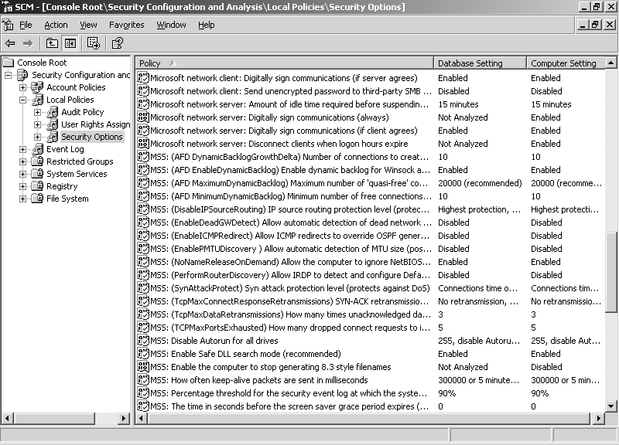

[A] SMB Server Packet Signing.
This check verifies that the SMB Server policy is set to SMB packet signing when possible.

If the value for “Microsoft Network Server: Digitally sign communications (if client agrees)” is not set to “Enabled”, then this is a finding.

Note: If the value for “Microsoft Network Server: Digitally sign communications (always)” is set to “Enabled”, then this would not be a finding.

Category/MAC/IA: | II / 1-CSP, 2-CSP, 3-CSP / ECSC-1
PDI: | 3.046: The Windows Server SMB server is not enabled to perform SMB packet signing when possible.
Reference: | MS Server 2003 Security Settings Guide, Chap 5, p. 77

[A] Unencrypted Passwords to 3rd Party SMB Servers
This check verifies that the computer will not send clear-text passwords to non-Microsoft SMB servers which do not support password encryption during authentication.

If the value for “Microsoft Network Client: Send unencrypted password to connect to third-party SMB servers” is not set to “Disabled”, then this is a finding.

Category/MAC/IA: | II / 1-CSP, 2-CSP, 3-CSP / ECSC-1, ECCT-1, ECCT-2
PDI: | 3.034: Unencrypted password is sent to 3rd party SMB server.
Reference: | MS Server 2003 Security Settings Guide, Chap 5, p. 78

[A] Idle Time Before Suspending a Session
This check verifies the amount of continuous idle time that must pass in a Server Message Block (SMB) session before the session is disconnected due to inactivity.

If the value for “Microsoft Network Server: Amount of idle time required before suspending a session” is not set to ”15 minutes” or less, then this is a finding.

Category/MAC/IA: | III / 1-CSP, 2-CSP, 3-CSP / ECSC-1
PDI: | 4.028: The amount of idle time before suspending an SMB session is improperly set.
Reference: | MS Server 2003 Security Settings Guide, Chap 5, p. 79

[A] Forcibly Disconnect when Logon Hours Expire
This check verifies Windows Server 2003 is configured that, if a user has restricted hours, this setting is enabled so the server will disconnect the user when the user’s logon hours expire.

If the value for “Microsoft Network Server: Disconnect Clients When Logon Hours Expire” is not set to “Enabled”, then this is a finding.

Note: The Gold Disk uses an API call to check internal system values, in addition to checking the related registry setting for this value. Using the MMC to review this setting may return a false positive; therefore, the Gold Disk result takes precedence. Setting this value with either the Gold Disk or the MMC updates the internal values as well as the appropriate registry value.

Category/MAC/IA: | III / 1-CSP, 2-CSP, 3-CSP / ECSC-1
PDI: | 4.006: Users are not forcibly disconnected when logon hours expire.
Reference: | MS Server 2003 Security Settings Guide, Chap 5, p. 79

[A] Additional Winsock Connections
This check verifies Windows Server 2003 is configured to control the number of additional connections for Windows Sockets applications, to help prevent denial of service attacks.

If the value for “MSS: (AFD DynamicBacklogGrowthDelta) Number of connections to create when additional connections are necessary for Winsock applications (10 recommended)” is not set to a value of “10” or less, then this is a finding.

Category/MAC/IA: | III / 1-CSP, 2-CSP, 3-CSP / ECSC-1, DCPP-1
PDI: | 5.086: Additional connections for Winsock applications are not controlled.
Reference: | MS Server 2003 Security Settings Guide, Chap 10, p. 254

[A] Dynamic Winsock Backlog
This check verifies Windows Server 2003 is configured to enable the dynamic backlog feature for Winsock applications.

If the value for “MSS: (AFD EnableDynamicBacklog) Enable dynamic backlog for Winsock applications (recommended)” is not set to “Enabled”, then this is a finding.

Category/MAC/IA: | III / 1-CSP, 2-CSP, 3-CSP / ECSC-1, DCPP-1
PDI: | 5.087: Dynamic backlog for Winsock applications is not enabled.
Reference: | MS Server 2003 Security Settings Guide, Chap 10, p. 255

[A] Winsock Quasi-free Connections
This check verifies Windows Server 2003 is configured to control the maximum number of quasi-free connections on a listening endpoint for Windows Sockets applications, to help prevent denial of service attacks.

If the value for “MSS: (AFD MaximumDynamicBacklog) Maximum number of quasi-free connections necessary for Winsock applications” is not set to a value of “20000 (recommended)” or less, then this is a finding.

Category/MAC/IA: | III / 1-CSP, 2-CSP, 3-CSP / ECSC-1, DCPP-1
PDI: | 5.088: The maximum number of quasi-free connections for Winsock applications are not controlled.
Reference: | MS Server 2003 Security Settings Guide, Chap 10, p. 256

[A] Winsock Free Connections
This check verifies Windows Server 2003 is configured to control the minimum number of free connections on a listening endpoint for Windows Sockets applications, to help prevent denial of service attacks.

If the value for “MSS: (AFD MinimumDynamicBacklog) Minimum number of free connections necessary for Winsock applications (20 recommended for system under attack, 10 otherwise)” is not set to a value between “10” to “20”, then this is a finding.

Category/MAC/IA: | III / 1-CSP, 2-CSP, 3-CSP / ECSC-1, DCPP-1
PDI: | 5.089: The minimum number of free connections for Winsock applications are not controlled.
Reference: | MS Server 2003 Security Settings Guide, Chap 10, p. 256

[A] IP Source Routing
This check verifies Windows Server 2003 is configured to protect against packet spoofing.

If the value for “MSS: (DisableIPSourceRouting) IP source routing protection level (protects against packet spoofing)” is not set to “Highest protection, source routing is completely disabled”, then this is a finding.

Category/MAC/IA: | III / 1-CSP, 2-CSP, 3-CSP / ECSC-1, DCPP-1
PDI: | 5.090: Source routing is not disabled.
Reference: | MS Server 2003 Security Settings Guide, Chap 10, p. 250

[A] Detection of Dead Gateways
This check verifies Windows Server 2003 is configured to disable dead gateway detection.

If the value for “MSS: (EnableDeadGWDetect) Allow automatic detection of dead network gateways (could lead to DoS)” is not set to “Disabled”, then this is a finding.

Category/MAC/IA: | III / 1-CSP, 2-CSP, 3-CSP / ECSC-1, DCPP-1
PDI: | 5.091: Dead gateway detection is not disabled.
Reference: | MS Server 2003 Security Settings Guide, Chap 10, p. 248

[A] ICMP Redirects
This check verifies Windows Server 2003 is configured to disable ICMP redirects.

If the value for “MSS: (EnableICMPRedirect) Allow ICMP redirects to override OSPF generated routes” is not set to “Disabled”, then this is a finding.

Category/MAC/IA: | III / 1-CSP, 2-CSP, 3-CSP / ECSC-1, DCPP-1
PDI: | 5.092: ICMP redirects is not disabled.
Reference: | MS Server 2003 Security Settings Guide, Chap 10, p. 246

Removed.

[A] NetBIOS Name Release
This check verifies Windows Server 2003 is configured to prevent release of its NetBIOS name when a name-release request is received.

If the value for “MSS: (NoNameReleaseOnDemand) Allow computer to ignore NetBIOS name release requests except from WINS servers” is not set to “Enabled”, then this is a finding.

Category/MAC/IA: | III / 1-CSP, 2-CSP, 3-CSP / ECSC-1, DCPP-1
PDI: | 5.094: The NetBIOS name is released on demand.
Reference: | MS Server 2003 Security Settings Guide, Chap 10, p. 257

[A] Router Discovery
This check verifies Windows Server 2003 is configured to disable the Internet Router Discovery Protocol (IDRP).

If the value for “MSS: (PerformRouterDiscovery) Allow IDRP to detect and configure Default Gateway addresses (could lead to DoS)” is not set to “Disabled”, then this is a finding.

Category/MAC/IA: | III / 1-CSP, 2-CSP, 3-CSP / ECSC-1, DCPP-1
PDI: | 5.095: The Internet Router Discovery Protocol is not disabled.
Reference: | MS Server 2003 Security Settings Guide, Chap 10, p. 252

[A] Syn Attack Protection Level
This check verifies Windows Server 2003 is configured to protect against Syn attacks.

If the value for “MSS: (SynAttackProtect) Syn attack protection level (protects against DoS)” is not set to “Connections time out sooner if a SYN attack is detected”, then this is a finding.

Category/MAC/IA: | III / 1-CSP, 2-CSP, 3-CSP / ECSC-1, DCPP-1
PDI: | 5.096: The system is not protected against Syn attacks.
Reference: | MS Server 2003 Security Settings Guide, Chap 10, p. 247

[A] TCP Connection Responses
This check verifies Windows Server 2003 is configured to control the maximum number of times that TCP retransmits a SYN before aborting the attempt.

If the value for “MSS: (TcpMaxConnectResponseRetransmissions) SYN –ACK retransmissions when a connection is not acknowledged” is not set to “No retransmission, half-open connections dropped after 3 seconds” or “3 seconds, half-open connections dropped after 9 seconds”, then this is a finding.

Note: Microsoft cautions that setting this to “No retransmission, half-open connections dropped after 3 seconds” may cause legitimate connection attempts from distant clients to fail due to time-out.

Category/MAC/IA: | III / 1-CSP, 2-CSP, 3-CSP / ECSC-1, DCPP-1
PDI: | 5.097: TCP connection response retransmissions are not controlled.
Reference: | MS Server 2003 Security Settings Guide, Chap 10, p. 250

[A] TCP Data Retransmissions
This check verifies Windows Server 2003 is configured to control the maximum number of times that TCP retransmits unacknowledged data segments before aborting the attempt.

If the value for “MSS: (TcpMaxDataRetransmissions) How many times unacknowledged data is retransmitted (3 recommended, 5 is the default)” is not set to “3” or less, then this is a finding.

Category/MAC/IA: | III / 1-CSP, 2-CSP, 3-CSP / ECSC-1, DCPP-1
PDI: | 5.098: TCP data retransmissions are not controlled.
Reference: | MS Server 2003 Security Settings Guide, Chap 10, p. 251

[A] TCP Dropped Connect Requests
This check verifies Windows Server 2003 is configured to begin SYN-attack protection when a number of connection requests are refused by the system

If the value for “MSS: (TcpMaxPortsExausted) How many dropped connect requests to initiate SYN attack protection (5 is recommended)” is not set to “5” or less, then this is a finding.

Category/MAC/IA: | III / 1-CSP, 2-CSP, 3-CSP / ECSC-1, DCPP-1
PDI: | 5.099: SYN attack protection initiation is not configured properly.
Reference: | MS Server 2003 Security Settings Guide, Chap 10, p. 253

[A] Disable Media Autoplay
This check verifies Windows Server 2003 is configured to turn off the Autorun feature on all drives.

If the value for “MSS: Disable Autorun on all drives” is not set to “255, disable Autorun for all drives”, then this is a finding.

Category/MAC/IA: | III / 1-CSP, 2-CSP, 3-CSP / ECSC-1
PDI: | 3.059: The system is configured to autoplay removable media.
Reference: | MS Server 2003 Security Settings Guide, Chap 10, p. 261

[A] Safe DLL Search Mode
This check verifies that Windows Server 2003 is configured to search the %Systemroot% for the DLL before searching the current directory or the rest of the path.

If the value for “MSS: Enable Safe DLL search mode (recommended)” is not set to “Enabled”, then this is a finding.

Category/MAC/IA: | II / 1-CSP, 2-CSP, 3-CSP / ECSC-1, DCSL-1
PDI: | 3.088: The safe DLL search path option is not enabled.
Reference: | MS Server 2003 Security Settings Guide, Chap 10, p. 264

[A] TCP Keep Alive Time
This check verifies that Windows Server 2003 is configured to control how often TCP attempts to verify that an idle connection is still intact by sending keep-alive a packet.

If the value for “MSS: How often keep-alive packets are sent in milliseconds (300,000 is recommended)” is not set to “300000” or less, then this is a finding.

Category/MAC/IA: | III / 1-CSP, 2-CSP, 3-CSP / ECSC-1, DCPP-1
PDI: | 5.100: The TCP keep-alive time is not configured properly.
Reference: | MS Server 2003 Security Settings Guide, Chap 10, p. 249

[A] Event Log Warning
This check verifies that Windows Server 2003 is configured to generate a warning when the Security Event Log has reached a defined threshold.

If the value for “MSS: Percentage threshold for the security event log at which the system will generate a warning” is not set to “90” or less, then this is a finding.

Note: If the system is configured to write to an audit server, or is configured to automatically archive full logs, then this check does not apply.

Category/MAC/IA: | IV / 1-CSP, 2-CSP, 3-CSP / ECSC-1, ECAT-1
PDI: | 5.101: The system doesn’t generate a warning when the Security log reaches a designated size.
Reference: | MS Server 2003 Security Settings Guide, Chap 10, p. 263

[A] Screen Saver Grace Period
This check verifies that Windows Server 2003 is configured to have password protection take effect immediately when the screen saver becomes active.

If the value for “MSS: The time in seconds before the screen saver grace period expires (o recommended)” is not set to “0”, then this is a finding.

Category/MAC/IA: | III / 1-CSP, 2-CSP, 3-CSP / ECSC-1, PESL-1
PDI: | 5.102: The Screen saver grace period is not set to 0.
Reference: | MS Server 2003 Security Settings Guide, Chap 10, p. 262

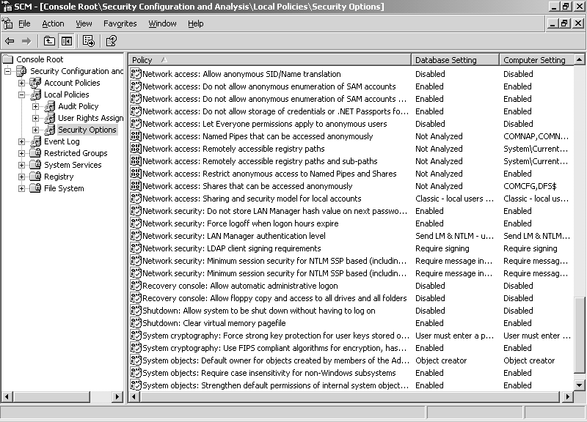
[MA] Anonymous SID/Name Translation
This check verifies Windows Server 2003 is configured to prevent users authenticated as anonymous users from performing SID/Name translation.

If the value for “Network access: Allow anonymous SID/Name translation” is not set to “Disabled”, then this is a finding.

Category/MAC/IA: | I / 1-CSP, 2-CSP, 3-CSP / ECSC-1, PRNK-1
PDI: | 3.062: Anonymous SID/Name translation is allowed.
Reference: | MS Server 2003 Security Settings Guide, Chap 5, p. 80

[AP] Restrict Anonymous Network Shares.
This check verifies that Windows Server 2003 is configured to prohibit anonymous logon users (also known as “null” session connections) from listing account names and enumerate share names.

If the value for “Network access: Do not allow anonymous enumeration of SAM accounts” is not set to “Enabled”, then this is a finding.

If the value for “Network access: Do not allow anonymous enumeration of SAM accounts and shares” is not set to “Enabled”, then this is a finding.

Note: In domains supporting Exchange 2003 servers and versions of Outlook earlier than Outlook 2003, the setting “Network access: Do not allow anonymous enumeration of SAM accounts and shares” should be set to “Disabled” on the Domain Controller Group Policy, to allow Outlook to anonymously query the global catalog service.

Category/MAC/IA: | I / 1-CSP, 2-CSP, 3-CSP / ECSC-1, PRNK-1
PDI: | 3.018: Anonymous shares are not restricted.
Reference: | MS Server 2003 Security Settings Guide, Chap 5, p. 81-82

[A] Storage of Credentials or .NET Passports
This check verifies Windows Server 2003 is configured to prevent storage of authentication credentials or .NET passports.

If the value for “Network access: Do not allow storage of credentials or .NET passports for network authentication” is not set to “Enabled”, then this is a finding.

Category/MAC/IA: | II / 1-CSP, 2-CSP, 3-CSP / ECSC-1
PDI: | 3.070: Storage of credentials or .NET Passports for network authentication is allowed.
Reference: | MS Server 2003 Security Settings Guide, Chap 5, p. 82

[AP] Everyone Permissions Apply to Anonymous Users
This check verifies Windows Server 2003 is configured to prevent anonymous users from having the same rights and permissions as the built-in Everyone group.

If the value for “Network access: Let everyone permissions apply to anonymous users” is not set to “Disabled”, then this is a finding.

Note: This setting will cause NT compatibility issues in mixed domains and may break cross domain trusts with Windows NT domains. In a mixed domain, it should be set to “Enabled”.

Category/MAC/IA: | II / 1-CSP, 2-CSP, 3-CSP / ECSC-1, ECLP-1
PDI: | 3.071: Everyone permissions are applied to anonymous users.
Reference: | MS Server 2003 Security Settings Guide, Chap 5, p. 82

[MA] Anonymous Access to Named Pipes
This check verifies Windows Server 2003 is configured to prevent anonymous access to unauthorized named pipes.

- If the value for “Network access: Named pipes that can be accessed anonymously” contains entries besides “COMNAP, COMNODE,SQL\QUERY, SPOOLSS, LLSRPC, EPMAPPER, LOCATOR, TrkWks, and TrkSvr”, then this is a finding.

Category/MAC/IA: | I / 1-CSP, 2-CSP, 3-CSP / ECSC-1, PRNK-1
PDI: | 3.063: Unauthorized named pipes are accessible with anonymous credentials.
Reference: | MS Server 2003 Security Settings Guide, Chap 5, p. 84

[MA] Remotely Accessible Registry Paths
This check verifies Windows Server 2003 is configured to prevent access to unauthorized registry paths from a remote computer

- If the value for “Network access: Remotely accessible registry paths” contains entries besides the following, then this is a finding:

System\CurrentControlSet\Control\ProductOptions
System\CurrentControlSet\Control\Print\Printers
System\CurrentControlSet\Control\Server Applications
System\CurrentControlSet\Services\Eventlog
Software\Microsoft\OLAP Server
Software\Microsoft\Windows NT\CurrentVersion
System\CurrentControlSet\Control\ContentIndex
System\CurrentControlSet\Control\Terminal Server
System\CurrentControlSet\Control\Terminal Server\Userconfig
System\CurrentControlSet\Control\Terminal Server\DefaultUserConfiguration

Category/MAC/IA: | I / 1-CSP, 2-CSP, 3-CSP / ECSC-1, PRNK-1
PDI: | 3.064: Unauthorized registry paths are remotely accessible.
Reference: | MS Server 2003 Security Settings Guide, Chap 5, p. 85

[MA] Remotely Accessible Registry Paths and Sub-paths
This check verifies Windows Server 2003 is configured to prevent access to unauthorized registry paths and sub-paths from a remote computer.

- If the value for “Network access: Remotely accessible registry paths and sub-paths” contains entries besides the following, then this is a finding:

Software\Microsoft\OLAP Server
Software\Microsoft\Windows NT\CurrentVersion\Perflib
Software\Microsoft\Windows NT\CurrentVersion\Print
Software\Microsoft\Windows NT\CurrentVersion\Windows
System\CurrentControlSet\Control\ContentIndex
System\CurrentControlSet\Control\Print\Printers
System\CurrentControlSet\Control\Terminal Server
System\CurrentControlSet\Control\Terminal Server\Userconfig
System\CurrentControlSet\Control\Terminal Server\DefaultUserConfiguration
System\CurrentControlSet\Services\Eventlog
System\CurrentControlSet\Services\Sysmonlog

Category: | I
PDI: | 3.108: Unauthorized registry paths and sub-paths are remotely accessible.
Reference: | MS Server 2003 Security Settings Guide, Chap 5, p. 85

[MA] Anonymous Access to Network Shares
This check verifies Windows Server 2003 is configured to prevent anonymous access to unauthorized network shares.

- If the value for “Network access: Shares that can be accessed anonymously” includes any entries, then this is a finding.

Category/MAC/IA: | I / 1-CSP, 2-CSP, 3-CSP / ECSC-1, PRNK-1
PDI: | 3.065: Unauthorized shares can be accessed anonymously.
Reference: | MS Server 2003 Security Settings Guide, Chap 5, p. 87

[A] Sharing and Security Model for Local Accounts
This check verifies Windows Server 2003 is configured to use the classic network-sharing security model.

- If the value for “Network access: Sharing and security model for local accounts” is not set to “Classic – local users authenticate as themselves”, then this is a finding.

Category/MAC/IA: | II / 1-CSP, 2-CSP, 3-CSP / ECSC-1, ECLO-1
PDI: | 3.072: The sharing and security model is not set to the ‘Classic’ mode.
Reference: | MS Server 2003 Security Settings Guide, Chap 5, p. 87

[AP] LAN Manager Hash Value
This check verifies Windows Server 2003 is configured to prevent the LAN Manager hash of the password from being stored in the SAM.

If the value for “Network security: Do not store LAN Manager hash value on next password change” is not set to “Enabled”, then this is a finding.

Note: Setting this will prevent authenticating to a Windows NT Domain Controller.

Category/MAC/IA: | II / 1-CSP, 2-CSP, 3-CSP / ECSC-1
PDI: | 3.073: LAN Manager hash values are stored on password changes.
Reference: | MS Server 2003 Security Settings Guide, Chap 5, p. 88

[A] Force Logoff when Logon Hours Expire
This check verifies Windows Server 2003 is configured to force users to log off when their allowed logon hours expire.

- If the value for “Network security: Force logoff when logon hours expire” is not set to “Enabled”, then this is a finding.

Category/MAC/IA: | II / 1-CSP, 2-CSP, 3-CSP / ECSC-1
PDI: | 3.074: Users are not forced to logoff when their logon hours expire.
Reference: | MS Server 2003 Security Settings Guide, Chap 5, p. 89

[AP] LanMan Compatible Password Option Not Properly Set 
This check verifies that Windows Server 2003 is configured to always send NTLMv2 authentication. This removes the use of LM challenge/response from the network, preventing many attacks.

If the value for “Network security: LAN Manager authentication level” is not set to “Send NTLMv2 response only\refuse LM & NTLM”, then this is a finding.

Note: For Windows 2003Member Servers in an NT4 domain, set this to “Send LM & NTLM - use NTLMv2 session security if negotiated”. Higher settings may cause authentication to fail.

Note: In a WIN2K/W2K3 domain running Exchange, this setting may need to be set to not exceed level 4 “Send NTLMv2 response/refuse LM”, on Domain Controllers and the Exchange Server.

Category/MAC/IA: | II / 1-CSP, 2-CSP, 3-CSP / ECSC-1, ECCR-1, ECCR-2
PDI: | 3.031: The Send download LanMan compatible password option is not set to “Send NTLMv2 response only.”
Reference: | MS Server 2003 Security Settings Guide, Chap 5, p. 89

[A] LDAP Client Signing
This check verifies Windows Server 2003 is configured for the minimum required signing requirements for LDAP clients.

- If the value for “Network security: LDAP client signing requirements” is not set to at least “Require signing”, then this is a finding.

Category/MAC/IA: | II / 1-CSP, 2-CSP, 3-CSP / ECSC-1
PDI: | 3.075: LDAP client signing is not required.
Reference: | MS Server 2003 Security Settings Guide, Chap 5, p. 92

[A] Minimum Session Security for NTLM SSP-based (including secure RPC) Clients
This check verifies Windows Server 2003 is configured to meet the requirements for securing RPC sessions.

- If the value for “Network security: Minimum session security for NTLM SSP based (including secure RPC) clients” is not set to “Require NTLMv2 session security”, ”Require 128-bit encryption”, ”Require Message Integrity”, and ”Require Message Confidentiality”, then this is a finding.

Note: Microsoft warns that setting these may prevent the client from communicating with legacy servers that do not support them.
Note: “Require NTLMv2 session security” will prevent authentication, if the “Network security: LAN Manager authentication level” is set to permit NTLM or LM authentication.
Category/MAC/IA: | II / 1-CSP, 2-CSP, 3-CSP / ECSC-1, ECCT-1, ECCT-2
PDI: | 3.076: NTLMv2 & 128 bit encryption is not required for NTLM SSP-based clients.
Reference: | MS Server 2003 Security Settings Guide, Chap 5, p. 93

[A] Minimum Session Security for NTLM SSP-based (including secure RPC) servers
This check verifies Windows Server 2003 is configured to meet the requirements for securing RPC sessions.

- If the value for “Network security: Minimum session security for NTLM SSP based (including secure RPC) servers” is not set to “Require NTLMv2 session security”, ”Require 128-bit encryption”, ”Require Message Integrity”, and ”Require Message Confidentiality”, then this is a finding.

Note: Microsoft warns that setting these may prevent the server from communicating with legacy clients that do not support them.
Note: “Require NTLMv2 session security” will prevent authentication, if the “Network security: LAN Manager authentication level” is set to permit NTLM or LM authentication.
Category/MAC/IA: | II / 1-CSP, 2-CSP, 3-CSP / ECSC-1, ECCT-1, ECCT-2
PDI: | 3.089: NTLMv2 & 128 bit encryption is not required for NTLM SSP-based servers.
Reference: | MS Server 2003 Security Settings Guide, Chap 5, p. 94

[A] Recovery Console – Automatic Logon.
This check verifies that the Recovery Console option to allow automatic logon is disabled.

If the value for “Recovery Console: Allow automatic administrative logon” is not set to “Disabled”, then this is a finding.

Category/MAC/IA | I / 1-CSP, 2-CSP, 3-CSP / ECSC-1, ECPA-1
PDI: | 3.049: The Recovery Console option is set to permit automatic logon to the system.
Reference: | MS Server 2003 Security Settings Guide, Chap 5, p. 94

[A] Recovery Console - Set Command.
This check verifies that the Recovery Console SET command is disabled.

If the value for “Recovery Console: Allow floppy copy and access to all drives and folders” is not set to “Disabled”, then this is a finding.

Category/MAC/IA | III / 1-CSP, 2-CSP, 3-CSP / ECSC-1, ECPA-1
PDI: | 3.048: The Recovery Console SET command is enabled.
Reference: | MS Server 2003 Security Settings Guide, Chap 5, p. 95

[A] Display Shutdown Button
This check verifies that Windows Server 2003 is configured to not display the “Shutdown” button in the logon dialog box. This requires a valid user to log into Windows Server 2003 prior to shutting down the system.

If the value for “Shutdown: Allow shutdown without having to log on” is not set to ”Disabled”, then this is a finding.
Category/MAC/IA: | IV / 1-CSP, 2-CSP, 3-CSP / ECSC-1
PDI: | 3.007: The system allows shutdown from the logon dialog box.
Reference: | MS Server 2003 Security Settings Guide, Chap 5, p. 96

[AP] Clear System Page File During Shutdown 
This check verifies that Windows Server 2003 is configured to wipe clean the system page file during a controlled system shutdown. Virtual Memory support of Windows Server 2003 uses a system page file to swap pages from memory for different processes onto disk when they are not being actively used.

Note: Critical servers that must be available on a 24 x 7 schedule, and that are kept in a secured, access- controlled area are an exception to this requirement. However, justification for this exception must be locally approved and documented with the ISSO.

If the value for “Shutdown: Clear virtual memory pagefile” is not set to “Enabled”, then this is a finding.

Category/MAC/IA: | II / 1-CSP, 2-CSP, 3-CSP / ECSC-1, ECRC-1
PDI: | 3.003: System pagefile is not cleared upon shutdown.
Reference: | MS Server 2003 Security Settings Guide, Chap 5, p. 96

[A] Strong Key Protection.
This check verifies that the system is configured to prevent users from using private keys without a password.

If the value for “System cryptography: Force strong key protection for user keys stored in the computer” is not set to “User must enter a password each time they use a key”, then this is a finding.
Category/MAC/IA: | II / 1-CSP, 2-CSP, 3-CSP / ECSC-1, ECCR-1, ECCR-2
PDI: | 3.109: Users are not required to enter a password to access private keys.
Reference: | MS Server 2003 Security Settings Guide, Chap 5, p. 97

[A] FIPS compliant Algorithms.
This check verifies that the system is configured to use algorithms that are FIPS compliant for encryption, hashing, and signing.

If the value for “System cryptography: Use FIPS compliant algorithms for encryption, hashing, and signing” is not set to “Enabled”, then this is a finding.

Note: Clients with this setting enabled will not be able to communicate via digitally encrypted or signed protocols with servers that do not support these algorithms. Both the Browser and Web Server must be configured to use TLS, or the browser will not be able to connect to a secure site.

Category/MAC/IA: | II / 1-CSP, 2-CSP, 3-CSP / ECSC-1, ECCT-1, ECCT-2
PDI: | 3.077: FIPS compliant algorithms are not used for encryption, hashing, and signing.
Reference: | MS Server 2003 Security Settings Guide, Chap 5, p. 98

[A] Objects Created by Members of the Administrators Group.
This check verifies that the system is configured to set the default owner to the object creator of objects created by the Administrator group.

If the value for “System objects: Default owner for object created by members of the Administrators group” is not set to “Object creator”, then this is a finding.

Category/MAC/IA: | II / 1-CSP, 2-CSP, 3-CSP / ECSC-1, ECCD-1, ECCD-2
PDI: | 2.016: Objects created by members of the administrators group are owned by the group instead of the individual by default.
Reference: | MS Server 2003 Security Settings Guide, Chap 5, p. 99

[A] Case Insensitivity for Non-Windows Subsystems.
This check verifies that the system is configured to require case insensitivity for non-Windows subsystems.

If the value for “System Object: Require Case Insensitivity for Non-Windows Subsystems” is not set to “Enabled”, then this is a finding.

Category/MAC/IA: | II / 1-CSP, 2-CSP, 3-CSP / ECSC-1
PDI: | 3.078: Case insensitivity is not required for non-Windows subsystems.
Reference: | MS Server 2003 Security Settings Guide, Chap 5, p. 100

[A] Global System Object Permission Strength.
This check verifies that the strength of the default discretionary access control list (DACL) for objects is increased.

If the value for “System Objects: Strengthen default permissions of internal system objects (e.g. Symbolic links)” is not set to “Enabled”, then this is a finding.

Category/MAC/IA: | III / 1-CSP, 2-CSP, 3-CSP / ECSC-1, ECCD-1, ECCD-2
PDI: | 3.055: The default permissions of global system objects are not increased.
Reference: | MS Server 2003 Security Settings Guide, Chap 5, p. 100
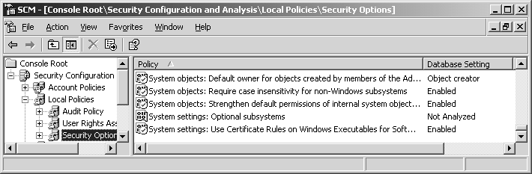

[A] Optional Subsystems.
This check verifies that additional subsystems are not permitted to run on the system.

If the value for “System Settings: Optional Subsystems” has entries listed, then this is a finding.

Category/MAC/IA: | III / 1-CSP, 2-CSP, 3-CSP / ECSC-1, DCSL-1
PDI: | 3.110: Optional Subsystems are permitted to operate on the system.
Reference: | MS Server 2003 Security Settings Guide, Chap 5, p. 101

[A] Software Restriction Policies.
This check verifies that certificate rules are enforced for a user process that attempts to run software with an .exe file name extension.

If the value for “System Settings: Use Certificate Rules on Windows Executables for Software Restriction Policies” is not set to “Enabled”, then this is a finding.

Category/MAC/IA: | II / 1-CSP, 2-CSP, 3-CSP / ECSC-1, DCSQ-1
PDI: | 3.111: Software certificate restriction policies are not enforced.
Reference: | MS Server 2003 Security Settings Guide, Chap 5, p. 102

Event Log Configuration
This check verifies that Windows Server 2003 is configured to preserve event data, should the size of the logs reach their maximum.

- Expand the “Security Configuration and Analysis” object in the tree window.
- Select the “Event Log” object.
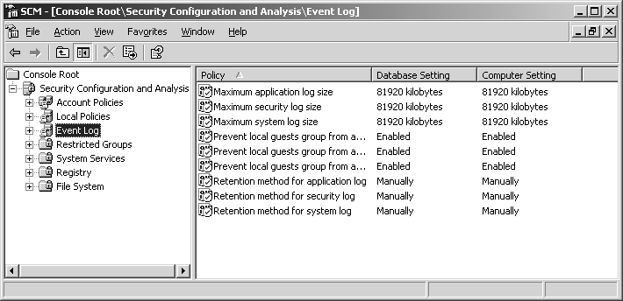

Note: The ‘Database Setting’ in the right pane reflects the required setting. The ‘Computer Setting’ is the effective setting on the machine.

[A] Event Log Sizes
This check determines if the event logs have been set to the proper size.

If any of the following conditions are true, then this is a finding:

____ The “Application” event log is not set to the proper size.

If the value for “Maximum application log size” is not set to a minimum of “81920 kilobytes”, then this is a finding.

____ The “Security” event log is not set to the proper size.

If the value for “Maximum security log size” is not set to a minimum of “81920 kilobytes”, then this is a finding.

____ The “System” event log is not set to the proper size.

If the value for “Maximum system log size” is not set to a minimum of “81920 kilobytes”, then this is a finding.

Note: If the machine is configured to write an event log directly to an audit server, the “Maximum log size” for that log does not have to conform to the requirements above.

Note: Microsoft recommends that the combined size of all the event logs (including DNS logs, Directory Services logs, and Replication logs on Servers or Domain Controllers) should not exceed 300 megabytes. Exceeding the recommended value can impact performance.

Category/MAC/IA: | II / 1-CSP, 2-CSP, 3-CSP / ECRR-1, ECTB-1
PDI: | 5.002: Event log sizes do not meet minimum requirements.
Reference: | MS Server 2003 Security Settings Guide, Chap 4, p. 103  DISA FSO Windows 2003 Addendum, Sect. 6.2

[A] Restrict Event Log Access Over Network
This check verifies that Windows Server 2003 is configured to restrict anonymous network access to the event logs over null-session shares.

If any of the following conditions are true, then this is a finding:

____ Windows Server 2003 is not configured to restrict guest access to the “Application” event log.

If the value for “Prevent local guests group from accessing application log” is not set to “Enabled”, then this is a finding.

____ Windows Server 2003 is not configured to restrict guest access to the “Security” event log.

If the value for “Prevent local guests group from accessing security log” is not set to “Enabled”, then this is a finding.

____ Windows Server 2003 is not configured to restrict guest access to the “System” event log.

If the value for “Prevent local guests group from accessing system log” is not set to “Enabled”, then this is a finding.

Category/MAC/IA: | II / 1-CSP, 2-CSP, 3-CSP / ECSC-1, ECTP-1
PDI: | 3.021: Anonymous access to the event logs is not restricted.
Reference: | MS Server 2003 Security Settings Guide, Chap 4, p. 105

[AP] Preserving Security Events
This check determines if the event logs have been set to save the proper number of days worth of events.

If any of the following conditions are true, then this is a finding:

____ The “Application” event log is not set to save events.

if the value for “Retention method for application log” is not set to “Do not overwrite events”, then this is a finding.

____ The “Security” event log is not set to save events.

if the value for “Retention method for security log” is not set “Do not overwrite events”, then this is a finding.

____ The “System” event log is not set to save events.

if the value for “Retention method for security log” is not set “Do not overwrite events”, then this is a finding.

Note: If the machine is configured to write an event log directly to an audit server, the “Retention method for log” for that log does not have to conform to the requirements above.

Category/MAC/IA: | II / 1-CSP, 2-CSP, 3-CSP / ECRR-1, ECTB-1
PDI: | 5.001: Security events are not properly preserved.
Reference: | MS Server 2003 Security Settings Guide, Chap 4, p. 106  DISA FSO Windows 2003 Addendum, Sect. 6.2

[A] Service Object Permissions
This check verifies that the ACLs for disabled services meet minimum requirements.

- Expand the “Security Configuration and Analysis” object in the tree window.
- Expand the “System Services” object and select each applicable disabled Service.
(Disabled Services can be identified using the Control Panel’s Services applet.
- Right click the Service and select Security.
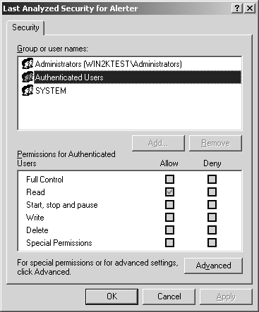
- Select ‘View Security’

If the ACLs for applicable disabled Services do not restrict permissions to Administrators, ‘full Control’, System ‘full control’, and Authenticated Users ‘Read’, then this is a finding.

Category/MAC/IA: | II / 1-CSP, 2-CSP, 3-CSP / ECSC-1, ECCD-1, ECCD-2
PDI: | 2.014: ACLs for disabled Services do not conform to minimum requirements.
Reference: | DISA FSO Windows 2003 Addendum, Sect. 7.6

Registry Key Permissions and Auditing
This check verifies that the access-control permissions applied to the directory object conforms to DISA standards

- Expand the “Security Configuration and Analysis” object in the tree window.
- Expand the “Registry” object and navigate to the key being investigated.

Note: The ‘Permission’ and ‘Audit’ columns indicate whether the required configuration matches the effective machine configuration. ‘OK’ indicates a match, and ‘investigate” indicates that there may be discrepancies.

To investigate a possible Registry ACL discrepancy:

- Select the object being investigated
- Right click on the object
- Select “Security”
- Click on the “View Security” button

- Highlight each group in turn to view effective settings.

[A] Anonymous Access to the Registry
This check verifies that the system is protected from anonymous access, the following registry key must exist and permissions must be set properly:

MACHINE/System/CurrentControlSet/Control/SecurePipeServers/Winreg

If the key does not exist, then this is a finding.

If the permissions are not at least as restrictive as those below or in Appendix A.2.1, then this is a finding.

Object Name | Account Assignment | Permission
\SYSTEM\CurrentControlSet\Control\SecurePipeServers\winreg | Administrators  Backup Operators  LOCAL SERVICE  (Exchange Enterprise Servers group on Domain Controllers and Exchange server  Note: If permissions are sub-delegated with the Exchange Administration feature, then additional accounts and groups may appear on the Winreg key. If this has been done then these should be documented with the site IAO and made available for any reviewer.) | all  read(QENR)  read(QENR)  all

Category/MAC/IA: | I / 1-CSP, 2-CSP, 3-CSP / ECSC-1, ECAN-1
PDI: | 3.030: Anonymous access to the Registry is not restricted.
Reference: | DISA FSO Windows 2003 Addendum, Appendix A.2.1

Auditing discrepancies cannot be investigated through the Security Configuration and Analysis snap-in. It will only indicate that a configuration matches. Regedt32.exe must be used to look at effective auditing settings.

To investigate a possible Registry Auditing discrepancy:

- Run regedt32
- Navigate to the key being investigated
- Right-click the registry key and select “permissions”
- Click on the “Advanced” button
- Select the Auditing tab
- Highlight an ‘Auditing Entry” and click the view button.

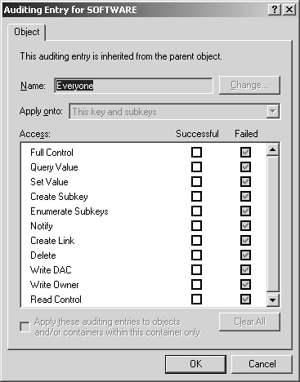
The following are the required entries:

Note: Due to the way Microsoft handles auditing settings on the Registry, settings are made at the root level, but must be checked at a sub-key level (e.g. HKLM\Security)

[A] Registry Key Auditing
This check verifies the auditing configuration for all the registry keys contained under the “HKEY_LOCAL_MACHINE” and “HKEY_USERS” hives. If system-level auditing is not enabled, then mark the check in this section as “FINDING.”

____ The auditing configuration of the “HKEY_LOCAL_MACHINE” registry hive does not meet minimum requirements.

____ The auditing configuration of the “HKEY_USERS” registry hive does not meet minimum requirements.

Category/MAC/IA: | II / 1-CSP, 2-CSP, 3-CSP / ECSC-1, ECAR-3
PDI: | 3.010: Registry key-auditing configuration does not meet minimum requirements.
Reference: | DISA FSO Windows 2003 Addendum, Sect. 6.6

File and Directory Permissions
This check verifies that the access-control permissions applied to the file or directory object conforms to DISA standards. If Windows Server 2003 is not installed on NTFS partitions, then mark all checks in this section as a “FINDING.”

- Expand the “Security Configuration and Analysis” object in the tree window.
- Expand the “File System” object and navigate to the directory/file being investigated.
Note: The ‘Permission’ and ‘Audit’ columns indicate whether the required configuration matches the effective machine configuration. ‘OK’ indicates a match, and ‘investigate” indicates that there may be discrepancies.

To investigate a possible ACL discrepancy:

- Select the object being investigated
- Right click on the object
- Select “Security”
- Click on the “View Security” button

- Highlight each group in turn to view effective settings.

[AP] System Files
NSA has determined that the default ACL settings are adequate when the Security Option “Network access: Let everyone permissions apply to anonymous users” is set to “Disabled” and Power User Group Membership is restricted. If the option is set to “Disabled” and Powers Users are restricted, this check should normally be marked “Not a Finding”, unless a spot check of the default permissions listed in Appendix A show that they have been made less restrictive. The Gold Disk will also review the default settings to ensure compliance.

This check applies when the conditions above are not met. After following the path to each directory/file, if the permissions for these files are not as restrictive as the ACL listed in Appendices A.1.1 and A.1.2, then this is a finding.

 Note: Some ACL findings may be reported by the SRR scripts that appear to be configured correctly. The
reviewer should manually inspect these settings to validate the finding.

Category/MAC/IA: | II / 1-CSP, 2-CSP, 3-CSP / ECSC-1, ECAN-1
PDI: | 2.006: ACLs for system files and directories do not conform to minimum requirements.
Reference: | DISA FSO Windows 2003 Addendum, Sect 7.3, Appendix A.1

File auditing discrepancies cannot be investigated through the Security Configuration and Analysis snap-in. It will only indicate that a configuration matches. Explorer.exe must be used to look at effective file auditing settings.

To investigate a possible Registry Auditing discrepancy:

- Run explorer.exe
- Navigate to the directory/file being investigated
- Right click on the directory/file
- Select “Properties”
- Select the Security tab
- Click on the “Advanced” button
- Select the Auditing tab
- Highlight an ‘Auditing Entry” and click the view button.

The following are the required entries:
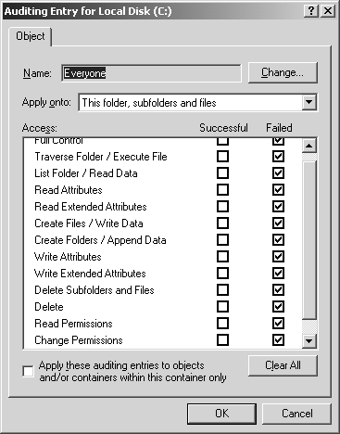

[A] File and Directory Auditing
This check verifies that the minimum auditing configuration is applied to all files and directories in conformance with DISA standards. If system-level auditing is not enabled, or if local files are not installed on NTFS partitions, then mark the check in this section as a “FINDING.”

If file and directory auditing for each local drive is not configured for the Everyone group as
shown in the figure above, then this is a finding

Category/MAC/IA: | II / 1-CSP, 2-CSP, 3-CSP / ECSC-1, ECAR-3
PDI: | 2.007: File-auditing configuration does not meet minimum requirements.
Reference: | DISA FSO Windows 2003 Addendum, Sect. 6.5

Control Panel
The “Control Panel” is responsible for many configuration options on Windows Server 2003

This program is accessed through the following procedures:

Click on the “Start” button.
Right-click “Control Panel” and select “Open”.

Upon completion, the “Control Panel” should appear:

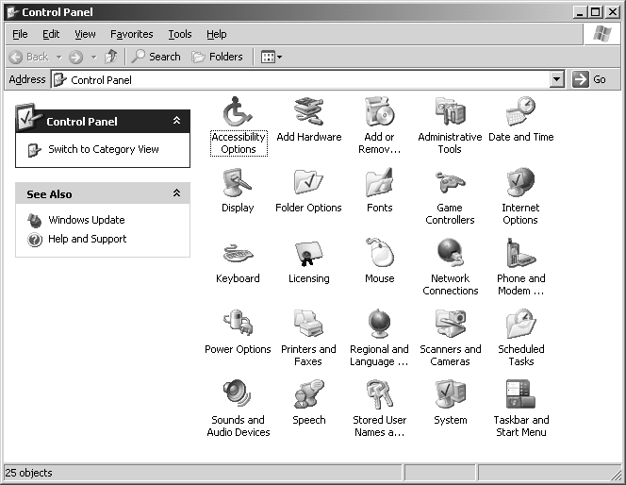

[AP] Password Protected Screen Savers
This check verifies that the current user’s configuration has a password-protected screen saver activated.

Note: Terminal servers are exempt from this requirement.

Note: Applications requiring continuous, real-time screen display (i.e., network management products) will be exempt from this requirement (Not Applicable) provided the following requirements are met:

- The logon session does not have Administrator rights.
- The inactivity exemption is justified and documented by the ISSO.
- The display station (i.e., keyboard, CRT) is located in a controlled access area.

- Double-click on the “Display” applet.
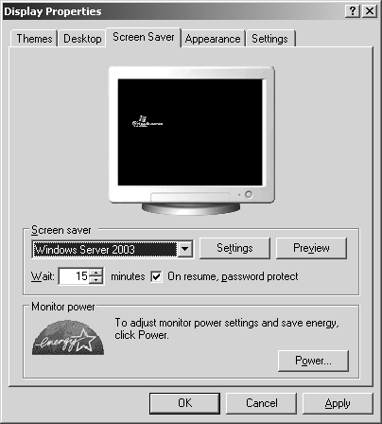
- Select the “Screen Saver” tab.

If any of the following conditions are true, then this is a finding:

____ The current user account does not have a screen saver selected.
If a valid screen saver is not displayed in the “Screen Saver” field, then this is a finding.

____ The current user account’s screen saver is not password-protected.
If the checkbox labeled “on resume, password protect” is not checked, then this is a finding.

____ The current user account’s screen saver does not engage in less than 15 minutes.
If the field labeled “Wait:” does not contain a value less than, or equal to, 15 minutes, then this is a finding.

Category/MAC/IA: | II / 1-CSP, 2-CSP, 3-CSP / PESL-1
PDI: | 5.006: Current user configuration is not set with a password-protected screen saver.
Reference: | DISA FSO Windows 2003 Addendum, Sect. 7.5

[MA] Booting into Multiple Operating Systems
This check verifies that the local system boots directly into Windows Server 2003.

- Double-click on the “System” applet.
- Click on the “Advanced” tab.
- Click the Startup and Recovery “Settings” button.
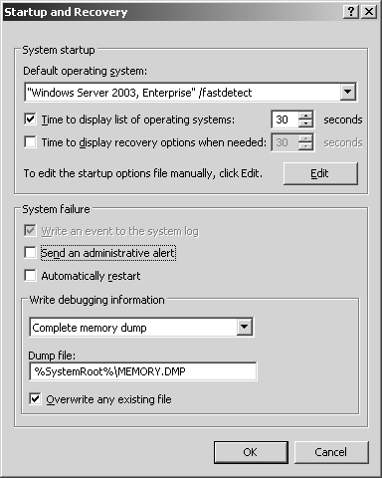

 If the drop-down listbox, “Default operating system:”, shows any operating system other than Windows Server 2003, this may be a finding. If all additional operating systems are STIG compliant, then this is not a finding.

Category/MAC/IA: | II / 1-CSP, 2-CSP, 3-CSP / ECSC-1
PDI: | 5.003: Booting into alternate operating systems is permitted.
Reference: | DISA FSO Windows 2003 Addendum, Sect. 3.1

Registry Editor
The “Registry Editor” permits users and administrators the capability to manage the permissions and audit configuration of file objects on NTFS volumes.

This program is accessed through the following procedures:

Click on the “Start” button.
Select “Run” from the “Start” Menu.
In the “Run” dialog box, enter “REGEDIT” or “REGEDT32” in the “Open” field.
Click on the “OK” button.

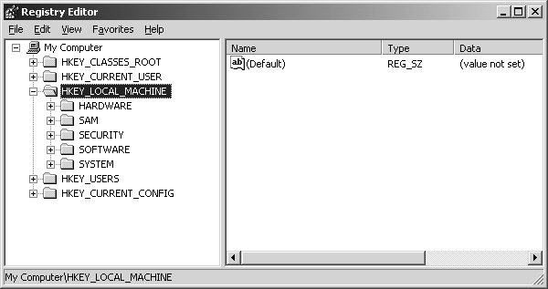
Upon completion, the “Registry Editor” application should appear:

Computer Administrative Templates Configuration
This check verifies that Administrative Templates options on the local system are configured to DISA standards. These settings are made using the Computer and User Administrative Templates in the Local Computer Policy snap-in or in Group Policy.

The Registry settings displayed are for checking purposes only and should not be modified directly, since this will not update the Administrative Template Policy file that is saved on the system, and the settings will not be displayed correctly in the MMC. These settings should only be made using the MMC Local Computer Policy snap-in or through Group Policy. This will insure that previous settings are not lost when any changes are made to the Administrative Template settings, and that findings are reported correctly by the Gold Disk.

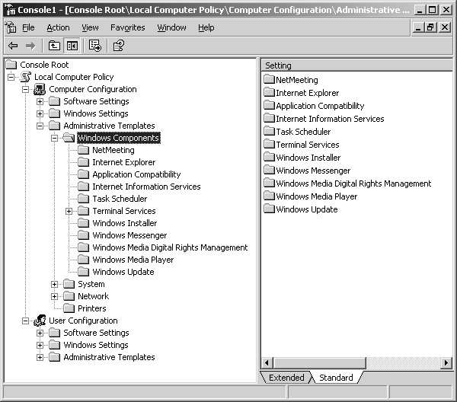
Note: Administrative template settings should be checked using the registry values shown in the following checks. Checking the Administrative Template settings using the MMC may show the values as “Not Defined”, when in fact they have been defined through a Group Policy.

Netmeeting

[A] NetMeeting: Disable Remote Desktop Sharing.
This check verifies that Remote Desktop Sharing should be disabled.

The policy value for Computer Configuration -> Administrative Templates -> Windows Components -> NetMeeting “Disable remote Desktop Sharing” will be set to “Enabled.

If the following registry value doesn’t exist or its value is not set to 1, then this is a finding:

Registry Hive: HKEY_LOCAL_MACHINE
Subkey: \Software\Policies\Microsoft\Conferencing\
Value Name: NoRDS
Type: REG_DWORD
Value: 1

Category/MAC/IA: | II / 1-CSP, 2-CSP, 3-CSP / ECSC-1, EBRP-1
PDI: | 5.027: Remote desktop sharing through NetMeeting is enabled.
Reference: | MS Server 2003 Security Settings Guide, Chap 7, p. 132

Internet Explorer

[A] IE - Security Zones: Use Only Machine Settings
This check verifies that the system enforces consistent security zone settings for all users of the computer.

The policy value for Computer Configuration -> Administrative Templates -> Windows Components -> Internet Explorer “Security Zones: Use only machine settings” will be set to “Enabled”.

If the following registry value doesn’t exist or its value is not set to 1, then this is a finding:

Registry Hive: HKEY_LOCAL_MACHINE
Subkey: \Software\Policies\Microsoft\Windows\CurrentVersion\Internet Settings\
Value Name: Security_HKLM_only
Type: REG_DWORD
Value: 1

Category/MAC/IA: | II / 1-CSP, 2-CSP, 3-CSP / ECSC-1
PDI: | 5.028: Use of machine based security zone settings is not enforced.
Reference: | MS Server 2003 Security Settings Guide, Chap 9, p. 173

[A] IE - Security Zones: Do Not Allow Users to Change Policies
This check verifies that the system is configured to prevent users from adding sites to various security zones.

The policy value for Computer Configuration -> Administrative Templates -> Windows Components -> Internet Explorer “Security Zones: Do Not Allow Users to Change Policies” will be set to “Enabled”.

If the following registry value doesn’t exist or its value is not set to 1, then this is a finding:

Registry Hive: HKEY_LOCAL_MACHINE
Subkey: \Software\Policies\Microsoft\Windows\CurrentVersion\Internet Settings\
Value Name: Security_Options_Edit
Type: REG_DWORD
Value: 1

Category/MAC/IA: | II / 1-CSP, 2-CSP, 3-CSP / ECSC-1, ECPA-1
PDI: | 5.029: Users are allowed to change the I.E. security policies.
Reference: | MS Server 2003 Security Settings Guide, Chap 9, p. 172

[A] IE - Security Zones: Do Not Allow Users to Add/Delete Sites
This check verifies that the system is configured to prevent users from adding sites to various security zones.

The policy value for Computer Configuration -> Administrative Templates -> Windows Components -> Internet Explorer “Security Zones: Do Not Allow Users to Add/Delete Sites” will be set to “Enabled”.

If the following registry value doesn’t exist or its value is not set to 1, then this is a finding:

Registry Hive: HKEY_LOCAL_MACHINE
Subkey: \Software\Policies\Microsoft\Windows\CurrentVersion\Internet Settings\
Value Name: Security_Zones_Map_Edit
Type: REG_DWORD
Value: 1

Category/MAC/IA: | II / 1-CSP, 2-CSP, 3-CSP / ECSC-1, ECPA-1
PDI: | 5.030: Users are allowed to add or delete sites to the I.E. security zones.
Reference: | MS Server 2003 Security Settings Guide, Chap 9, p. 172

[A] IE - Make Proxy Settings Per Machine
This check verifies that the system is configured to make the Internet Explorer proxy settings on a per-machine basis.

The policy value for Computer Configuration -> Administrative Templates -> Windows Components -> Internet Explorer “Make proxy settings per-machine (rather than per user)” will be set to “Enabled”.

If the following registry value doesn’t exist or its value is not set to 0, then this is a finding:

Registry Hive: HKEY_LOCAL_MACHINE
Subkey: \Software\Policies\Microsoft\Windows\CurrentVersion\Internet Settings\
Value Name: ProxySettingsPerUser
Type: REG_DWORD
Value: 0

Category/MAC/IA: | II / 1-CSP, 2-CSP, 3-CSP / ECSC-1
PDI: | 5.031: Proxy server settings are not per machine.
Reference: | MS Server 2003 Security Settings Guide, Chap 9, p. 171

[A] IE - Disable Automatic Install of Internet Explorer Components
This check verifies that the system is configured to prevent the automatic installation of components if it goes to a site that requires components that are not currently installed.

The policy value for Computer Configuration -> Administrative Templates -> Windows Components -> Internet Explorer “Disable Automatic Install of Internet Explorer components” will be set to “Enabled”.

If the following registry value doesn’t exist or its value is not set to 1, then this is a finding:

Registry Hive: HKEY_LOCAL_MACHINE
Subkey: \Software\Policies\Microsoft\Internet Explorer\InfoDelivery\Restrictions\
Value Name: NoJITSetup
Type: REG_DWORD
Value: 1

Category/MAC/IA: | II / 1-CSP, 2-CSP, 3-CSP / ECSC-1, DCSQ-1
PDI: | 5.032: Automatic install of I.E. components is not disabled.
Reference: | MS Server 2003 Security Settings Guide, Chap 9, p. 169

[A] IE - Disable Periodic Check for Internet Explorer Software Updates
This check verifies that the system is configured to prevent periodically checking the Microsoft web sites to determine if there are updates to Internet Explorer available.

The policy value for Computer Configuration -> Administrative Templates -> Windows Components -> Internet Explorer “Disable Periodic Check for Internet Explorer Software Updates” will be set to “Enabled”.

If the following registry value doesn’t exist or its value is not set to 1, then this is a finding:

Registry Hive: HKEY_LOCAL_MACHINE
Subkey: \Software\Policies\Microsoft\Internet Explorer\InfoDelivery\Restrictions\
Value Name: NoUpdateCheck
Type: REG_DWORD
Value: 1

Category/MAC/IA: | II / 1-CSP, 2-CSP, 3-CSP / ECSC-1, DCSQ-1
PDI: | 5.033: I.E. automatically checks for program updates.
Reference: | MS Server 2003 Security Settings Guide, Chap 9, p. 169

[A] IE - Disable Software Update Shell Notifications on Program Launch
This check verifies that the system is configured to notify users when programs are modified through the software distribution channel.

The policy value for Computer Configuration -> Administrative Templates -> Windows Components -> Internet Explorer “Disable Software Update Shell Notifications on Program Launch” will be set to “Disabled”.

If the following registry value exists and its value is not set to 0, then this is a finding:

Registry Hive: HKEY_LOCAL_MACHINE
Subkey: \Software\Microsoft\Windows\CurrentVersion\Policies\Explorer\
Value Name: NoMSAppLogo5ChannelNotify
Type: REG_DWORD
Value: 0

Category/MAC/IA: | II / 1-CSP, 2-CSP, 3-CSP / ECSC-1, DCSQ-1
PDI: | 5.034: Users are not notified if an I.E. software distribution channel is used to modify software on their system.
Reference: | MS Server 2003 Security Settings Guide, Chap 9, p. 171

Task Scheduler

[A] Task Scheduler - Hide Property Pages
This check verifies that the system is configured to will prevent users from viewing or changing the properties of a scheduled task.

The policy value for Computer Configuration -> Administrative Templates -> Windows Components -> Task Scheduler “Hide property pages” will be set to “Enabled”.

If the following registry value doesn’t exist or its value is not set to 1, then this is a finding:

Registry Hive: HKEY_LOCAL_MACHINE
Subkey: \Software\Policies\Microsoft\Windows\TaskScheduler5.0\
Value Name: Property Pages
Type: REG_DWORD
Value: 1

Note: If the site has authorized the use of Task Scheduler, then this check is not applicable.
Category/MAC/IA: | III / 1-CSP, 2-CSP, 3-CSP / ECSC-1
PDI: | 5.035: Task property pages are viewable.
Reference: | DISA FSO Windows 2003 Addendum, Sect. 7.6.15

[A] Task Scheduler - Prohibit New Task Creation
This check verifies that the system is configured to will prevent users from creating new tasks with the New Task Wizard.

The policy value for Computer Configuration -> Administrative Templates -> Windows Components -> Task Scheduler “Prohibit New Task Creation” will be set to “Enabled”.

If the following registry value doesn’t exist or its value is not set to 1, then this is a finding:

Registry Hive: HKEY_LOCAL_MACHINE
Subkey: \Software\Policies\Microsoft\Windows\TaskScheduler5.0\
Value Name: Task Creation
Type: REG_DWORD
Value: 1

Note: If the site has authorized the use of Task Scheduler, then this check is not applicable.
Category/MAC/IA: | III / 1-CSP, 2-CSP, 3-CSP / ECSC-1, ECLP-1
PDI: | 5.036: New task creation is not disabled.
Reference: | DISA FSO Windows 2003 Addendum, Sect. 7.6.15

Terminal Services

[A] Terminal Services - Limit Users to One Remote Session
This check verifies that the system is configured to limit users to one remote session.

The policy value for Computer Configuration -> Administrative Templates -> Windows Components -> Terminal Services “Restrict Terminal Server users to a Single Remote Session” will be set to “Enabled”.

If the following registry value doesn’t exist or its value is not set to 1, then this is a finding:
Registry Hive: HKEY_LOCAL_MACHINE
Subkey: \Software\Policies\Microsoft\Windows NT\Terminal Services\
Value Name: fSingleSessionPerUser
Type: REG_DWORD
Value: 1

Note: If the system has the role as a Terminal Server, or the site is using terminal services for remote administration, then this would not be a finding.

Category/MAC/IA: | II / 1-CSP, 2-CSP, 3-CSP / ECSC-1
PDI: | 5.038: Users are not limited to one session.
Reference: | DISA FSO Windows 2003 Addendum, Sect. 8.3.2.2

[A] Terminal Services - Limit Number of Connections
This check verifies that the system is configured to limit the number of simultaneous connections to the terminal server.

- The policy value for Computer Configuration -> Administrative Templates -> Windows Components -> Terminal Services “Limit Number of Connections” will be set to “Enabled”, and the value “TS maximum connections allowed” will be no more than “1”.

If the following registry value doesn’t exist or its value is not set to 1, then this is a finding:
Registry Hive: HKEY_LOCAL_MACHINE
Subkey: \Software\Policies\Microsoft\Windows NT\Terminal Services\
Value Name: MaxInstanceCount
Type: REG_DWORD
Value: 1
Note: If the system has the role as a Terminal Server, or the site is using terminal services for remote administration, then this would not be a finding.
Category/MAC/IA: | II / 1-CSP, 2-CSP, 3-CSP / ECSC-1
PDI: | 5.039: The number of incoming connections is not limited.
Reference: | DISA FSO Windows 2003 Addendum, Sect. 8.3.2.3

[A] Terminal Services - Do Not Allow Local Administrators to Customize Permissions
This check verifies that the system is configured to prevent the local Administrator accounts from modifying the permissions in the Terminal Services Configuration tool.

- The policy value for Computer Configuration -> Administrative Templates -> Windows Components -> Terminal Services “Do Not Allow Local Administrators to Customize Permissions” will be set to “Enabled”.

If the following registry value doesn’t exist or its value is not set to 0, then this is a finding:

Registry Hive: HKEY_LOCAL_MACHINE
Subkey: \Software\Policies\Microsoft\Windows NT\Terminal Services\
Value Name: fWritableTSCCPermTab
Type: REG_DWORD
Value: 0

Category/MAC/IA: | II / 1-CSP, 2-CSP, 3-CSP / ECSC-1, ECPA-1
PDI: | 5.041: Local administrators can customize Terminal Services permissions.
Reference: | MS Server 2003 Security Settings Guide, Chap 9, p. 175

[A] Terminal Services - Remote Control Settings
This check verifies that the system is configured to prevent Remote Control of sessions.

- The policy value for Computer Configuration -> Administrative Templates -> Windows Components -> Terminal Services “Sets rules for remote control of Terminal Services user settings” will be set to “Enabled” and the “Options” will be set to “No remote control allowed”.

If the following registry value doesn’t exist or its value is not set to 0, then this is a finding:

Registry Hive: HKEY_LOCAL_MACHINE
Subkey: \Software\Policies\Microsoft\Windows NT\Terminal Services\
Value Name: Shadow
Type: REG_DWORD
Value: 0

Category/MAC/IA: | I / 1-CSP, 2-CSP, 3-CSP / ECSC-1, EBRP-1
PDI: | 3.066: Remote control of the system is allowed.
Reference: | MS Server 2003 Security Settings Guide, Chap 9, p. 176

[A] Terminal Services - Always Prompt Client for Password upon Connection
This check verifies that the system is configured to require users to supply passwords as part of their Remote Desktop Connection.

- The policy value for Computer Configuration -> Administrative Templates -> Windows Components -> Terminal Services -> Encryption and Security “Always Prompt Client for Password upon Connection” will be set to “Enabled”.

If the following registry value doesn’t exist or its value is not set to 1, then this is a finding:

Registry Hive: HKEY_LOCAL_MACHINE
Subkey: \Software\Policies\Microsoft\Windows NT\Terminal Services\
Value Name: fPromptForPassword
Type: REG_DWORD
Value: 1

Category/MAC/IA: | II / 1-CSP, 2-CSP, 3-CSP / ECSC-1, ECLO-1, ECLO-2
PDI: | 5.042: Clients are not always prompted for a password on connection.
Reference: | MS Server 2003 Security Settings Guide, Chap 9, p. 183

[A] Terminal Services - Set Client Connection Encryption Level
This check verifies that the system is configured to require the proper encryption level that is used for the client connection.

- The policy value for Computer Configuration -> Administrative Templates -> Windows Components -> Terminal Services -> Encryption and Security “Set Client Connection Encryption Level” will be set to “Enabled”, and set to “high”.

If the following registry value doesn’t exist or its value is not set to 3, then this is a finding:

Registry Hive: HKEY_LOCAL_MACHINE
Subkey: \Software\Policies\Microsoft\Windows NT\Terminal Services\
Value Name: MinEncryptionLevel
Type: REG_DWORD
Value: 3

Category/MAC/IA: | II / 1-CSP, 2-CSP, 3-CSP / ECSC-1, ECCT-1, ECCT-2
PDI: | 5.043: The client encryption level is not set to ‘High’.
Reference: | MS Server 2003 Security Settings Guide, Chap 9, p. 182

[A] Terminal Services – Secure Server
This check verifies that the Terminal Server is configured to require secure remote procedure call (RPC) communication with clients.

- The policy value for Computer Configuration -> Administrative Templates -> Windows Components -> Terminal Services -> Encryption and Security -> RPC Security Policy “Secure Server (Require Security)” will set to “Enabled”.

If the following registry value doesn’t exist or its value is not set to 1, then this is a finding:

Registry Hive: HKEY_LOCAL_MACHINE
Subkey: \Software\Policies\Microsoft\Windows NT\Terminal Services\
Value Name: fEncryptRPCTraffic
Type: REG_DWORD
Value: 1

Category/MAC/IA: | II / 1-CSP, 2-CSP, 3-CSP / ECSC-1, ECCT-1, ECCT-2
PDI: | 5.103: The Terminal Server does not require secure RPC communication.
Reference: | MS Server 2003 Security Settings Guide, Chap 9, p. 183

[A] Terminal Services - Do Not Use Temp Folders per Session
This check verifies that the system is configured to require per session temporary folders.

- The policy value for Computer Configuration -> Administrative Templates -> Windows Components -> Terminal Services -> Temporary Folders “Do Not Use Temp Folders per Session” will be set to “Disabled”.

If the following registry value doesn’t exist or its value is not set to 1, then this is a finding:

Registry Hive: HKEY_LOCAL_MACHINE
Subkey: \Software\Policies\Microsoft\Windows NT\Terminal Services\
Value Name: PerSessionTempDir
Type: REG_DWORD
Value: 1

Category/MAC/IA: | II / 1-CSP, 2-CSP, 3-CSP / ECSC-1, ECRC-1
PDI: | 5.044: A common temporary folder is used instead of a per-session temporary folder.
Reference: | DISA FSO Windows 2003 Addendum, Sect. 8.3.2.5

[A] Terminal Services - Do Not Delete Temp Folder upon Exit
This check verifies that the system is configured to require the deletion of the temporary folders when the session is terminated.

- The policy value for Computer Configuration -> Administrative Templates -> Windows Components -> Terminal Services -> Temporary Folders “Do Not Delete Temp Folder upon Exit” will be set to “Disabled”.

If the following registry value doesn’t exist or its value is not set to 1, then this is a finding:

Registry Hive: HKEY_LOCAL_MACHINE
Subkey: \Software\Policies\Microsoft\Windows NT\Terminal Services\
Value Name: DeleteTempDirsOnExit
Type: REG_DWORD
Value: 1

Category/MAC/IA: | II / 1-CSP, 2-CSP, 3-CSP / ECSC-1, ECRC-1
PDI: | 5.045: The temp folder is not deleted when the session terminates.
Reference: | DISA FSO Windows 2003 Addendum, Sect. 8.3.2.6

[A] Terminal Services - Set Time Limit for Disconnected Sessions
This check verifies that the system is configured to end disconnected sessions after 1 minute.

- The policy value for Computer Configuration -> Administrative Templates -> Windows Components -> Terminal Services -> Sessions “Set Time Limit for Disconnected Sessions” will be set to “Enabled”, and the “End a disconnected session” set to “1” minute or less.

If the following registry value doesn’t exist or its value is not set to 1 minute or less, then this is a finding:

Registry Hive: HKEY_LOCAL_MACHINE
Subkey: \Software\Policies\Microsoft\Windows NT\Terminal Services\
Value Name: MaxDisconnectionTime
Type: REG_DWORD
Value: 0x0000ea60 (60000)

Category/MAC/IA: | II / 1-CSP, 2-CSP, 3-CSP / ECSC-1
PDI: | 5.046: The time limit for disconnected sessions is more than 1 minute.
Reference: | MS Server 2003 Security Settings Guide, Chap 9, p. 184

[A] Terminal Services - Set Time Limit for Idle Sessions
This check verifies that the system is configured to disconnect idle sessions after no more than 15 minutes.

- The policy value for Computer Configuration -> Administrative Templates -> Windows Components -> Terminal Services -> Sessions “Set time limit for active but idle Terminal Services sessions” will be set to “Enabled”, and the “Idle session limit” set to 15 minutes or less.

If the following registry value doesn’t exist or its value is not set to 15 minutes or less, then this is a finding:

Registry Hive: HKEY_LOCAL_MACHINE
Subkey: \Software\Policies\Microsoft\Windows NT\Terminal Services\
Value Name: MaxIdleTime
Type: REG_DWORD
Value: 0x000dbba0 (900000)

Category/MAC/IA: | II / 1-CSP, 2-CSP, 3-CSP / ECSC-1
PDI: | 5.047: The time limit for idle session is more than 15 minutes.
Reference: | DISA FSO Windows 2003 Addendum, Sect. 8.3.2.7

[A] Terminal Services - Allow Reconnection from Original Client Only
This check verifies that the system is configured to allow only the original client to resume a session.

- The policy value for Computer Configuration -> Administrative Templates -> Windows Components -> Terminal Services -> Sessions “Allow Reconnection from Original Client Only” will be set to “Enabled”.

If the following registry value doesn’t exist or its value is not set to 1, then this is a finding:

Registry Hive: HKEY_LOCAL_MACHINE
Subkey: \Software\Policies\Microsoft\Windows NT\Terminal Services\
Value Name: fReconnectSame
Type: REG_DWORD
Value: 1

Category/MAC/IA: | II / 1-CSP, 2-CSP, 3-CSP / ECSC-1
PDI: | 5.048: Reconnections from clients other than the original are allowed.
Reference: | MS Server 2003 Security Settings Guide, Chap 9, p. 185

[A] Terminal Services - Terminate Session When Time Limits are Reached
This check verifies that the system is configured to forcefully disconnect clients if their terminal services time limit is exceeded.

- The policy value for Computer Configuration -> Administrative Templates -> Windows Components -> Terminal Services -> Sessions “Terminate Session When Time Limits are Reached” will be set to “Enabled”.

If the following registry value doesn’t exist or its value is not set to 1, then this is a finding:

Registry Hive: HKEY_LOCAL_MACHINE
Subkey: \Software\Policies\Microsoft\Windows NT\Terminal Services\
Value Name: fResetBroken
Type: REG_DWORD
Value: 1

Category/MAC/IA: | II / 1-CSP, 2-CSP, 3-CSP / ECSC-1
PDI: | 5.049: Sessions are not terminated when time limits are reached.
Reference: | DISA FSO Windows 2003 Addendum, Sect. 8.3.2.8

Windows Installer

[A] Windows Installer - Always Install with Elevated Privileges
This check verifies that the system is configured to prevent Windows Installer from executing with elevated privileges.

- The policy value for Computer Configuration -> Administrative Templates -> Windows Components -> Windows Installer “Always Install with Elevated Privileges” will be set to “Disabled”.

If the following registry exists and is not set to 0, then this is a finding:

Registry Hive: HKEY_LOCAL_MACHINE
Subkey: \Software\Policies\Microsoft\Windows\Installer
Value Name: AlwaysInstallElevated
Type: REG_DWORD
Value: 0

Category/MAC/IA: | I / 1-CSP, 2-CSP, 3-CSP / ECSC-1, ECLP-1
PDI: | 4.037: Windows installer always installs with elevated privileges.
Reference: | DISA FSO Windows 2003 Addendum, Sect. 8.3.3.1

[A] Windows Installer - Disable IE Security Prompt for Windows Installer Scripts
This check verifies that the system is configured to prompt users when a web-based program attempts to install software on the system.

- The policy value for Computer Configuration -> Administrative Templates -> Windows Components -> Windows Installer “Disable IE Security Prompt for Windows Installer Scripts” will be set to “Disabled”.

If the following registry value exists and is not set to 0, then this is a finding:

Registry Hive: HKEY_LOCAL_MACHINE
Subkey: \Software\Policies\Microsoft\Windows\Installer
Value Name: SafeForScripting
Type: REG_DWORD
Value: 0

Category/MAC/IA: | III / 1-CSP, 2-CSP, 3-CSP / ECSC-1, DCSQ-1
PDI: | 5.050: Users are not prompted when a program attempts to install through I.E.
Reference: | DISA FSO Windows 2003 Addendum, Sect. 8.3.3.2

[A] Windows Installer - Enable User Control Over Installs
This check verifies that the system is configured to prevent users from changing installation settings that are normally only available to System Administrators.

- The policy value for Computer Configuration -> Administrative Templates -> Windows Components -> Windows Installer “Enable User Control Over Installs” is not set to “Disabled”.

If the following registry value exists and is not set to 0, then this is a finding:

Registry Hive: HKEY_LOCAL_MACHINE
Subkey: \Software\Policies\Microsoft\Windows\Installer
Value Name: EnableUserControl
Type: REG_DWORD
Value: 0

Category/MAC/IA: | II / 1-CSP, 2-CSP, 3-CSP / ECSC-1, ECLP-1
PDI: | 5.051: Non-administrative users have control over installation packages.
Reference: | DISA FSO Windows 2003 Addendum, Sect. 8.3.3.3

[A] Windows Installer - Enable User to Browse for Source While Elevated
This check verifies that the system is configured to prevent users from browsing the disk if an installer package executing with elevated privileges.

- The policy value for Computer Configuration -> Administrative Templates -> Windows Components -> Windows Installer “Enable User to Browse for Source While Elevated” will be set to “Disabled”.

If the following registry value exists and is not set to 0, then this is a finding:

Registry Hive: HKEY_LOCAL_MACHINE
Subkey: \Software\Policies\Microsoft\Windows\Installer
Value Name: AllowLockDownBrowse
Type: REG_DWORD
Value: 0

Category/MAC/IA: | II / 1-CSP, 2-CSP, 3-CSP / ECSC-1, ECLP-1
PDI: | 5.052: The user may browse while executing an install with elevated privileges.
Reference: | DISA FSO Windows 2003 Addendum, Sect. 8.3.3.4

[A] Windows Installer - Enable User to Use Media Source While Elevated
This check verifies that the system is configured to prevent users from installing programs from removable media when executing an installer package that is running with elevated privileges.

- The policy value for Computer Configuration -> Administrative Templates -> Windows Components -> Windows Installer “Enable User to Use Media Source While Elevated” will be set to “Disabled”.

If the following registry value exists and is not set to 0, then this is a finding:

Registry Hive: HKEY_LOCAL_MACHINE
Subkey: \Software\Policies\Microsoft\Windows\Installer
Value Name: AllowLockDownMedia
Type: REG_DWORD
Value: 0

Category/MAC/IA: | II / 1-CSP, 2-CSP, 3-CSP / ECSC-1, ECLP-1
PDI: | 5.053: The user may use media while executing an install with elevated privileges.
Reference: | DISA FSO Windows 2003 Addendum, Sect. 8.3.3.5

[A] Windows Installer - Enable User to Patch Elevated Products
This check verifies that the system is configured to prevent users from patching a product that was installed with elevated privileges.

- The policy value for Computer Configuration -> Administrative Templates -> Windows Components -> Windows Installer “Enable User to Patch Elevated Products” will be set to “Disabled”.

If the following registry value exists and is not set to 0, then this is a finding:

Registry Hive: HKEY_LOCAL_MACHINE
Subkey: \Software\Policies\Microsoft\Windows\Installer
Value Name: AllowLockDownPatch
Type: REG_DWORD
Value: 0

Category/MAC/IA: | II / 1-CSP, 2-CSP, 3-CSP / ECSC-1, ECLP-1
PDI: | 5.054: The user may patch products that were installed with elevated privileges.
Reference: | DISA FSO Windows 2003 Addendum, Sect. 8.3.3.6

[A] Windows Installer - Allow Admin to Install from Terminal Services Session
This check verifies that the system is configured to prevent Terminal Services Administrators from installing and administering software remotely.

- The policy value for Computer Configuration -> Administrative Templates -> Windows Components -> Windows Installer “Allow Admin to Install from Terminal Services Session” will be set to “Disabled”.

If the following registry value exists and is not set to 0, then this is a finding:

Registry Hive: HKEY_LOCAL_MACHINE
Subkey: \Software\Policies\Microsoft\Windows\Installer
Value Name: EnableAdminTSRemote
Type: REG_DWORD
Value: 0
Note: If the site is using terminal services for remote administration, then this would not be a finding.
Category/MAC/IA: | II / 1-CSP, 2-CSP, 3-CSP / ECSC-1, EBRP-1
PDI: | 5.055: Software installation is allowed through Terminal Services sessions.
Reference: | DISA FSO Windows 2003 Addendum, Sect. 8.3.3.7

[A] Windows Installer - Cache Transforms in Secure Location on Workstation
This check verifies that the system is configured to store the transform file in a secure location on the machine, instead of in a user’s profile.

- The policy value for Computer Configuration -> Administrative Templates -> Windows Components -> Windows Installer “Cache Transforms in Secure Location on Workstation” will be set to “Enabled”.

If the following registry value doesn’t exist or its value is not set to 1, then this is a finding:

Registry Hive: HKEY_LOCAL_MACHINE
Subkey: \Software\Policies\Microsoft\Windows\Installer
Value Name: TransformsSecure
Type: REG_DWORD
Value: 1

Category/MAC/IA: | II / 1-CSP, 2-CSP, 3-CSP / ECSC-1, ECCD-1
PDI: | 5.056: Transforms are not cached in a secure location on the workstation.
Reference: | DISA FSO Windows 2003 Addendum, Sect. 8.3.3.8

Media Player (Computer)

[A] Media Player - Disabling Media Player for Automatic Updates
This check verifies that the system is configured to prevent automatic updates by the Windows Media Player.

- The policy value for Computer Configuration -> Administrative Templates -> Windows Components -> Windows Media Player “Prevent Automatic Updates” will be set to “Enabled”.

If the following registry value doesn’t exist or its value is not set to 1, then this is a finding:

Registry Hive: HKEY_LOCAL_MACHINE
Subkey: \Software\Policies\Microsoft\WindowsMediaPlayer\
Value Name: DisableAutoupdate
Type: REG_DWORD
Value: 1

Category/MAC/IA: | II / 1-CSP, 2-CSP, 3-CSP / ECSC-1, DCSQ-1
PDI: | 5.060: Windows Media Player for Automatic Updates are not disabled.
Reference: | DISA FSO Windows 2003 Addendum, Sect. 8.3.11

Windows Messenger
Generally, Windows Messenger should not be active on a Windows 2003 system. However, if a site has a requirement for using Windows Messenger, then it will be permitted with the following conditions: All workstations and servers, with active Windows Messenger clients, must have personal firewalls installed that are configured to block access to public instant messaging providers such as AOL or MSN. The site must also have network controls in place to block the same access. Any applicable Microsoft security-related hot fixes must also be applied.

Note: This is a separate application from the Messenger Service, and should not be confused with it. They are unrelated.

[A] Windows Messenger - Do Not Allow Windows Messenger to be Run
This check verifies that the system is configured to prevent the Windows Messenger client from being run.

- The policy value for Computer Configuration -> Administrative Templates -> Windows Components -> Windows Messenger “Do Not Allow Windows Messenger to be Run” will be set to “Enabled”.

If the following registry value doesn’t exist or its value is not set to 1, then this is a finding:
Registry Hive: HKEY_LOCAL_MACHINE
Subkey: \Software\Policies\Microsoft\Messenger\Client\
Value Name: PreventRun
Type: REG_DWORD
Value: 1

Note: If the site has a requirement for Windows Messaging that is documented with the IAO, and meets the conditions in 5.6.1.7, then this would not be a finding.

Category/MAC/IA: | II / 1-CSP, 2-CSP, 3-CSP / ECSC-1, ECLP-1
PDI: | 5.017: The user is allowed to launch Windows Messenger (MSN Messenger, .NET Messenger)
Reference: | MS Server 2003 Security Settings Guide, Chap 9, p. 187  DISA FSO Windows 2003 Addendum, Sect. 8.3.4.1

[A] Windows Messenger - Do Not Automatically Start Windows Messenger Initially
This check verifies that the system is configured to prevent the automatic launch of Windows Messenger at user logon.

- The policy value for Computer Configuration -> Administrative Templates -> Windows Components -> Windows Messenger “Do Not Automatically Start Windows Messenger Initially” will be set to “Enabled”.

If the following registry value doesn’t exist or its value is not set to 1, then this is a finding:
Registry Hive: HKEY_LOCAL_MACHINE
Subkey: \Software\Policies\Microsoft\Messenger\Client\
Value Name: PreventAutoRun
Type: REG_DWORD
Value: 1

Note: If the site has a requirement for Windows Messaging that is documented with the IAO, and meets the conditions in 5.6.1.7, then this would not be a finding.
Category/MAC/IA: | II / 1-CSP, 2-CSP, 3-CSP / ECSC-1
PDI: | 5.018: Windows Messenger (MSN Messenger, .NET messenger) is run at system startup.
Reference: | DISA FSO Windows 2003 Addendum, Sect. 8.3.4.2

[A] Windows Messenger – Internet Access Blocked
This check verifies that, if installed, Windows Messenger is correctly configured to prevent access outside of the internal network. The existence of the
HKLM\Software\ Microsoft\MessengerService Registry key indicates that Windows Messenger has been installed.

If Windows Messenger is installed and the following registry value doesn’t exist, or is not set to 1, then this is a finding:

Registry Hive: HKEY_LOCAL_MACHINE
Subkey: \Software\Policies\Microsoft\Messenger\Client\{9b017612-c9f1-11d2-8d9f-0000f875c541}
Value Name: Disabled
Type: REG_DWORD
Value: 1

Category/MAC/IA: | II / 1-CSP, 2-CSP, 3-CSP / ECSC-1, ECLP-1
PDI: | 5.105: Windows Messenger has not been configured to prevent access to the Internet.
Reference: | DISA FSO Windows 2003 Addendum, Sect. 8.3.4

Logon

[A] Logon - Always Wait for the Network at Computer Startup and Logon
This check verifies that the system is configured to cause Windows to wait for complete network initialization before allowing the user to log on.

- The policy value for Computer Configuration -> Administrative Templates -> System -> Logon “Always Wait for the Network at Computer Startup and Logon” will be set to “Enabled”.

If the following registry value doesn’t exist or its value is not set to 1, then this is a finding:

Registry Hive: HKEY_LOCAL_MACHINE
Subkey: \Software\Policies\Microsoft\Windows NT\CurrentVersion\Winlogon\
Value Name: SyncForegroundPolicy
Type: REG_DWORD
Value: 1

Category/MAC/IA: | II / 1-CSP, 2-CSP, 3-CSP / ECSC-1, ECLO-1, ECLO-2
PDI: | 3.067: The computer does not wait for the network at computer startup.
Reference: | DISA FSO Windows 2003 Addendum, Sect. 8.3.5

Group Policy

[A] Group Policy - Turn Off Background Refresh of Group Policy
This check verifies that the system is configured to insure that Group Policy settings are refreshed while a user is currently logged on.

- The policy value for Computer Configuration -> Administrative Templates -> System -> Group Policy “Turn Off Background Refresh of Group Policy” will be set to “Disabled”.

If the following registry value exists and its value is not set to 0, then this is a finding:

Registry Hive: HKEY_LOCAL_MACHINE
Subkey: \Software\Microsoft\Windows\CurrentVersion\Policies\system\
Value Name: DisableBkGndGroupPolicy
Type: REG_DWORD
Value: 0

Category/MAC/IA: | II / 1-CSP, 2-CSP, 3-CSP / ECSC-1, ECLO-1, ECLO-2
PDI: | 3.080: Background refresh of group policy is disabled.
Reference: | DISA FSO Windows 2003 Addendum, Sect. 4.3.2

[A] Group Policy – Registry Policy Processing
This check verifies that the system is configured to insure that Group Policy settings overwrite any unauthorized local security policy changes.

- The policy value for Computer Configuration -> Administrative Templates -> System -> Group Policy “Registry Policy Processing” will be set to “Enabled”,
and
the option “Process even if the Group Policy objects have not changed” selected.

If the following registry value doesn’t exist or its value is not set to 0, then this is a finding:
Registry Hive: HKEY_LOCAL_MACHINE
Subkey: \Software\Policies\Microsoft\Windows\Group Policy\
{35378EAC-683F-11D2-A89A-00C04FBBCFA2}\
Value Name: NoBackgroundPolicy
Type: REG_DWORD
Value: 0

Category/MAC/IA: | II / 1-CSP, 2-CSP, 3-CSP / ECSC-1, ECLO-1, ECLO-2
PDI: | 3.112: Group Policy objects are not reprocessed if they have not changed.
Reference: | MS Server 2003 Security Settings Guide, Chap 9, p. 202

Remote Assistance

[A] Remote Assistance - Solicited Remote Assistance
This check verifies that the system is configured to prevent solicited remote assistance from this computer.

- The policy value for Computer Configuration -> Administrative Templates -> System -> Remote Assistance “Solicited Remote Assistance” will be set to “Disabled”.

If the following registry value doesn’t exist or its value is not set to 0, then this is a finding:

Registry Hive: HKEY_LOCAL_MACHINE
Subkey: \Software\Policies\Microsoft\Windows NT\Terminal Services\
Value Name: fAllowToGetHelp
Type: REG_DWORD
Value: 0

Category/MAC/IA: | I / 1-CSP, 2-CSP, 3-CSP / ECSC-1, EBRP-1
PDI: | 3.068: Solicited Remote Assistance is allowed.
Reference: | MS Server 2003 Security Settings Guide, Chap 9, p. 214

[A] Remote Assistance - Offer Remote Assistance
This check verifies that the system is configured to prevent unsolicited offers of help to this computer.

- The policy value for Computer Configuration -> Administrative Templates -> System -> Remote Assistance “Offer Remote Assistance” will be set to “Disabled”.

If the following registry value doesn’t exist or its value is not set to 0, then this is a finding:

Registry Hive: HKEY_LOCAL_MACHINE
Subkey: \Software\Policies\Microsoft\Windows NT\Terminal Services\
Value Name: fAllowUnsolicited
Type: REG_DWORD
Value: 0

Category/MAC/IA: | II / 1-CSP, 2-CSP, 3-CSP / ECSC-1, EBRP-1
PDI: | 3.082: Remote Assistance offers are allowed.
Reference: | MS Server 2003 Security Settings Guide, Chap 9, p. 215

Error Reporting

[A] Error Reporting - Report Errors
This check verifies that the system is configured to prevent reporting of errors to Microsoft.

- The policy value for Computer Configuration -> Administrative Templates -> System -> Error Reporting “Report Errors” will be set to “Disabled”.

If the following registry value doesn’t exist or its value is not set to 0, then this is a finding:

Registry Hive: HKEY_LOCAL_MACHINE
Subkey: \Software\Policies\Microsoft\PCHealth\ErrorReporting\
Value Name: DoReport
Type: REG_DWORD
Value: 0

Category/MAC/IA: | II / 1-CSP, 2-CSP, 3-CSP / ECSC-1, ECRC-1
PDI: | 3.083: Error Reporting is not disabled.
Reference: | MS Server 2003 Security Settings Guide, Chap 9, p. 218

Windows Time Service

[AP] Windows Time Service – Configure Windows NTP Client
If the Windows Time Service is used, this check verifies that the system is configured to synchronize with a secure, authorized time source, and not the Microsoft time server.

- If the value for Computer Configuration -> Administrative Templates -> System -> Windows Time Service -> Time Providers “Configure Windows NTP Client” is set to “Enabled”, then the “NtpServer” field will point to an authorized time server. The Microsoft time server (e.g. time.windows.com) is not an authorized time server.

If the following registry value exists and its value is set to “time.windows.com” or other unauthorized server, then this is a finding:

Registry Hive: HKEY_LOCAL_MACHINE
Subkey: \Software\Policies\Microsoft\W32time\Parameters\
Value Name: NTPServer
Type: REG_SZ
Value: <authorized url>

Category/MAC/IA: | III / 1-CSP, 2-CSP, 3-CSP / ECSC-1
PDI: | 3.084: The Windows time Service uses an unauthorized time server.
Reference: | DISA FSO Windows 2003 Addendum, Sect. 8.3.8

Network Connections

[A] Network Connections – Internet Connection Sharing
This check verifies that the system is configured to prevent the computer from acting as a gateway for other systems to access the Internet.

- The policy value for Computer Configuration -> Administrative Templates -> Network -> Network Connections “Prohibit Use of Internet Connection Sharing on your DNS Domain Network” will be set to “Enabled”.

If the following registry value doesn’t exist or its value is not set to 0, then this is a finding:

Registry Hive: HKEY_LOCAL_MACHINE
Subkey: \Software\Policies\Microsoft\Windows\Network Connections\
Value Name: NC_ShowSharedAccessUI
Type: REG_DWORD
Value: 0

Category/MAC/IA: | II / 1-CSP, 2-CSP, 3-CSP / ECSC-1
PDI: | 3.085: Internet Connection Sharing is not prohibited.
Reference: | DISA FSO Windows 2003 Addendum, Sect 8.3.9.1

[A] Network Connections – Prohibit Installation and Configuration of Network Bridge on the DNS Domain Network
This check verifies that the system is configured to prevent the computer from acting as a network bridge.

- The policy value for Computer Configuration -> Administrative Templates -> Network -> Network Connections “Prohibit Installation and Configuration of Network Bridge on your DNS Domain Network” will be set to “Enabled”.

If the following registry value doesn’t exist or its value is not set to 0, then this is a finding:

Registry Hive: HKEY_LOCAL_MACHINE
Subkey: \Software\Policies\Microsoft\Windows\Network Connections\
Value Name: NC_AllowNetBridge_NLA
Type: REG_DWORD
Value: 0

Category/MAC/IA: | II / 1-CSP, 2-CSP, 3-CSP / ECSC-1
PDI: | 3.086: The system is not prohibited from acting as a network bridge.
Reference: | DISA FSO Windows 2003 Addendum, Sect 8.3.9.2

SNMP

[AP] SNMP – Communities
This check verifies that the system is not configured to use well-known community names like Private and Public should not be used.

- If the value for Computer Configuration -> Administrative Templates -> Network -> SNMP “Communities” is set to “Enabled”, well-known community names such as “Private” and “Public” will not be used.

If the following registry key exists and it contains values for well-known community names, then this is a finding:

Registry Hive: HKEY_LOCAL_MACHINE
Subkey: \Software\Policies\SNMP\Parameters\ValidCommunities\
Value Name: (e.g. 1 )
Type: REG_SZ
Value: <community name>

Category/MAC/IA: | II / 1-CSP, 2-CSP, 3-CSP / ECSC-1
PDI: | 5.057: Well known community names are used with the SNMP service.
Reference: | DISA FSO Windows 2003 Addendum, Sect. 7.6.13

[AP] SNMP – Permitted Managers
If SNMP is being used, this check verifies that the system is configured to use a list of permitted managers.

- If the value for Computer Configuration -> Administrative Templates -> Network -> SNMP “Permitted Managers” is set to “Enabled”, a list of permitted managers will be used.

If the following registry key exists and it doesn’t contains values for permitted managers, then this is a finding:

Registry Hive: HKEY_LOCAL_MACHINE
Subkey: \Software\Policies\SNMP\Parameters\PermittedManagers\
Value Name: (e.g. 1 )
Type: REG_SZ
Value: <manager IP>

Category/MAC/IA: | II / 1-CSP, 2-CSP, 3-CSP / ECSC-1
PDI: | 5.058: A list of authorized SNMP managers is not configured.
Reference: | DISA FSO Windows 2003 Addendum, Sect. 7.6.13

[AP] SNMP – Traps for Public Community
If SNMP is being used, this check verifies that the system is configured to control where trap messages are sent when generated by the SNMP agent.

- If the value for Computer Configuration -> Administrative Templates -> Network -> SNMP “Traps for Public Community” is set to “Enabled”, the list of trap recipients will contain authorized recipients.

If the following registry key exists and it doesn’t contains values for only authorized recipients, then this is a finding:

Registry Hive: HKEY_LOCAL_MACHINE
Subkey: \Software\Policies\\SNMP\Parameters\TrapDestinations\Public\
Value Name: (e.g. 1 )
Type: REG_SZ
Value: <recipient IP>

Category/MAC/IA: | II / 1-CSP, 2-CSP, 3-CSP / ECSC-1
PDI: | 5.059: A list of authorized SNMP trap recipients is not configured.
Reference: | DISA FSO Windows 2003 Addendum, Sect. 7.6.13

Printers

[A] Printers - Disallow Installation of Printers Using Kernel-mode Drivers
If SNMP is being used, this check verifies that the system is configured to prevent the installation of kernel-mode print drivers.

- The policy value for Computer Configuration -> Administrative Templates -> System -> Printers “Disallow Installation of Printers Using Kernel-mode Drivers” will be set to “Enabled”.

If the following registry value doesn’t exist or its value is not set to 1, then this is a finding:

Registry Hive: HKEY_LOCAL_MACHINE
Subkey: \Software\Policies\Microsoft\Windows NT\Printers\
Value Name: KMPrintersAreBlocked
Type: REG_DWORD
Value: 1

Category/MAC/IA: | II / 1-CSP, 2-CSP, 3-CSP / ECSC-1, DCSQ-1
PDI: | 3.087: Installation of printers using kernel mode drivers is allowed.
Reference: | DISA FSO Windows 2003 Addendum, Sect 8.3.10

Media Player (User)

[A] Media Player – Prevent Codec Download
This check verifies that the system is configured to insure that all CODECs are installed by the System Administrator, and not automatically downloaded.

- The policy value for User Configuration -> Administrative Templates -> Windows Components -> Windows Media Player -> Playback “Prevent Codec Download” will be set to “Enabled”.

If the following registry value doesn’t exist or its value is not set to 1, then this is a finding:

Registry Hive: HKEY_Current_User
Subkey: \Software\Policies\Microsoft\WindowsMediaPlayer\
Value Name: PreventCodecDownload
Type: REG_DWORD
Value: 1

Category/MAC/IA: | II / 1-CSP, 2-CSP, 3-CSP / ECSC-1, DCSQ-1
PDI: | 5.061: Automatic Codec downloads for Windows Media Player are not disabled.
Reference: | DISA FSO Windows 2003 Addendum, Sect 8.3.11

[A] POSIX Subsystem Registry Keys Installed 
In the Registry Editor, navigate to the following registry key:

Registry Hive: HKEY_LOCAL_MACHINE
Subkey: \SYSTEM\CurrentControlSet\Control\Session Manager\Subsystems
Value Name: Posix

If the above listed registry value exists, then this is a finding.

Category/MAC/IA: | II / 1-CSP, 2-CSP, 3-CSP / ECSC-1, DCSL-1
PDI: | 3.002: POSIX subsystem registry key exists.
Reference: | MS Windows Server 2003 Security Guide, pg. 101  DISA FSO Windows 2003 Addendum, Sect. 3.1

[AP] Security-related Software Patches
This check verifies that security-related software patches are applied to the system on a timely basis. Systems can be kept current with security-related patches by configuring the box to point to the DOD or a local Software Updates Server (SUS).

If the following security-related patches are not applied, then this is a finding:

None.

Note1: If any of the patches not installed are Microsoft ‘Critical’, then the category code should be elevated to a ‘1’.

Note2: If a VAAP scan has been run on the network, that will report findings if security-related updates are not applied. Then this check may be marked as “Not Applicable”.

Category/MAC/IA: | II / 1-CSP, 2-CSP, 3-CSP / ECSC-1, DCSQ-1
PDI: | 2.019: Security-related software patches are not being applied.
Reference: | DISA FSO Windows 2003 Addendum, Sect. 2.2

[A] Recycle Bin Configured to Delete Files
This check verifies that Windows 2003 Servers have the Recycle Bin configured to delete files.

In the Registry Editor, navigate to the following registry key:

Registry Hive: HKEY_LOCAL_MACHINE
Subkey: \Software\Microsoft\Windows\CurrentVersion\Explorer\BitBucket
Value Name: NukeOnDelete
Data Type: REG_DWORD
Value Data: 0x1

If the value data is not set to “0x1”, then this is a finding.

Category/MAC/IA: | III / 1-CSP, 2-CSP, 3-CSP / ECSC-1, ECRC-1
PDI: | 3.051: The Recycle Bin on a Server is not configured to delete files.
Reference: | DISA FSO Windows 2003 Addendum, Sect. 7.13

Using “DumpSec” (DumpACL)
The program “DumpSec,” distributed by SomarSoft, Inc., provides reports on the contents of the SAM database.

This program is not a part of the basic Windows Server 2003 installation, and must be acquired separately. This program is also distributed under the name “DumpACL”.

This program is accessed through the following procedures:

Click on the “Start” button.
Select “Run” from the “Start” Menu.
In the “Run” dialog box, enter the explicit path of the “DumpSec”
application in the “Open” field.
Click on the “OK” button.

Upon completion, the “DumpSec” application should appear:

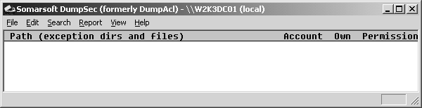

User Account Configuration
This check verifies that user accounts defined on the local system conform to DISA requirements.

- Select “Dump Users as Table” from the “Report” menu.
- Select the available fields in the following sequence, and click on the “Add” button for each entry:
UserName
SID
PswdRequired
PswdExpires
LastLogonTime
AcctDisabled
Groups
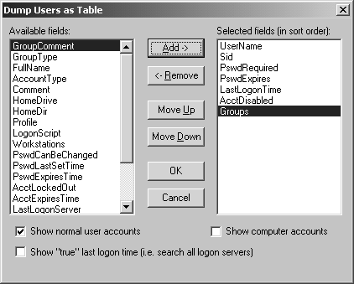

- Click “OK” to proceed.

Note: When DumpSec is run on a domain controller, check the box for ‘Show “true” last logon time (i.e. search all logon servers).
Next, compare the report’s output with the following check procedures. Some user accounts may appear repetitively, because “Groups” is included in the report.
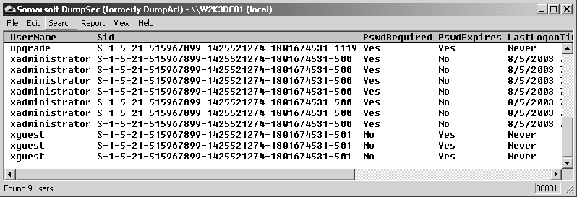

[AP] Passwords Requirement
If any accounts listed in the user report have a “No” in the “PswdRequired” column, then this is a finding.

Note: For a DISABLED account(s) with a blank or null password, classify/downgrade this finding to a Severity Code 2 finding.

Note: Some built in accounts such as the Guest account will not have this flag set. It can be set by entering the following on a command line: “Net user <account_name> /passwordreq:yes”

Category/MAC/IA: | I / 1-CSP, 2-CSP, 3-CSP / ECSC-1, IAIA-1
PDI: | 4.017: User account does not require a password.
Reference: | MS Server 2003 Security Settings Guide, Chap 2, p. 6

[AP] Passwords Expiration
If any accounts listed in the user report have a “No” in the “PswdExpires” column, then this is a finding.

 The following accounts are exempt from this check:
- The built-in administrator account
- Application accounts

Note: The site should have a local policy to ensure that passwords for application accounts are changed at least once a year.

Category/MAC/IA: | II / 1-CSP, 2-CSP, 3-CSP / ECSC-1, IAIA-1
PDI: | 4.018: User account password does not expire.
Reference: | MS Server 2003 Security Settings Guide, Chap 2, p. 7

[AP] Dormant Accounts
If any enabled accounts have not been logged into within the past 35 days, then this is a finding. This can be ascertained by examining the time in the “LastLogonTime” column. The following accounts are exempt from this check:

- The built-in administrator account
- The built-in guest account
- Application accounts
- The “IUSR”-guest account (used with IIS or Peer Web Services)
- Accounts that are less than 35 days-old
- Disabled accounts

- Note: The reviewer should review the list with the SA to determine the finding validity for each account reported.

Category/MAC/IA: | III / 1-CSP, 2-CSP, 3-CSP / ECSC-1, IAAC-1
PDI: | 4.019: User account is dormant.
Reference: | DISA FSO Windows 2003 Addendum, Sect. 5.3

[A] Decoy Administrator Account
An account should exist with the user name “Administrator” and have a SID ending with a value other than “-500”. If this account does not exist, then this is a finding.

Category/MAC/IA: | III / 1-CSP, 2-CSP, 3-CSP / ECSC-1, IAAC-1
PDI: | 4.023: A decoy Administrator account does not exist.
Reference: | DISA FSO Windows 2003 Addendum, Appendix E

[AP] Restricted Administrator Group Membership
 If a User, without administrator duties, is a member of the Administrators group then this is a finding.

Category/MAC/IA: | II / 1-CSP, 2-CSP, 3-CSP / ECSC-1, IAAC-1
PDI: | 4.027: A regular user has Administrator rights on the system.
Reference: | DISA FSO Windows 2003 Addendum, Sect 5.4

[M] Decoy Administrator Account Not Disabled.
If the decoy administrator account has not been disabled, then this is a finding.

Category/MAC/IA: | IV / 1-CSP, 2-CSP, 3-CSP / ECSC-1, IAAC-1
PDI: | 4.035: The decoy administrator account has not been disabled.
Reference: | DISA FSO Windows 2003 Addendum, Appendix E.

[MA] HelpAssistant or Support_388945a0 Accounts Not Disabled.
If the HelpAssistant or Support_388945a0 accounts have not been disabled, then this is a finding.

Category/MAC/IA: | II / 1-CSP, 2-CSP, 3-CSP / ECSC-1, IAAC-1
PDI: | 4.048: The HelpAssistant or Support_388945a0 accounts are not disabled.
Reference: | DISA FSO Windows 2003 Addendum, Sect 5.2

Using “Command Prompt”
The “Command Prompt” permits the assignment of direct commands to the Windows Server 2003 operating system.

This program is accessed through the following procedures:

Click on the “Start” button.
Select “All Programs” from the “Start” Menu.
Select “Accessories”.
Select “Command Prompt.”

Upon completion, the “Command Prompt” window should appear:

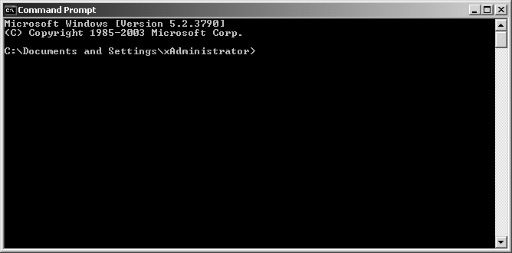

FTP (File Transfer Protocol) Server Configuration
This check verifies that the FTP server is configured in accordance with DISA standards. If an FTP server (such as the “FTP Publishing Service” included with Microsoft IIS for Windows Server 2003 ) is running, then perform the following checks.

To test for the existence of an FTP-server on the local system, enter the following command in the “Command Prompt” window:

X:\>ftp 127.0.0.1
-> ftp: connect:Connection refused
ftp>

If the command returns a “Connection refused” error message, then mark the following two checks as “NOT A FINDING.”

[AP] Prohibited FTP Logins Permitted
Anonymous ftp will not be configured on systems that are inside the protected perimeter. This check does not apply to systems that are outside the perimeter, where FTP is installed on a dedicated machine. Accounts with administrator privileges will not be used to access ftp.

In the “Command Prompt” window, enter the following command, and attempt to logon as the user “anonymous:”

C:\>ftp 127.0.0.1
Connected to ftru014538.ncr.disa.mil.
220 ftru014538 Microsoft FTP Service (Version 2.0).
User (ftru014538.ncr.disa.mil:(none)): anonymous
331 Anonymous access allowed, send identity (e-mail name) as password.
Password: password
230 Anonymous user logged in.
ftp>

If the command response indicates that an anonymous FTP login was permitted, then this is a finding.

If accounts with administrator privileges are used to access FTP, then this becomes a category I finding.

Category/MAC/IA: | II (I if accounts with admin privileges are used )  / 1-CSP, 2-CSP, 3-CSP / ECSC-1, ECLP-1
PDI: | 5.004: Installed FTP server is configured to allow prohibited logins.
Reference: | DISA FSO Windows 2003 Addendum, Sect 7.6.3

[A] Access to System Drive Permitted
In the “Command Prompt” window, enter the following command, log on using an authenticated FTP account, and attempt to access the root of the boot drive:

X:\>ftp 127.0.0.1
Connected to ftru065103.ncr.disa.mil.
220 ftru065103 Microsoft FTP Service (Version 2.0).
User (ftru065103.ncr.disa.mil:(none)): ftpuser
331 Password required for ftpuser.
Password: password
230 User ftpuser logged in.
ftp> dir /
200 PORT command successful.
150 Opening ASCII mode data connection for /bin/ls.
---------- 1 owner group 36864 Mar 5 15:29 __ofidxT.ffl
d--------- 1 owner group 0 Mar 12 12:25 Acrobat3
---------- 1 owner group 0 Mar 11 13:33 AUTOEXEC.BAK
---------- 1 owner group 27 Mar 12 18:54 AUTOEXEC.BAT
d--------- 1 owner group 0 Jun 15 19:02 ccmobile
---------- 1 owner group 0 Mar 11 13:33 CONFIG.SYS
d--------- 1 owner group 0 Apr 15 15:45 ExecSoft
d--------- 1 owner group 0 Mar 12 17:16 LANMAN.DOS
d--------- 1 owner group 0 May 26 12:21 MS
d--------- 1 owner group 0 May 22 12:03 Msinput
d--------- 1 owner group 0 Mar 25 16:26 NETSCAPE
d--------- 1 owner group 0 Mar 12 19:18 OFFICE
d--------- 1 owner group 0 Mar 12 17:17 OIWIN
---------- 1 owner group 78643200 Jun 18 11:55 pagefile.sys
d--------- 1 owner group 0 May 29 18:19 Program Files
d--------- 1 owner group 0 Mar 12 17:07 QVPLUS
d--------- 1 owner group 0 Jun 17 20:34 SRRDBC
d--------- 1 owner group 0 Jun 18 16:50 TEMP
d--------- 1 owner group 0 Jun 18 16:17 WINDOWS
226 Transfer complete.
1897 bytes received in 0.17 seconds (11.16 Kbytes/sec)
ftp>

If the FTP session indicates access to operating system files like “PAGEFILE.SYS” or “NTLDR,” then this is a finding.

Category/MAC/IA: | I / 1-CSP, 2-CSP, 3-CSP / ECSC-1, DCSL-1
PDI: | 5.005: Installed FTP server is configured to allow access to the system drive.
Reference: | DISA FSO Windows 2003 Addendum, Sect 7.6.3

IAVM Compliance

The VCTS automatically sends out alerts that could affect critical systems. If appropriate actions are not taken, this could leave the systems open to a potential compromise.

The platform must be checked to see if applicable Information Assurance Vulnerability Management (IAVM) bulletins have been applied.

Appendix B – Information Assurance Vulnerability Management (IAVM) Bulletin Compliance contains detailed instructions on checking IAVM compliance.

 Note: Due to the differences of internal configurations on some machines, several IAVM checks could be
reported as findings, in error, by the SRR scripts. The reviewer should validate any findings that are
questionable.

Additional Microsoft Components.
The setup wizard in Windows Server 2003 does not allow as much flexibility in component selection as previous version of Windows. Since that is the case, several default components are installed. These components should be removed from the system. In addition, there are several optional components available in Windows Server 2003. These components are either currently being evaluated or have been evaluated and found to pose a risk to the system. Until the evaluation is complete or known security holes are fixed, these optional components should not be installed.

The status of these components are accessed through the following procedure:

Select “Start”
Select “Control Panel”
Select the “Add or Remove Programs” applet.
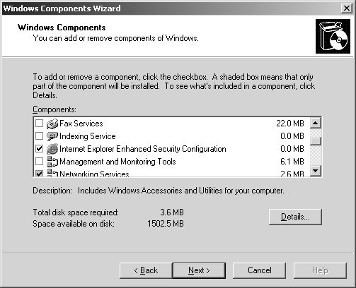
Select “Add/Remove Windows Components”.

Optional MS Components.

[MA] Print Services for UNIX.
This check verifies that Print Services for UNIX are not installed on the system.

Highlight “Other Network File and Print Services” and select details.

If the entry for “Print Services for Unix” is selected, and the site has no documented requirement for its use, then this is a finding.

Category/MAC/IA: | II / 1-CSP, 2-CSP, 3-CSP / ECSC-1, DCPP-1
PDI: | 5.026: Print Services for UNIX are installed on the system.
Reference: | DISA FSO Windows 2003 Addendum, Sect. 7.6.5

[MA] ASP.NET Common Runtime Host (.NET Framework)
This check verifies that common runtime host, ASP.NET, of the .NET Framework is not installed on the system.

Select “Application Server” -> Details

If the ASP.NET Framework application is installed, then this is a finding.

Note: It has been reported that Exchange Server 2003 requires this application to be installed to function properly. This case would not be considered a finding.

Note: If the ASP.NET host of the .NET Framework is installed, it may only be used for locally developed applications (due to DOD restrictions on mobile code), and must be at the current service pack level.

Category/MAC/IA: | II / 1-CSP, 2-CSP, 3-CSP / ECSC-1
PDI: | 5.069: The .NET Framework is installed.
Reference: | DISA FSO Windows 2003 Addendum, Sect 8.4.3

MQ Series security checks

This section defines the checks that should be made on a Windows Server 2003 platform that is running IBM’s MQSeries. To determine if MQSeries is installed, use the Microsoft Registry Editor, following the procedure in Section 5.6 of this checklist. Determine if the following Key exists:

HKLM\Software\IBM\MQSeries

If this key exists, then MQSeries is installed. Navigate to the following registry value:

HKLM\Software\IBM\MQSeries\CurrentVersion\FilePath

This is the directory where MQSeries is installed. It will be used for the checks in this section.

[MA] MQSeries Log Configuration (Server only)
This check verifies that the default setting for MQSeries Logs is set to preserve recorded events.

In the Registry Editor, navigate to the following registry value:

Registry Hive: HKEY_LOCAL_MACHINE
Subkey: \Software\IBM\MQSeries\CurrentVersion\Configuration\LogDefaults
Value Name: LogType
Data Type: REG_SZ
Value Data: “Linear”

If the registry value doesn’t exist, or is not set to the value shown, then this is a finding.

Category/MAC/IA: | II / 1-CSP, 2-CSP, 3-CSP / ECSC-1, ECTP-1
PDI: | 8.005: The MQ Series log has been configured to overwrite events.
Reference: | DISA FSO Windows 2003 Addendum, Sect. 8.4.1

[MA] Queue Manager Log Configuration (Server)
This check verifies that the default setting for each Queue Manager log is set to preserve recorded events.

In the Registry Editor, for each queue, navigate to the following registry value (replace <Queue Name> with each queue found:

Registry Hive: HKEY_LOCAL_MACHINE
Subkey: \Software\IBM\MQSeries\CurrentVersion\Configuration\QueueManager\
<Queue name>\Log
Value Name: LogType
Data Type: REG_SZ
Value Data: “Linear”

If the registry value doesn’t exist, and the previous check was a finding, then this is a finding. If the value exists and is not set to the value shown, then this is a finding.

Category/MAC/IA: | II / 1-CSP, 2-CSP, 3-CSP / ECSC-1, ECTP-1
PDI: | 8.006: The Queue Manager log has been configured to overwrite events.
Reference: | DISA FSO Windows 2003 Addendum, Sect. 8.4.1

[M] MCAUSER Attribute (Server)
This check verifies that the MCAUSER attribute on each queue manager’s server connection channel does not have a blank value. The MCAUSER attribute should contain a non-blank account name. The account should have no access to MQSeries objects.

To view the setting of the MCAUSER attribute on each queue’s server connection channel, have the system administrator use the MQSeries Explorer application or the MSQC command line utility. Request that he display each channel’s attributes. Include in this check the MQSeries default server connection channel (SYSTEM.DEF.SVRCONN).

The following procedure should allow reviewers to do this check:

Goto start-> run -> type ‘cmd’ and press enter.

Change directory to the Websphere MQ bin directory,

Enter the following.
RUNMQSC -V

To verify the queue manager type ‘DSPMQ’ this will return the active queues that are running on the system.

To open an active session type RUNMQSC ACTIVE_QUEUE_NAME
Note: ACTIVE_QUEUE_NAME is case sensitive.

DISPLAY CHANNEL(*)

You should now have a list of all active channels. To view the MCAUSER value type for each channel perform the following action.
DISPLAY CHANNEL(ACTIVE.CHANNEL.TYPE) MCAUSER

This will return the value of the MCAUSER value that is currently configured for the channel queried.

When finished enter END to end the RUNMQSC session and exit out of the command line.

If any server connection channel contains a blank value, then this is a finding.

Note: If a Channel Security Exit is in use, and provides a user identifier, then this value can be blank and will not be a finding.

Category/MAC/IA: | I / 1-CSP, 2-CSP, 3-CSP / ECSC-1, IAIA-1
PDI: | 8.008: The “MCAUSER” attribute of a server connection channel has a blank value.
Reference: | DISA FSO Windows 2003 Addendum, Sect. 8.4.1

[MA] MQM Group Existence (Server)
This check verifies that the MQM group exists and has not been deleted or renamed.

- Enter START Control Panel Administrative Tools Computer Management.
- Select Local Users and Groups Groups.
- Insure that MQM appears in the list of groups.

If the MQM group is not present, then this is a finding.

Category/MAC/IA: | II / 1-CSP, 2-CSP, 3-CSP / ECSC-1, ECLP-1
PDI: | 8.001: The MQM group does not exist.
Reference: | DISA FSO Windows 2003 Addendum, Sect. 8.4.1

[MA] MQM Group Membership (Server)
This check verifies that membership in the MQM group has been restricted to only those users or groups needing elevated access to maintain MQSeries

- Enter START Control Panel Administrative Tools Computer Management.
- Select Local Users and Groups Groups.
- Double-click the MQM group

If the MQM group contains members or groups that do not require elevated privileges for maintaining MQSeries, then this is a finding.

Category/MAC/IA: | II / 1-CSP, 2-CSP, 3-CSP / ECSC-1, ECLP-1
PDI: | 8.002: Membership in the MQM group is not restricted to those accounts or groups needing elevated access to MQ Series.
Reference: | DISA FSO Windows 2003 Addendum, Sect. 8.4.1

[MA] Configuration Files (Server and Client)
This check verifies that the configuration files from older releases of MQ Series have been removed from the server.

Using Windows Explorer and the directory location determined at the start of this section, open the “config” subdirectory.

If the MQ.ini or QM.ini configuration files exist, then this is a finding.

Category/MAC/IA: | III / 1-CSP, 2-CSP, 3-CSP / ECSC-1, DCSQ-1
PDI: | 8.007: Versions of the older MQ.ini and QM.ini files exist on the system.
Reference: | DISA FSO Windows 2003 Addendum, Sect. 8.4.1

[MA] MQSeries Files (Server and Client)
This check verifies that the file and directory permissions conform to DISA standards.

- Using Microsoft Explorer, select the indicated file or directory object
- Right-click the object
- Select Properties Security tab
- Compare the permission settings with those listed below:

Object Name | Account Assignment | Directory  Permission | File  Permission
…\MQSeries  Folder, subfolders, and files | Administrators  Authenticated Users  MQM  (MCAUSER name)(Server only)*  SYSTEM | all  RX  all  deny  all | all  RX  all  deny  all
…\MQSeries\qmgrs\<queue name>\Queues | Administrators  Authenticated Users  MQM  (MCAUSER name)(Server only)*  SYSTEM | all  RWX  all  deny  all | all  RWX  All  deny  all
*Only required if a Channel Security Exit is not used.

If the permissions on these files/directories are not as restrictive as those listed, then this is a finding.

Category/MAC/IA: | II / 1-CSP, 2-CSP, 3-CSP / ECSC-1, ECCD-1, ECCD-2
PDI: | 8.003: ACLs for MQ Series directories and files do not conform to minimum standards.
Reference: | DISA FSO Windows 2003 Addendum, Sect. 8.4.1

[M] MQ Series Services (Server and Client)
This check verifies that the MQSeries services are not run under the system account.

- Select Start Control Panel Administrative Tools Services
- Double click each MQSeries service
- Elect the Log on tab

If the service is configured to log on as the system account, then this is a finding.

Category/MAC/IA: | II / 1-CSP, 2-CSP, 3-CSP / ECSC-1, ECLP-1
PDI: | 8.004: MQ Series services are running under the local system account.
Reference: | DISA FSO Windows 2003 Addendum, Sect. 8.4.1

ORACLE Database security checks

This section defines the checks that should be made on a Windows Server 2003 platform that is running the ORACLE DataBase. To determine if ORACLE is installed, use the Microsoft Registry Editor, following the procedure in Section 5.6 of this checklist. Determine if the following Key exists:

HKLM\Software\ORACLE\Home0

If this key exists, then the ORACLE database application is installed.

Note: On a workstation, the existence of the HKLM\Software\ORACLE key, in most cases, means that an ORACLE Client is installed. These checks are not applicable to a client.

Navigate to the following registry value:

HKLM\Software\ORACLE\ORACLE_HOME

Record the directory path listed here. This is the home directory for the ORACLE software. It is the directory referred to as the ORACLE_HOME in the following checks.

Navigate to the following registry value:

HKLM\Software\ORACLE\HOME0\ORACLE_BASE

Record the directory path listed here. This is the directory referred to as the ORACLE_BASE in the following checks.

The ‘Oracle owner’ referred to in the following checks is typically called Oracle, DBAgroup, or Oinstall; however, it may have another account name that was created for this purpose.

[MA] Registry Permissions

Registry permissions should be restricted as follows:

Object Name | Account Assignment | Permission
HKLM\SOFTWARE\ORACLE  (include all subkeys) | Administrators  (Oracle owner)  (DBA group)  SYSTEM | all  QSCEN R (Write)  QSCEN R (Write)  all
HKLM\System\CurrentControlSet\Control\Services\Oracle* (all ORACLE services)  (include all subkeys) | Administrators  Authenticated Users  (Oracle owner)  SYSTEM | all  QENR (read)  all  all

If access permissions are not restricted as specified, then this is a Finding.

Category/MAC/IA: | II / 1-CSP, 2-CSP, 3-CSP / ECSC-1, ECCD-1, ECCD-2
PDI: | DO3777: Registry Permissions
Reference: | Database STIG F.14.4 and C.19.2.2

[M] Oracle File Owner
Check that all files in the ORACLE_HOME directory and other Oracle common system files are owned by the Oracle software owner (Typically Oracle, DBAgroup, or Oinstall).

If the Oracle Software owner, or the Administrators group, is not the owner of all the files, then this is a Finding.

Category/MAC/IA: | II / 1-CSP, 2-CSP, 3-CSP / ECSC-1, ECCD-1, ECCD-2
PDI: | DO3616: Oracle File Owner
Reference: | Database STIG C.19.1.6

[MA] Oracle File Permissions
Check permissions on Oracle system files. Permissions to files or directories in an Oracle installation should be granted to:
Object Name | Account Assignment | Directory  Permission | File  Permission
ORACLE_HOME\  Folder, subfolders, and files | Administrators  Authenticated Users  (Oracle owner)  (DBA group)  SYSTEM | all  RX  all  all  all | all  RX  all  all  all
ORACLE_HOME\bin  Folder, subfolders, and files | Administrators  Users  (Oracle owner)  (DBA group)  SYSTEM | all  RX  all  all  all | all  RX  all  all  all
*.dbf, *.log, *.ctl files  (use Explorer -> Search and search the ORACLE_HOME\ directory and subdirectorues for occurrences of the above file types) | Administrators  (Oracle owner)  (DBA group)  SYSTEM | all  all  all  all | all  all  all  all
ORACLE_BASE\ordata\DB_Name  Folder, subfolders, and files | Administrators  (Application Accounts)  (Oracle owner)  (DBA group)  SYSTEM | all  RX  all  all  all | all  RX  all  all  all

If access to these files and directories are not restricted as specified, then this is a Finding.

Category/MAC/IA: | II / 1-CSP, 2-CSP, 3-CSP / ECSC-1, ECCD-1, ECCD-2
PDI: | DO3613: Oracle File Permissions
Reference: | Database STIG C.19.2.1

[MA] File Permissions - strtSID.cmd (version 8 only)
This file contains the internal privileged account password. This file is created during particular Oracle version installations and may have been removed or may not exist on the system under review.

Object Name | Account Assignment | Directory  Permission | File  Permission
ORACLE_HOME\database\ directory\strtSID.cmd | Administrators  (Oracle owner)  (DBA group)  SYSTEM |  | all  all  all  all

If access to this file is not restricted as specified, then this is a Finding.

Category/MAC/IA: | II / 1-CSP, 2-CSP, 3-CSP / ECSC-1, ECCD-1, ECCD-2
PDI: | DO3845: File Permissions – strtSID.cmd
Reference: | Database STIG 4.2

[MA] File Permissions – listener.ora
The listener.ora file contains the listener password. Access to read this file could allow someone to determine the listener service password and to start and stop the listener service.

Object Name | Account Assignment | Directory  Permission | File  Permission
ORACLE_HOME\\network\admin\listener.ora | Administrators  (Oracle owner)  (DBA group)  SYSTEM |  | all  all  all  all

If access to the listener.ora file is not restricted as specified above, then this is a Finding.

Category/MAC/IA: | I / 1-CSP, 2-CSP, 3-CSP / ECSC-1, ECCD-1, ECCD-2
PDI: | DO3623: File Permissions – Listener.ora
Reference: | Database STIG C.7.3

[MA] File Permissions – snmp file
The snmp.ora or snmp_rw.ora file contains the Oracle SNMP password. The Simple Network Management Protocol (SNMP) password (contained in the SNMP file) is used to prevent unauthorized users from issuing commands to the database via SNMP.

Object Name | Account Assignment | Directory  Permission | File  Permission
ORACLE_HOME\\network\admin\snmp.ora | Administrators  (Oracle owner)  (DBA group)  SYSTEM |  | all  all  all  all
ORACLE_HOME\\network\admin\snmp_rw.ora | Administrators  (Oracle owner)  (DBA group)  SYSTEM |  | all  all  all  all

If access to the snmp_rw.ora and snmp.ora files are not restricted as specified above, then this is a Finding.

Category/MAC/IA: | I / 1-CSP, 2-CSP, 3-CSP / ECSC-1, ECCD-1, ECCD-2
PDI: | DO3842: File Permissions – SNMP file
Reference: | Database STIG C.15.6

[M] File Permissions – SYSDBA password file
Oracle stores the internal and SYS database privileged accounts passwords and passwords of accounts granted the SYSDBA or SYSOPER role in the PWD<SID>.ora file. Although the passwords are encrypted, privilege to this file should be restricted to prevent brute force attacks against the encrypted passwords.

Object Name | Account Assignment | Directory  Permission | File  Permission
ORACLE_HOME\\database\ PWD<SID>.ora | Administrators  (Oracle owner)  (DBA group)  SYSTEM |  | all  all  all  all

If access to the Oracle password file is not restricted as specified above, then this is a Finding.

Category/MAC/IA: | II / 1-CSP, 2-CSP, 3-CSP / ECSC-1, ECCD-1, ECCD-2
PDI: | DO3621: File Permissions - SYSDBA password file
Reference: | Database STIG C.7.2

[M] Listener Clear Text Password
The listener password may be stored in plain text in the listener.ora file.

The listener.ora file can be found in the ORACLE_HOME\network\admin directory.

Open and review the entry for “PASSWORDS_LISTENER =”.

If the entry for the “PASSWORDS_LISTENER =” doesn’t exist, is blank, or is not encrypted, then this is a Finding.

Category/MAC/IA: | I / 1-CSP, 2-CSP, 3-CSP / ECSC-1, ECCD-1, ECCD-2
PDI: | DO3471: Listener Clear Text Password
Reference: | Database STIG C.15.5 and C.7.3.1

WebSphere Application Server (Server)

This section defines the checks that should be made on a Windows platform that is running IBM’s WebSphere Application Server. To determine if WebSphere is installed, use the Microsoft Explorer search function and look for the “WebSphere” installation directory. This is typically n:\WebSphere. If the directory exists, then verify with the SA that the WebSphere Application Server is used on the machine.

This is the directory that will be used for the checks in this section.

[M] Websphere Administrator Account
This check verifies that a separate account has been created for using the WebSphere Administrative Console.

If a separate account has not been created for using the WebSphere Administrative Console, then this is a finding.

Category/MAC/IA: | II / 1-CSP, 2-CSP, 3-CSP / ECSC-1, ECLP-1
PDI: | 8.011: WebSphere - A separate security account has not been created for using the WebSphere Administrative Console.
Reference: | FSO NT/WIN2K/XP Addendum, Section 8.4.2

[M] Websphere Authentication
WebSphere is dependent upon the operating system for security of its functions and files. This check verifies that Websphere has been configured to use Windows authentication. Interview the WebSphere SA to determine if it has been configured this way.

If WebSphere has not been configured to use Windows authentication, then this is a finding.

Category/MAC/IA: | II / 1-CSP, 2-CSP, 3-CSP / ECSC-1, IAIA-1
PDI: | 8.012: WebSphere is not configured to use Windows authentication.
Reference: | FSO NT/WIN2K/XP Addendum, Section 8.4.2

[M] Websphere File Security
WebSphere is dependent upon the operating system for security of its functions and files. This check verifies that critical files and directories Websphere has been protected from unauthorized access. Permissions to WebSphere files and directories should be limited to those users and groups that need access. At a minimum, the WebSphere Application will need “Full Access”. Normal users should have no more than “Read” access.

Interview the WebSphere SA to determine the location of all the files listed below:

- Directories containing the JAVA programs, JAVA beans, JAVA servlets, and web applications used by WebSphere. Access is limited to the WebSphere account and WebSphere administrators.

- Directories containing XML files, which contain security attributes for enterprise JAVA beans and web applications. These files may contain password data, as well as other sensitive information. (“n:\WebSphere\APPServer”)

- Directories containing the WebSphere Administrative Console functions.

- The WebSphere client keyring file “sas.server.props” contains sensitive information and certificate information that is not encoded. It is located in the installation root\properties directory (“n:\WebSphere\Properties”).

- Any directories containing files used in the development or execution of code that is used by WebSphere.

If critical WebSphere folders and files have not been protected from unauthorized access, then this is a finding.

Category/MAC/IA: | II / 1-CSP, 2-CSP, 3-CSP / ECSC-1, ECCD-1, ECCD-2
PDI: | 8.013: WebSphere - Sensitive files and directories are not protected.
Reference: | FSO NT/WIN2K/XP Addendum, Section 8.4.2

Group Policy Object Protection (Domain Controllers only)

[M] Group Policy Permissions
This check is only applicable Domain Controllers. It need only be done on one Domain Controller in an individual domain. Its purpose is to verify that the access permissions have been applied properly to Group Policy Objects. Permissions should be checked for all Group Policies that may be assigned at the site, domain or organizational unit level. The procedure for checking permissions is basically the same, regardless of the level at which it is assigned.

The Group Policy is accessed through the following procedure.

- Select Start -> Programs -> Administrative Tools.
- Select Active Directory Users and Computers (for Domain and OU policies)
Or
Active Directory Sites and Services (for Site policies).
- Select the Domain, OU or Site name in the left-hand window.
- Right-click on the selected name.
- Select Properties.
- Select the Group Policy tab.
- Click on Properties.
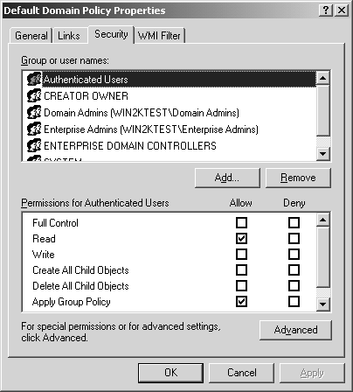
- Select the Security tab.

If the “Authenticated Users” group or a locally created group for users, or individual user, has less restrictive permissions than those shown in the figure above, then this is a finding.

Note: Only Administrator-related groups, Creator Owner, or System can have less restrictive
privileges.

Category/MAC/IA: | I / 1-CSP, 2-CSP, 3-CSP / ECSC-1, ECCD-1, ECCD-2
PDI: | 2.013: ACLs for Group Policy objects do not conform to minimum standards.
Reference: | DISA FSO Windows 2003 Addendum, Sect. 4.2.1

[M] Group Policy Auditing
This check is only applicable Domain Controllers. It need only be done on one Domain Controller in an individual domain. Its purpose is to verify that audit settings have been applied properly to Group Policy Objects. Audit Settings should be checked for all Group Policies that may be assigned at the site, domain or organizational unit level. The procedure for checking permissions is basically the same, regardless of the level at which it is assigned.

The Group Policy is accessed through the following procedure.

- Select Start -> Programs -> Administrative Tools.
- Select Active Directory Users and Computers (for Domain and OU policies)
Or
Active Directory Sites and Services (for Site policies).
- Select the Domain, OU or Site name in the left-hand window.
- Right-click on the selected name.
- Select Properties.
- Select the Group Policy tab.
- Click on Properties.
- Select the Security tab.
- Click the “Advanced” button and select the Auditing tab.
If the “Everyone” group is not audited for all failures then this is a finding.

Category/MAC/IA: | II / 1-CSP, 2-CSP, 3-CSP / ECSC-1, ECAR-3
PDI: | 2.021: Auditing for Group Policy objects do not conform to DOD standards.
Reference: | DISA FSO Windows 2003 Addendum, Sect. 4.2.2

Password Integrity Checking
Detailed instructions for checking for missing or weak passwords are contained in Appendix D - Password Strength Verification - Standard Operating Procedures.

[M] Weak Passwords (Domain Controllers)
If output from the password strength checking scripts indicates that there are weak passwords on the system, then this is a finding.

Note: If weak passwords are uncovered, verify that the complex password filter is installed properly (i.e. Enpasflt, PPE), and that it is configured to enforce password complexity requirements (PPE - mix of upper case letters, lower case letters, numbers, and special
characters, including at least one of each (e.g., emPagd2!)).

Category/MAC/IA: | II / 1-CSP, 2-CSP, 3-CSP / ECSC-1, IAIA-1
PDI: | 4.034: Accounts on the system contain weak passwords.
Reference: | DISA FSO Windows 2003 Addendum, Sect. 4.5.3

